# **SUCCESS STORY**

Africa RISING/NAFAKA Technologies Embraced by Farmers in Semi-Arid Agro-ecology of Iringa District CouncilORFarmers applying promising technologies beyond demonstration plots in Iringa DC(choose one please)

Soil moisture is the most limiting factor for crop production in the semi-arid of Iringa District Council. Worse still, impact of climate change which is already being felt by majority of smallholder farmers has haltered the rainfall pattern thus threatening food and nutritional security. Maize is a principal cereal grain and a main source of livelihoods for majority of famers in Iringa DC. However, farmers reported a notoriously low yield which ranges between 1 and 3 bags/acre an equivalent of 100kg to 300kg/acre which translates into less than 1ton/ha. Recently, the Africa RISING/NAFAKA Project has introduced the best technologies as a sound strategy for addressing challenges spelt out above in semi-arid agro-ecology of Iringa DC. These include tied and open ridges tillage methods for enhancing soil moisture conservation, use of improved maize varieties and use of fertilizers as well as good agronomic practices. Farmers situated in areas with Africa RISING/NAFAKA demonstration plots and neighboring villages have been fascinated with fabulous performance of technologies introduced. Farmers at Mkungugu and Kisingá villages reported that during 2018/2019 cropping season experienced absolute crop failures in most of their fields. However, what surprised them is that technologies demonstrated under Africa RISING/NAFAKA Project had inspiring results whereby maize planted on open/tied ridges with an integration of improved maize varieties registered maize grain yield of up to 6t/ha. Interviewed farmers acknowledged that Africa RISING/NAFAKA technologies have the potential of addressing the multitude of challenges and thus during 2019/2020 cropping season they have been incited to applythem in their own fields. For example, Mr Kikimba a farmers at Ndolela village from none participating village bordering Mkungugu village a participating village applied tied ridges, DKC 8031 improved maize varietyand fertilizer in his field with promising crop performance compared to fellow farmers using conventional tillage practices and local landraces(Figure 1). Similarly, Mr Simon Kabogo a farmer at Mkungugu village has 3 acres with same technologies with promising performance.

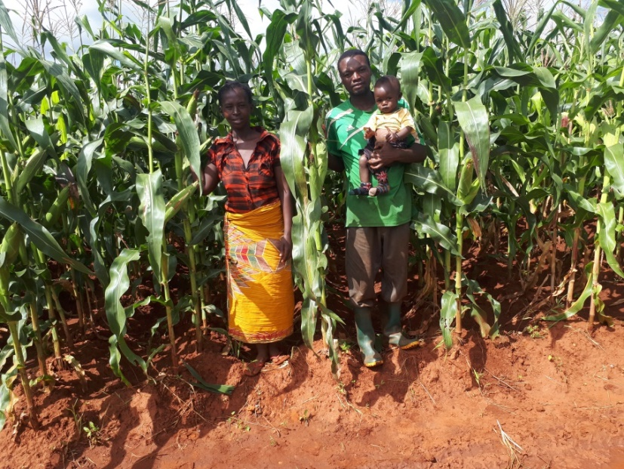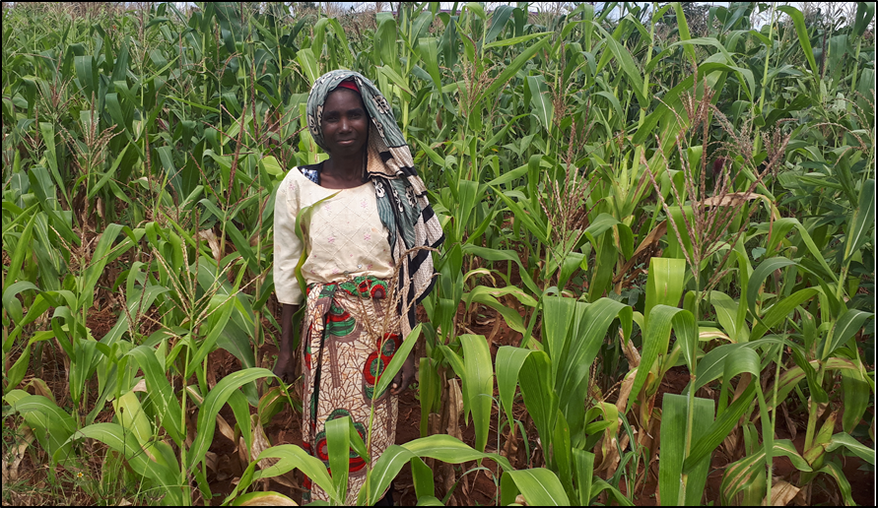

**Figure 1: Mr and Mrs Evodi Kikimba (left) installed tied ridges in their field with good crop performance compared with Ms Nuru her Neighbor (right) using conventional tillage and local landrace during 2019/2020 cropping season at Ndolela village, Iringa DC.**