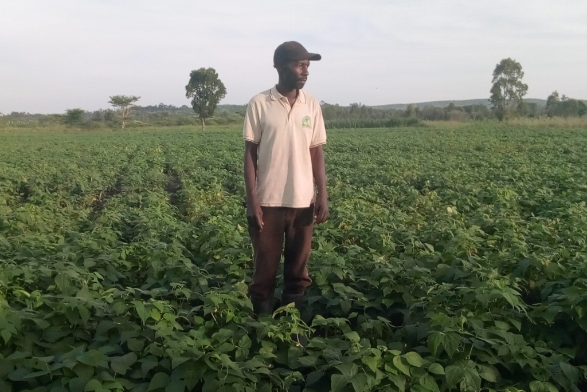

Salvatory Mulokozi is the smallholder farmer resided Kenyana village, Kilimilile ward in Missenyi District, started engaged in common bean seed production since 2013 after receiving training on seed production and seed business from ARI Maruku and TOSCI with assistance CIAT under Tropical Legume project.

The project has transform his local farming practices which normal yield 200 – 300 kg of total yield to good agronomic practices (GAP) such as use of correct plant spacing which increase the plant population and improved common bean variety which result to production of up to 700 kg of clean common bean seeds.

His income has increase significantly as the results of engaged in the production of improved common bean seed. The price of the common bean seed is TSh. 2,500 (US$1.16) per kilogram which is far high compared to grain which fetches a price TSh. 600 – 800 (US$ 0.28 – 0.37) in the local market.

He started with 2 acres of Njano Uyole in the long season of 2013 where he harvested 1,600 Kg of clean seeds. He sold out 1,400 Kg at the price of TSh. 2,500 per Kg to his fellow farmers in Missenyi and to the Missenyi District Council and earned a gross profit of Tsh. 3,500,000 (US$ 1628). He continued in seed production until 2017 September – December season he increased the acreage to 8 acres were he harvested 5,600 Kg of Njano Uyole.

The future Plans
“I have already requested at least 50 acres from the village government so that I can expand the production of improved common bean seeds and having office which will be used to sell seeds and provide agricultural services within and outside Missenyi District” Mulokozi said

He wants to increase the seed production activities and have seed agent office where he will be selling common bean and other crop seeds

Success
- He has manage to buy a satellite TV set
- Paying school fees of his children
- Bought his own farm
- Built a store for storing his produces
- House electrification

Challenges
- Climate change for two consecutive year the area have be stricken by drought which affect the production of the beans in 2015 and 2016
- Waiting for sometime before selling the seeds. This sometime become a challenges to him because there is a time he need to cash-money but he cannot getting from selling bean seeds because seed business has a season as well but when it come and it’s not a season to earn money from selling the last season seeds. “ To solve this I have different income generating activities in which I can depend on before selling out my bean produce” said Mulokozi

