**TANZANIA AGRICULTURAL RESEARCH INSTITUTE**



**2nd Quarter Progress Report 1st OCTOBER -31st DECEMBER 2023**

**Technology Transfer and Partnership-TARI Mikocheni**

**Prepared by:**

**Vidah Y. Mahava**

**Coordinator for Technology Transfer and Partnership TARI Mikocheni**

**DECEMBER 31st2023**

**1.0 Introduction**

Tanzania Agricultural Research Institute-(TARI-Mikocheni) is one of the 17 research centres under TARI.TARI-Mikocheni mandate is in two-folds, namely conduct and promote research for the development of the coconut sub-sector and promote research and utilization of agricultural biotechnology for socio-economic development in the country.

The centre’s head office is in Dar es Salaam at Mikocheni B, Plot 22 along the Coca Cola Road. It has two sub-stations, namely Chambezi and Mkuranga, where most of the research activities are conducted. The former is located about 55 KM North of Dar es Salaam near Bagamoyo town at latitude S6.520 and longitude E 38.910, while Mkuranga sub-station is located at S 7.120 and Longitude E 39.200, about 50 KM South of Dar es Salaam.

There are two departments: 1) Research and Innovation and 2) Technology Transfer and Partnership. Under these departments there are six subprograms: Crop Research, Natural Resources, Post-harvest Management, Socio-economics and Marketing; Technology Dissemination, Commercialization and Partnership; and Knowledge Management and Communication Programs.

The Mikocheni centre basically has two research programs, which its mandates are: Coconut and Biotechnology. The coconut program is the main with four (4) research units which include: Agronomy, Disease & Pest Control, Socio-economics, Post-harvest and Technology Transfer; the Biotechnology Program accommodate three (3) units Tissue Culture, Molecular Diagnostics and Genetic Engineering Laboratories. All the research activities in each unit in the coconut program are designed to address all agricultural challenges facing the coconut agro-ecological systems which include poor coconut husbandry practices, effect of drought stress, poor soil fertility, incidence and severity of noxious pests, high incidence and damage by the coconut Lethal Disease and planting of low yielding varieties. Other challenges are low expansion, low level of rehabilitation of the area under coconuts, limited value addition/processing and poor marketing. Biotechnology in the centre acts as a tool cut across all crops and supports other research mandate.

1. **Technology Dissemination pathways used by TARI**

Various pathways were used for dissemination of agricultural technologies from research to different stakeholders which includes demonstration plots and the use of hubs (AgriTeCH).

**2.1: Technologies disseminated through AgriTecH(s)**

During this reporting time AgriTechs hubs continue to disseminate Agriculture technologies as follow: At Mwl Julius Nyerere eight (6) technologies were disseminated in which (1) demo plot on Banana tissue culture with varieties of Mzuzu, Kimalindi, Bukoba and Fia 23, (1) demo plot where Coconuts are intercropped with mangoes and oranges, one (1) demo plot at Nzuguni-Dodoma with Coconuts only, (1) one demo plot at Fatma Mwasa-Tabora with Coconuts only and One (1) demo plot at Nyakabindi-Shinyanga hub with coconuts intercropped with Bio-Fortified maize.

**Table 1: Technologies disseminated by TARI through AgriTecH(s)**

|  |  |  |
| --- | --- | --- |
| **AgriTecH** | **Crop** | **Variety/technology disseminated** |
| Fatma Mwasa, Tabora | 1. Coconuts | Coconuts (East African Tall) |
| **Total No. technologies disseminated** | **1** |
| Nzuguni, Dodoma | 1.Coconuts | Coconuts (East African Tall) |
| **Total No. technologies disseminated** | **1** |
| Mwl. Julius Nyerere, Morogoro | 1.Banana tissue culture | Banana (Mzuzu,Kimalindi,Bukoba and Fia 23) |
| 2.Coconuts, Mangoes and Oranges | Intercropping with fruit tree crops |
| **Total No. technologies disseminate** | **5** |
| Nyakabindi, Shinyanga | 1.Coconuts | Coconuts (East African Tall) intercropped with Bio-Fortified Maize |
| **Total No. technologies disseminated** | **1** |
| **TOTAL** | **Total No. technologies disseminated** | **6** |

**2.2. Stakeholders reached with improved technologies disseminated by TARI Mikocheni**

**2.2.1. Stakeholders reached with improved technologies in Mikocheni Substations**

In this reporting period total number of **295** **Farmers (182 Males and 113 Females**) were reached in Mikocheni substations, in which **231** **Farmers (134 Males and 97 Females)** visited Chambezi sub-station and **64 Farmers (48 Males and 16Females)** visited Mkuranga sub-station requested on buying coconut, mangoes and oranges seedlings, asking different questions concerning management and pest control in coconuts, mangoes and oranges.

**Table 2: Number of stakeholders reached by technologies in Substations.**

|  |  |  |
| --- | --- | --- |
| **Place** | **Stakeholders** | **Technologies disseminated** |
| Chambezi | 231Farmers (134 Males and 397 Females) | 1. Coconuts intercropped with mangoes and orange to control pests through weaver ants which feed on coreid bugs.  2. Mechanical remover of beetles using hook.  3. Cultural control by cleaning field removing dead logs which are breeding site for beetles.  4. Using of Traps (Pheromones, PVC Pipe and Tin) to trap beetles. |
| Mkuranga | 64 Farmers (48 Males and 16 Females) | 1. Coconuts intercropped with mangoes and orange to control pests through weaver ants which feed on coreid bugs.  2. Mechanical remover of beetles using hook.  3. Cultural control by cleaning field removing dead logs which are breeding site for beetles.  4. Using of Traps (Pheromones, PVC Pipe and Tin) to trap beetles. |
| **Total number of technologies disseminated** | | **4** |

**2.2.2 Stakeholders reached with Technologies Disseminated from TARI Mikocheni Centre to various places**

In this reporting period,total number of **31 farmers (15 Males and Females 16**) and **7 extension officers (5 Males and 2 Females**) extension officers were trained on improved vegetables varieties under FRESH Project.Agronomy department were the main participants in this project in collaboration with other departments at TARI Centre. The total number of **4 demonstration plots** were established in two regions Morogoroat Kingolwira Village in Morogoro Municipal and at Mlali village in Mvomero District and at Dule village in Bumbuli District and at Mkumbara village in Korogwe District in Tanga. The demo plots were established to showcase different technologies to farmers and extension officers which are: **Improved Vegetable Varieties**  of Amaranthus (Poli, Nguruma and Akeri), one variety of African Eggplant (DB3) and technologies demonstrated were on **Good Agronomic Practices (GPAs)** which field layout and preparations, transplanting of vegetable seedlings, establishment of vegetable Nursery, and field management practices.

**Table 3: Number of trainees on field layout and transplanting.**

|  |  |  |  |  |
| --- | --- | --- | --- | --- |
| **District/ Municipal** | **Farmers**    **((**  **(9NPK)** | | **Extension officers** | |
| **Males** | **Females** | **Males** | **Females** |
| Morogoro Municipal | 5 | 2 | 1 | 1 |
| Mvomero | 4 | 0 | 2 | 0 |
| Bumbuli | 2 | 6 | 1 | 1 |
| Korogwe | 4 | 8 | 1 | 0 |
| **Total** | **15** | **16** | **5** | **2** |

**Demo plots established on improved vegetable varieties in different districts are shown on pictures below:**

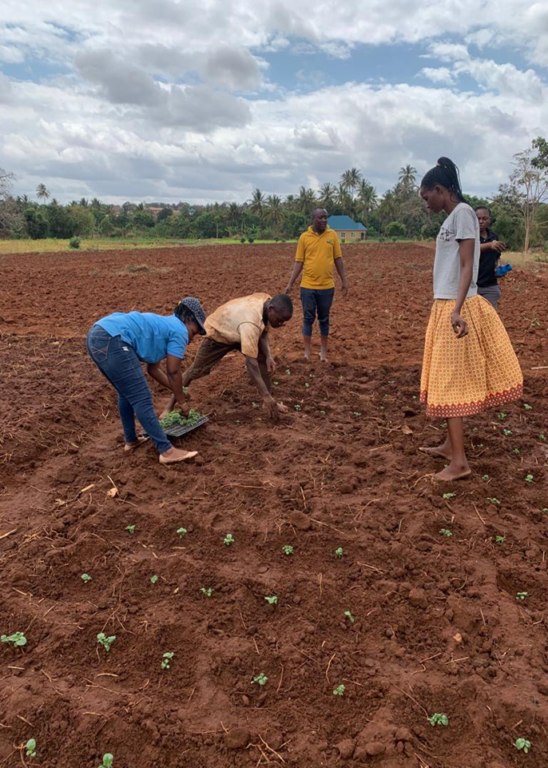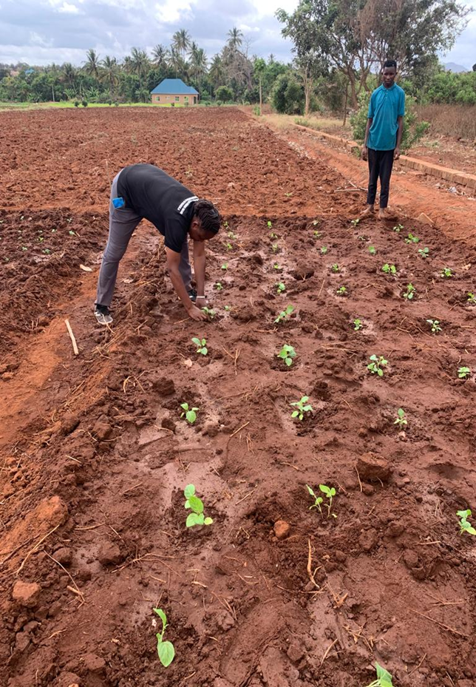

***Picture 1: Agronomists from TARI Mikocheni transplanting DB3 eggplants with farmers and Extension Officer at Kingolwira Village in Morogoro Municipal***

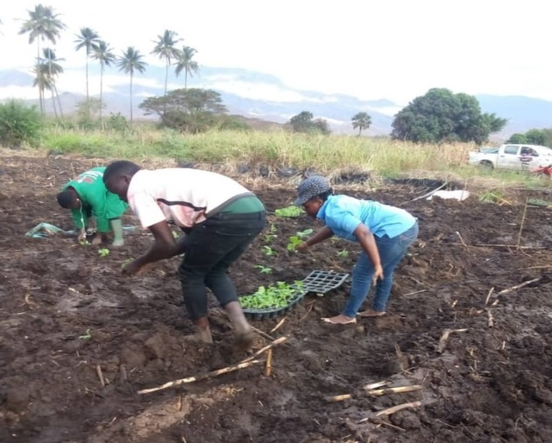 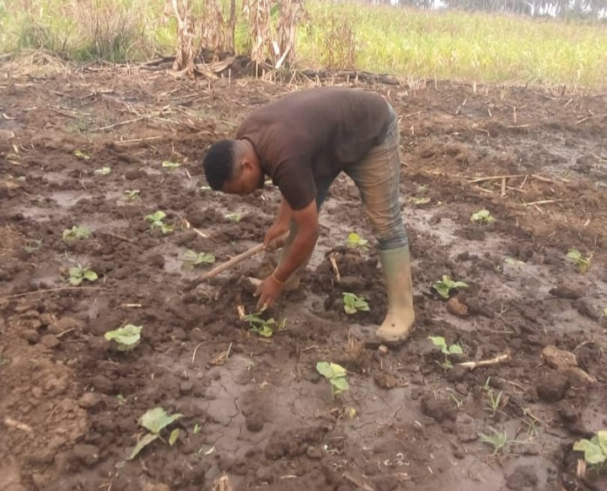

***Picture 2: Agronomists from TARI Mikocheni transplanting Amaranth with farmers and Extension Officer at Mlali Village in Mvomero District***

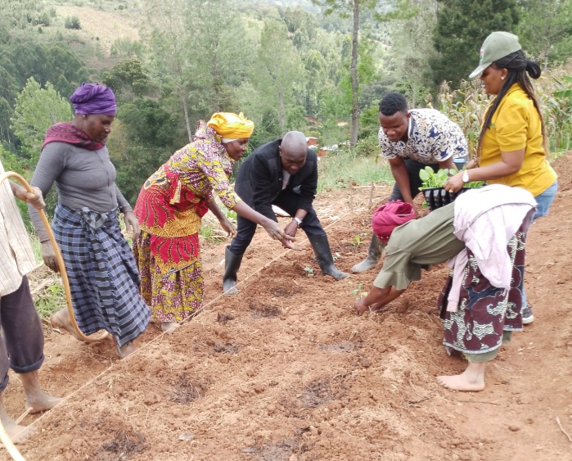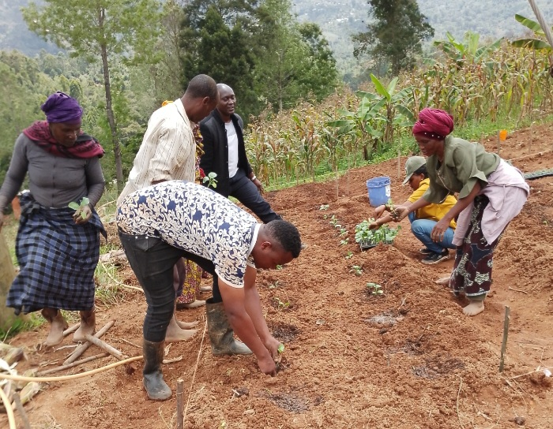

***Picture 3: Agronomists from TARI Mikocheni transplanting Amaranth with farmers and Extension Officer at Dule Village in Bumbuli District***

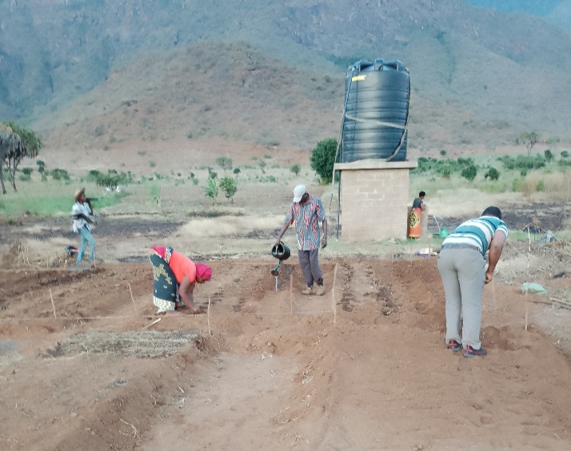 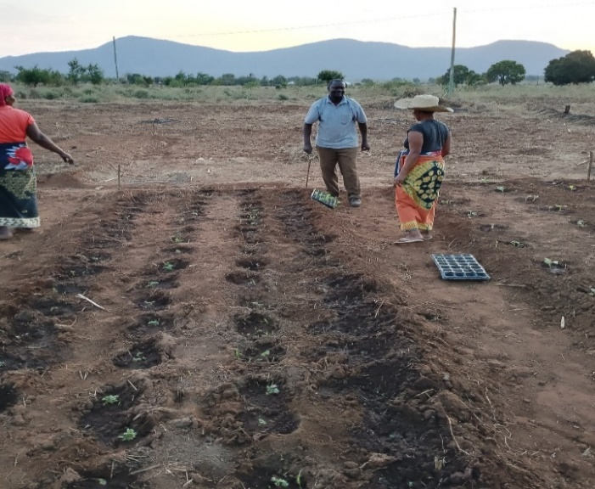

***Picture 4: Agronomists from TARI Mikocheni transplanting Amaranth with farmers and Extension Officer at Mkumbara Village in Korogwe District***

**3. Knowledge Management and Communication**

**3.1 TARI Website Content management**

**Different information was uploaded to TARI website as shown by the table 3 below:**

**Table 4: Type and numbers of information uploaded to TARI website for Quarter 2**

|  |  |  |  |  |
| --- | --- | --- | --- | --- |
| **Centre** | **Type of information uploaded** | **Number/frequency** | **Remarks/any feedback** | **Challenges** |
| TARI – Mikocheni | News | 2 | - | Lack of facilities including Internet, Camera for taking photos and documentaries, Computer, Scanner, Photocopy machine and Mobile phones |
| Publications | 1 |
| Images/photos | 12 |
| Videos | 0 |
|  |  |

**3.2 Information Education and Communication materials**

Planned number of materials to be disseminated in Quarter 2 were 300 leaflets on coconut, tissue culture and improved vegetables where 43 leaflets were managed to be disseminated.

**Table 5: Information materials produced and distributed.**

|  |  |  |  |  |  |  |  |  |
| --- | --- | --- | --- | --- | --- | --- | --- | --- |
| **Centre** | **Number of print communication materials** | | | | | | | |
| **Posters** | **Signboards** | **Fliers** | **Brochures** | **Banners** | **Wheel covers** | **Leaflets** | **Others specify** |
| TARI – Mikocheni | **-** | **-** | **-** | **-** | **-** | **-** | **43** | **-** |
|  |  |  |  |  |  |  |  |

**4 TARI Visibility**

**4.1 Signboards: Nil**

Preparation of signboards: areas fixed with signboards with uniform format and design across TARI Centres.

**4.2 Mass media prepared by TARI Mikocheni in Quarter 2**

In this reporting period, Mass Media planned to air 8 TV while aired 0 TV. Also planned Radio were 8 while aired 0 radio, also Planned 7 newspapers actual released were 0 also Planned Social Media were 115 while aired Social Media were 46 as shown on the table 5 below.

**Table 6: Number of TVs, radio, newspapers, and social media produced and disseminated**

|  |  |  |  |  |  |  |  |
| --- | --- | --- | --- | --- | --- | --- | --- |
| **Centre** | **Numbers prepared/hired/made/received** | | | | | | |
| TARI – Mikocheni | **TV** | **Radio** | **Newspapers** | **Social media** | **Short Messages** | **Phone calls** | **Others specify** |
| 0 | 0 | 0 | 46 | 47 | 73 | - |

**5.0 Strengthening Partnerships and Collaboration**

**5.1 Meetings/ conferences/ symposia/ workshops**

One Researcher (Female) attended training workshop New Library Auditorium at Mwalimu J.K. Nyerere Campus (UDSM, in which the main objective was to get exposure on how to edit Gene sequences. The workshop took place from 16th to 20th October 2023. One (Female) Senior Research Officer who is the Centre Coordinator of Technology Transfer and Partnership (CTTP) attended a workshop in Botswana. The two days’ workshop was convened from the 20th to the 21st of November 2023 at Gaborone, Botswana. The workshop was organized by The Centre for Coordination of Agricultural Research and Development for Southern Africa (CCARDESA). This workshop was a physical event brought together participants and Gender experts in an interactive approach to validate the gender policy. Key relevant stakeholders validate the Gender, Youth Inclusion Policy. The specific objectives of this assignment was to input in the CCARDESA gender and Youth Inclusion policy and validate it. The main output of the workshop is to have a CARDESA gender and Youth Inclusion policy finalized to be shared among member states for implementation. Also the CTTP participated in the workshop on ICT-Based Knowledge Products Validation which was done by the Consultant in three SADC countries. Also there was a follow up workshop on Success Stories Validation. One of the roles of the CAADP-XP4 programme is to strengthen knowledge management and communication policy support with the aim of becoming a knowledge broker in the SADC region. Success story development is a key component in knowledge management as it promotes the sharing of organizational best practices. Under the CAADP-XP4 project’ Activity area 4.1.3: Develop knowledge products with various stakeholders for dissemination via the knowledge platforms CCARDESA engaged the Southern African Research and Documentation Centre (SARDC) whom they have a running Memorandum of Understanding (MoU).Activity Code Convener Organized by CCARDESA undertake to compile success stories into a coffee table book based on the thematic areas and CCARDESA projects/ initiatives at large. Therefore the workshop was to validation the success stories.

**Table 7: Meetings/conferences/symposia/workshops conducted/attended by TARI staffs.**

|  |  |  |  |  |  |
| --- | --- | --- | --- | --- | --- |
| **No** | **Tittle/themes** | **Dates** | **Venue** | **Partners** | **Type of event (workshop/**  **Meeting** |
| 1. | Gene editing | 16th to 20th October 2023 | New Library Auditorium at Mwalimu J.K. Nyerere Campus (UDSM) | Researchers and Scientists from African countries, i.e. Nigeria, Mozambique, Ethiopia, Kenya, Uganda, Sudan, Malawi ,Southern Africa etc. | Training Workshop |
| 2. | Gender Policy Validation  . | 20th to 21st November 2023 | Grand Aria Hotel, Gaborone- Botswana | The primary participants were the National Gender focal persons, the CAADPXP4 Institutions Lead Gender Focal persons (CORAF), Board Member under Civil Society, and some Members States participants including Tanzania. Tanzania as a member state was represented by participant form Tanzania Agricultural Research Institute (TARI). | Workshop |
| 3. | ICT-Based Knowledge Products and  Success Stories Validation | 4th to 7th December 2023 | Holiday Inn Johannesburg South Africa | The primary participants will be the National CCARDESA ICKM focal persons, Farmers the CAADPXP4 Team, Board Member, Civil Society, and some Members States participants | Workshop |

**5.2 Partnership and collaboration**

**5.2.1 Strengthen Collaboration**

Two Scientists from DEEJAY COCONUT FARM PVT LTD (DJCFPL) in India visited Mikocheni Centre at Chambezi and Mkuranga substations on 18th and 19th  October 2023.The aim was to survey and analyzing the current situations in substations before negotiating with Mikocheni Centre on how to collaborate supporting advancement of coconut cultivation to help small farmers as well as large cultivation to increase coconut production in Tanzania. The Deejay Hybrid Coconut it yields three times the number of nuts per acre compared to traditional tall coconut variety which will improve the economics of farmers substantively.

**Below are some pictures taken during the Deejay Group visit at Mikocheni Centre**.

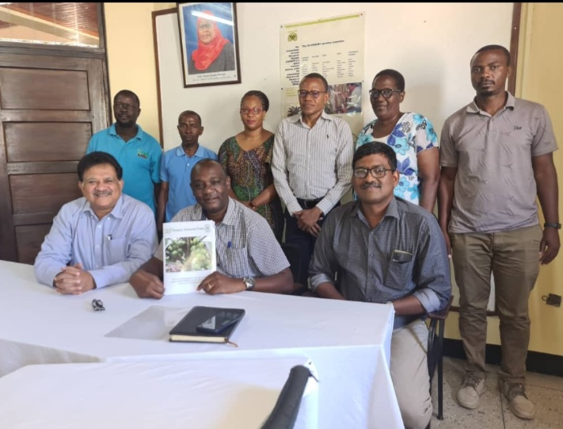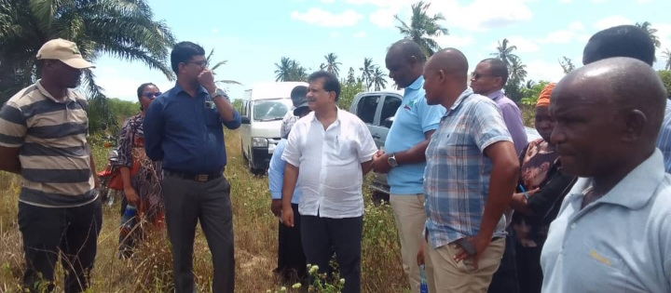

***Picture 5:(LEFT SIDE) Mikocheni Centre Manager, Dr. Fred Tairo (between) with Chief Executive Officer of Deejay Group, Mr. Saibal K.De (Left) and Head of Production Department at Deejay Coconut Farm, John Magesh (Right) taking a picture with Mikocheni Head of Departments and other staffs during the visit at Mikocheni Meeting Room.(RIGHT SIDE) Scientists from India, Mr. Saibal K.De (with white shirt) and John Magesh(with black shirt) on discuss on issue pertaining coconut productivity with Centre Manager, Dr.Fred Tairo(with light blue T-shirt) and other Mikocheni staffs during the visit at Chambezi Substation***

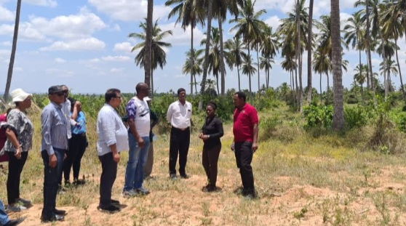 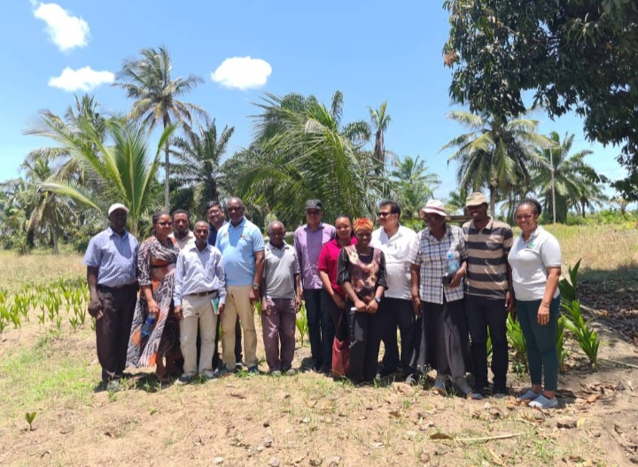

***Picture 6:(LEFT SIDE) Centre Manager, Dr. Fred Tairo (between) with Scientists from Deejay Group, Mr. Saibal K.De (left) and John Magesh(right) and other Mikocheni staffs listening to Sub-station Manager, Mr. Abdulrazak Kyobya elaborating on current status of coconut production during the visit at Mkuranga Substation,(RIGHT SIDE) Mikocheni Centre Manager, Scientists from Deejay Group, head of departments and other Mikocheni staffs members taking a picture during the visit at Chambezi Substation.***

**5.2 .2 Strengthen Partnerships**

TARI Mikocheni received visitors from Tourism, Business and Agriculture Committee from Zanzibar and other Government leaders aim at observing and learning on Biotechnology Program conducted by the Centre. The visitors visited three Biotechnology units of Tissue culture, Molecular Diagnostics and Genetic Engineering laboratories where they observed different activities performed by each unit. The purpose of observing the activities goes perpendicular with the need of Zanzibar Research Institute (ZARI) to collaborate with TARI Mikocheni to build capacity to ZARI researchers on Biotechnology.

**Below are some of the pictures taken during the visit at Mikocheni Centre**

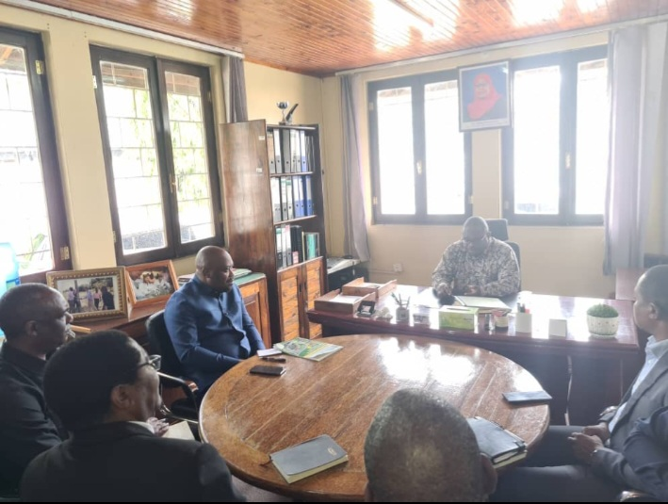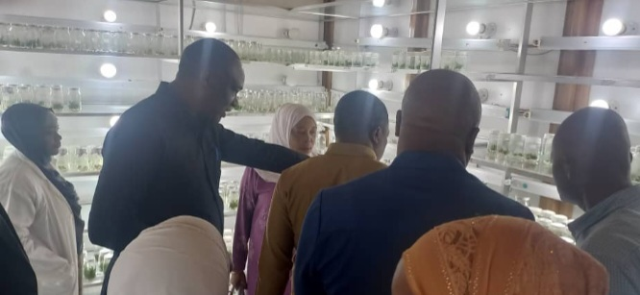

***Picture 7:(LEFT SIDE)Minister of Agriculture, Irrigation, Tourism and livestock Zanzibar Hon. Shamata Khamis (sitting in front) explaining on matters pertaining Agriculture sector to General Secretary Ministry of Agriculture, Hon.Gerard Mweli(1st left),Centre Manager, Dr.Fred Tairo(2nd left),TARI Director General, Dr.Geoffrey Mkamilo(3rd left) and ZARI Director General, Dr.Mohamed Kombo(1st right) at Mikocheni Centre Manager Office, RIGHT SIDE )Mikocheni Centre Manager, Dr. Fred Tairo elaborating to the visitors on the media used to grow sisal plant in Tissue culture laboratory***

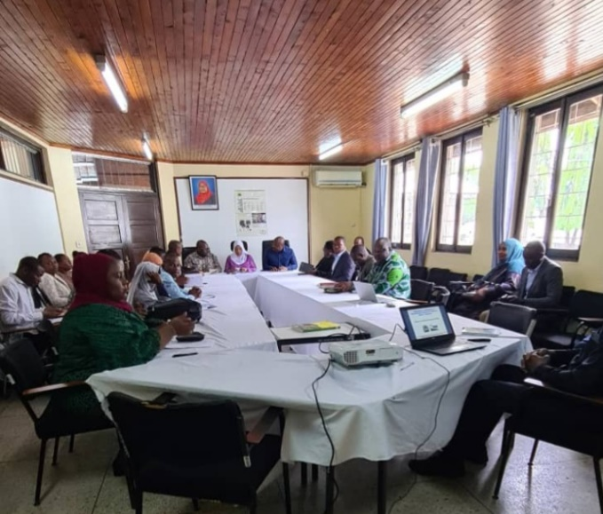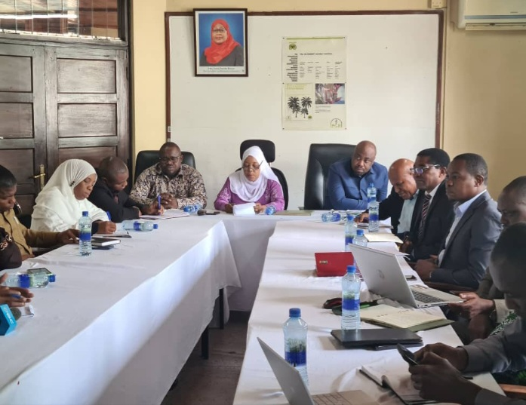

***Picture 8: Chairman of the Tourism, Business and Agriculture Committee from Zanzibar, Hon. Mtumwa Yusuph (sitting between) explaining mandate functions of the Committee to the government leaders and TARI Mikocheni Staffs at the Mikocheni Centre Meeting Room***

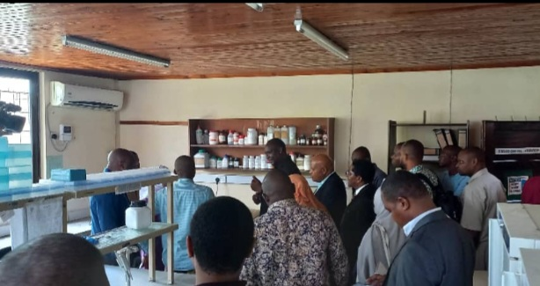

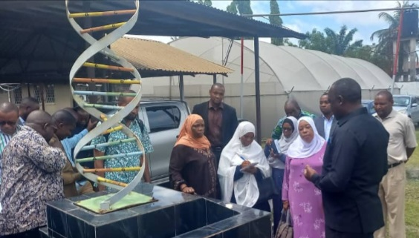

***Picture 9:(LEFT SIDE) Mikocheni Centre Manager, Dr. Fred Tairo explaining to the visitors on the diagnosis of diseases in plants at Molecular Diagnostics laboratory, (RIGHT SIDE) Mikocheni Centre Manager, Dr. Fred Tairo (with black suit) describing to the visitors on how to DNA of a plant is altered at Genetic Engineering laboratory.***

**5.3.3 Building Good Relationship**

In building good relationship TARI Mikocheni received visitors in one of the substation of Chambezi in Bagamoyo district in Pwani Region. The guest of honour was Honorable Hussein Mohamed Bashe, the Agriculture Minister. The aim of the visit was to solve disputes on land ownership between Chambezi substation and Chama Cha Mapinduzi (CCM) Administration, the visit enables reclaiming of land taken by invaders which will be used for coconut production.

**Below are some of the pictures taken during the visit:**

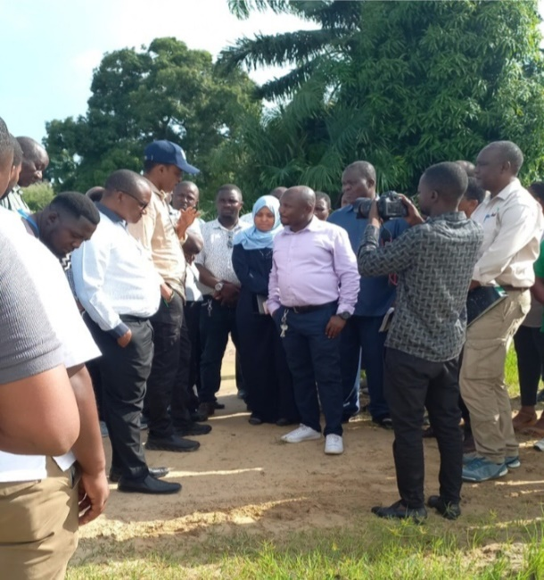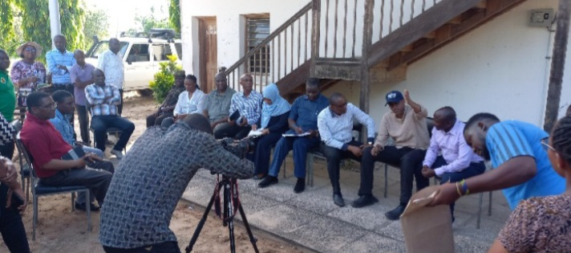

**Picture** **10 :( LEFT SIDE), Minister of Agriculture, Hon.Hussein Bashe (with darkblue cap) asking questions concerning land disputes to Kiromo Ward Councilor, Mr. Salum Mikugo (with white shirt)**

**(RIGHT SIDE), Minister of Agriculture, Hon.Hussein Bashe (with dark blue cap) suggesting ways forward on solving the land conflict issue.**

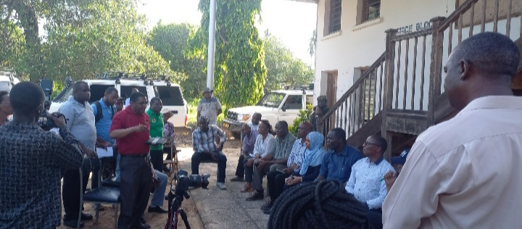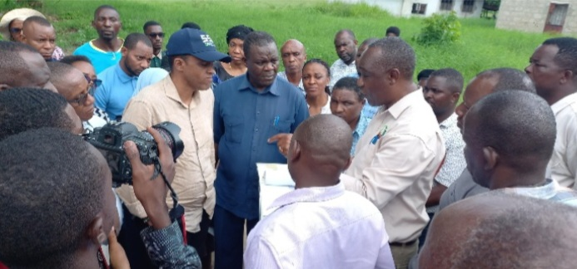

**Picture 11:(LEFT SIDE), Director General of TARI, Dr. Geoffrey Mkamilo explaining on the current status of the Chambezi substation, (RIGHT SIDE), Mikocheni Centre Manager, Dr. Fred Tairo elaborating on the map showing territory of the Chambezi substation**

**5.3. Visitations**

In this reporting time total number of **50 visitors (40 Males and 10 Females)** stakeholders visited the centre for different purposes as shown in Table 8 below.

**Table 8: Visitors visited the centre.**

|  |  |  |  |  |  |
| --- | --- | --- | --- | --- | --- |
| **S/No** | **Date of the visit** | **Type of visitors** | | **Total number** | **Aim of the visit** |
| 1 | 02nd October 2023 | Farmers from Kigamboni -DSM | | 1 Male and 1 Female | They were asking on coconut and sisal seedlings to buy along with preservative to store maize |
| 2 | 03rd October 2023 | Farmer from Arusha | | 2 Males | They were asking on buying coconut and banana seedlings |
| Farmer from DSM | |
| 3 | 11st October 2023 | Farmers from Kisarawe and Mikocheni-DSM | | 4 Males and 1 Female | They wanted to buy coconut seedlings. |
| Researcher from TARI Kibaha-Pwani | | 1 Female | She wanted to buy Tissue culture banana |
| Individual farmer from Muheza-Tanga | | 1 Male | He wanted to buy coconut seedlings |
| 4 | 16th October 2023 | STEROX Ambassadors | | 1 Female and 1 Male | They wanted to get accessibility of hiring vehicles for and purposes |
| 5 | 28th October 2023 | Individual farmer from Pwani | | 1Male | He wanted coconut farming education as well as buying coconut seedlings for establishment |
| 6 | 30th October 2023 | Individual farmer from DSM | | 1 Male | Requesting for coconut learning materials |
| 7 | 01st November 2023 | | Individual farmer from Goba –DSM | 1 Male | He wanted to buy maize seeds for production, and he was directed to TARI Ilonga |
| 8 | 02nd October 2023 | | Farmers from Goba- DSM | 2 Males | They were asking on buying banana seedlings |
| 9 | 3rd November 2023 | | A reporter from Wananchi | 1 Male | Request for publication |
| 10 | 06th November 2023 | | Ambassador from SANKU | 1 Male | He wanted to provide education to workers on food affordability for survival |
| 11 | 07th November 2023 | | Farmers from Ifakara-Morogoro | 2 Males | They wanted coconut farming education as well as buying coconut seedlings for establishment |
| 12 | 08th November 2023 | | Individual farmer from Tabata-DSM | 1 Male | He wanted to get coconut farming education |
| 13 | 10th November 2023 | | Representatives from Forever Living | 2 Females | They wanted to provide education on their health products |
| Farmers from Kitunda-Dsm | 1 Female and 1 Male | They wanted to get education on Agriculture issues |
| 14 | 14th November 2023 | | Individual farmer from Upanga-DSM | 1 Male | He wanted to buy Mangoes, Oranges, and pawpaw seedlings |
| 15 | 15th November 2023 | | Individual farmer | 1 Female | She wanted to buy Mangoes seedlings |
| 16 | 16th November 2023 | | Farmers from DSM and Mtwara | 4 Males | They wanted to get coconut seedlings |
| 17 | 20th November 2023 | | Farmer from DSM | 1 Female | She wanted to buy coconut seedlings |
| 18 | 21st November 2023 | | Farmers from DSM | 2 Males | They wanted to get Mangoes seedlings |
| Individual farmer | 1 Male | He wanted to buy coconut seedlings |
| 19 | 27th November 2023 | | Individual farmer from Mlandizi-Kibaha | 1 Male | He wanted to get education coconut seedlings |
| Individual farmer from Mbezi-DSM | 1 Male | He wanted to get education on coconut and sesame agricultural production |

|  |  |  |  |  |
| --- | --- | --- | --- | --- |
| 20 | 04th December 2023 | Individual farmer from Msasani –DSM | 1 Male | He wanted education on coconut farming |
| 21 | 05th December2023 | Reporters from Tumaini Media | 2 Males | They wanted to get documentaries from coconut farming on soil world day |
| 22 | 06th  December 2023 | A farmer from Segerea - DSM | 1 Male | He wanted education on coconut farming |
| 23 | 11th December 2023 | A farmer from Morogoro Municipal | 1 Female | They wanted to buy coconut seedlings for coconut plantation establishment |
| A farmer from Ifakara -Morogoro | 1 Male |  |
| A farmer from Ngamiani -Tanga | 1. Male |  |
| 24 | 13th December 2023 | Farmers from DSM | 1 Male | He wanted coconut farming education as well as buying coconut seedlings |
| 25 | 19th December 2023 | Individual farmers from DSM | 2 Males | They wanted to buy coconut seedlings |
| 26 | 29th December 2023 | Farmer from DSM | 1 Male | He wanted to buy coconut seedlings |

**5.4 Challenges**

* Absence of Facilities and Equipment for effective and efficiency of the TTP Unit
* Absence of water to irrigate due to rain absence which hinder coconut productivity and other crops to be intercropped with coconuts
* Lack of coconuts seedlings for disseminating to coconut farmers/stakeholders
* Lack of funds for supporting processing of various coconut by products. i.e., Coconut oil, milk, powder, soap etc. Lack of funds hinders the preparation of different dissemination materials to our last mile

**5.5 Conclusion and Recommendations**

* Alternative on water supply in substations should be established so as to solve the water shortage problem in absence of rainfall which reduce coconut productivity
* Funds should be provided to support nursery practices so as to increase coconut seedlings to satisfy the needs of coconut growers
* Due to the need of coconut by products funds should be provided for expanding and rehabilitation of the extracting machines and processing premises