BANANA FARMER INTERVIEW
Farmer name : Mr. Anacret Ishemoi
Contact: +255752923942
Village : Kaibanja
Ward: Kaibanja
District: Bukoba

Land Size : 1.5 acres
Crops grown: Banana
Banana plantation Acreage : 1.5
What challenges do you have with banana production?
I have been involved in banana farming longtime, but I was facing too many challenges such as pest and diseases, declining soil fertility, and drought.

What benefits have you got from the trainings of the Banana Agronomy Project? (If benefits have not been realized to-date then what is hoped to be achieved)
‘Before I adopted improved agronomic practices, I used to harvest as low as 5 bunches per acre per month weigh less than 10 Kg/Bunch but now, I harvest 80-90 bunches per acre which are bigger and marketable weigh 40-80kg per bunch depend on variety,’ said Mr. Anacret Ishemoi. I managed to serve some money from bunches sales and I used to buy 12 goats and expand my banana plantation from 1 acre to 1.5 acres.

What is your estimated yield loss in the whole of your plantation before the project? (for a month)
The yield lost was 100%, I used to buy banana from the market for family consumption. ‘Initially, I used to get very little returns from my plantation, and the energy I used was immense, I almost wanted to change my mind and given up with banana cultivation and planned to move to cassava as an alternative crop,” said Mr. Anacret Ishemoi.

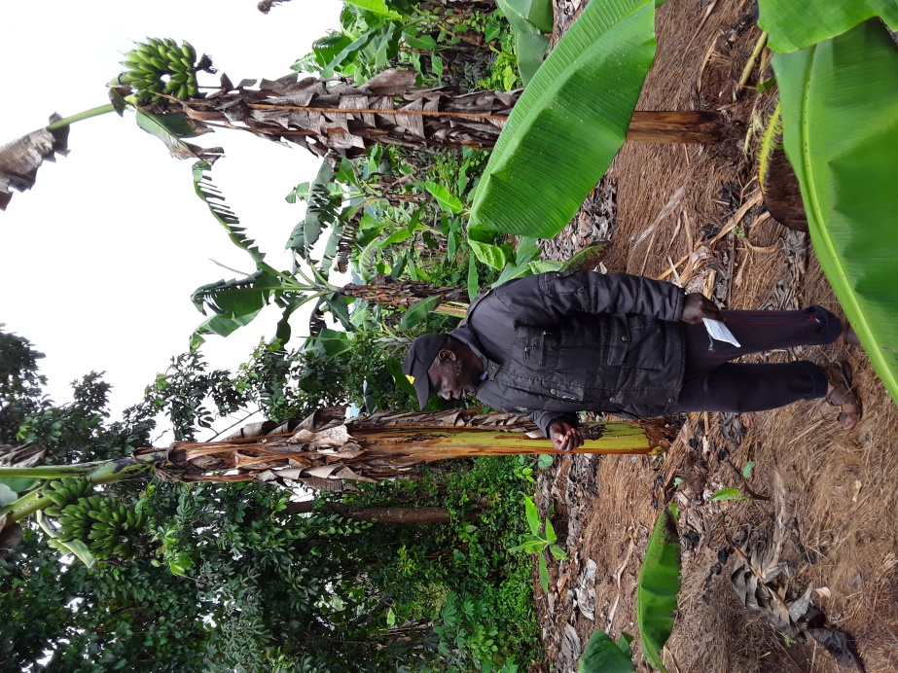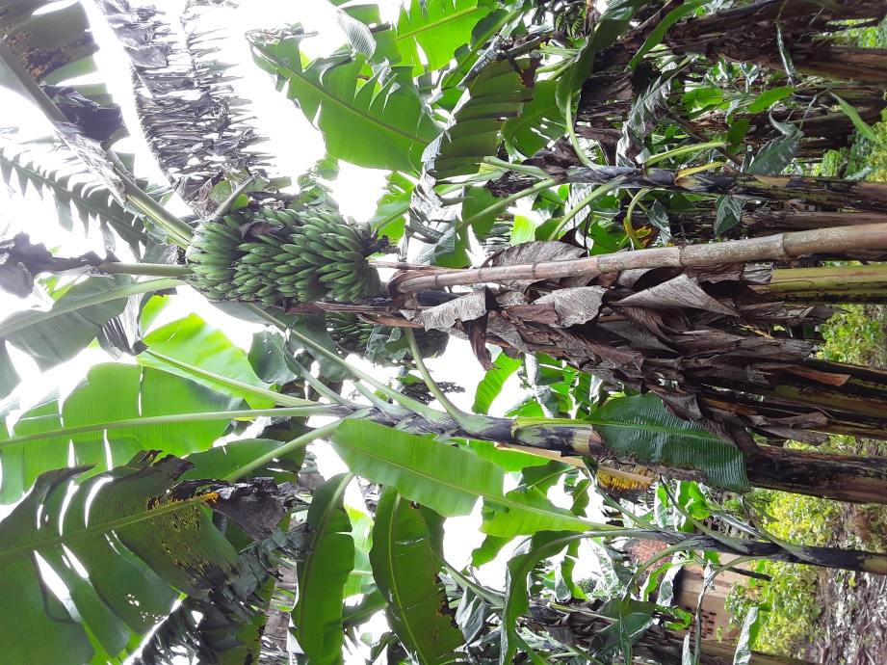
Mr. Anacret Ishamoi on his plantation: Size of the bunches before improvement (Left) and size of the bunches after improvement.

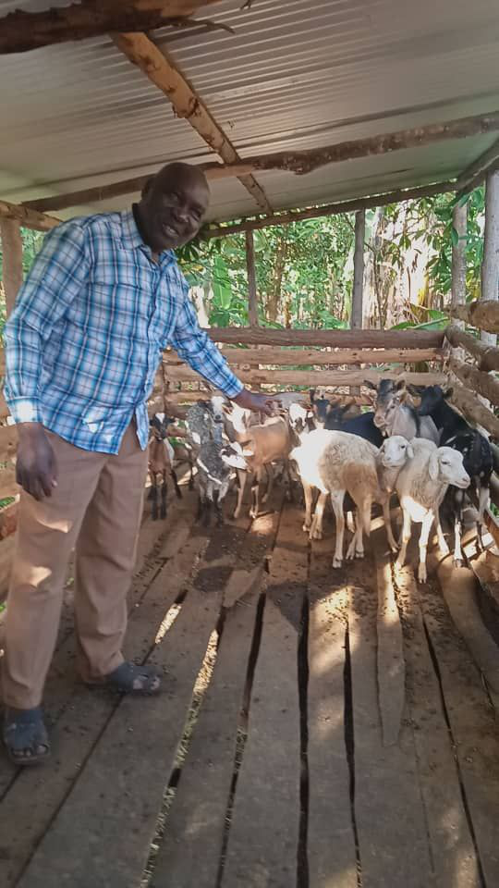
Mr. Anacret Ishamoi showing some of his goats

