**TANZANIA AGRICULTURAL RESEARCH INSTITUTE**

‘

**1st Quarter Progress Report 30th September 2024**

**Technology Transfer and Partnership-TARI Mikocheni**

**Prepared by:**

**Vidah Y. Mahava**

**Coordinator for Technology Transfer and Partnership TARI Mikocheni**

**SEPTEMBER 30th 2024**

**1.0 Introduction**

Tanzania Agricultural Research Institute-(TARI-Mikocheni) is one of the 17 research centres under TARI.TARI-Mikocheni mandate is in two-folds, namely conduct and promote research for the development of the coconut sub-sector and promote research and utilization of agricultural biotechnology for socio-economic development in the country.

The centre’s head office is in Dar es Salaam at Mikocheni B, Plot 22 along the Coca Cola Road. It has two sub-stations, namely Chambezi and Mkuranga, where most of the research activities are conducted. The former is located about 55 KM North of Dar es Salaam near Bagamoyo town at latitude S6.520 and longitude E 38.910, while Mkuranga sub-station is located at S 7.120 and Longitude E 39.200, about 50 KM South of Dar es Salaam.

There are two departments: 1) Research and Innovation and 2) Technology Transfer and Partnership. Under these departments there are six subprograms: Crop Research, Natural Resources, Post-harvest Management, Socioeconomics and Marketing; Technology Dissemination, Commercialization and Partnership; and Knowledge Management and Communication Programs.

The Mikocheni centre basically has two research programs, which its mandates are: Coconut and Biotechnology. The coconut program is the main with four (4) research units which include: Agronomy, Disease & Pest Control, Socioeconomics, Post-harvest, and Technology Transfer; the Biotechnology Program accommodate three (3) units Tissue Culture, Molecular Diagnostics and Genetic Engineering Laboratories. All the research activities in each unit in the coconut program are designed to address all agricultural challenges facing the coconut agro-ecological systems which include poor coconut husbandry practices, effect of drought stress, poor soil fertility, incidence and severity of noxious pests, high incidence and damage by the coconut Lethal Disease and planting of low yielding varieties. Other challenges are low expansion, low level of rehabilitation of the area under coconuts, limited value addition/processing and poor marketing. Biotechnology in the centre acts as a tool cut across all crops and supports other research mandate.

1. **Technology Dissemination pathways used by TARI.**

Various pathways were used for dissemination of agricultural technologies from research to different stakeholders which includes the use of hubs (AgriTecHs), demonstration plots and agricultural exhibitions.

**2.1: Technologies disseminated through AgriTecH(s)**

In this reporting period Agricultural Technology Hubs (AgriTechs) continue to disseminate agricultural technologies as follow: At Mwl Julius Nyerere two (2) technologies were disseminated in which (1) demo plot on Banana tissue culture with varieties of Mzuzu, Kimalindi, Bukoba and Fia 23, (1) demo plot where Coconuts are intercropped with mangoes, oranges, and white turtle beans. One (1) demo plot at Nzuguni-Dodoma with Coconuts intercropped with improved Cowpea varieties of Vuli Ar 1, Vuli 1,Raha 2,Tumaini,Fahari and Raha 1 and Maize local varieties of Yanga, Mehheboo, Mamaypink, Mamay,Mehhe Zambarau, Mamay mpauko, Hapee,Mehhe and Nyekundu (2) two demo plots at FatmaMwasa- Tabora with coconuts intercropped with Sweet potatoes varieties of NASPOT 13 and KABODE and one (1) demo plot at Nyakabindi- Shinyanga hub with coconuts intercropped Sorghum varieties of TARISO 1 and TARISO 2.

**Table 1: Technologies disseminated by TARI through AgriTecH(s)**

|  |  |  |
| --- | --- | --- |
| **AgriTecH** | **Crop** | **Variety/technology disseminated** |
| Fatma-Mwasa, Tabora | 1. Coconuts and Sweet potatoes | Coconuts (East African Tall) intercropped with sweet potatoes varieties of NASPOT 13 and KABODE |
| **Total No. technologies disseminated** | **1** |
| Nzuguni, Dodoma | 1.Coconuts, maize and beans | Coconuts (East African Tall) intercropped with maize local varieties (Yanga, Mehheboo, Mamaypink, Mamay, Mehhe Zambarau, Mamay Mpauko, Hapee, Mehhe and Nyekundu) and cowpea improved varieties (Vuli Ar 1, Vuli 1, Raha 2, Tumaini, Fahari and Raha 1) |
| **Total No. technologies disseminated** | **2** |
| Mwl. Julius Nyerere, Morogoro | 1.Banana tissue culture | Banana (Mzuzu, Kimalindi, Bukoba and Fia 23) |
| 2.Coconuts, Mangoes, Oranges and white turtle beans | Intercropping with fruit tree crops and beans |
| **Total No. technologies disseminate** | **2** |
| Nyakabindi, Shinyanga | 1.Coconuts and Sorghum | Coconuts (East African Tall) intercropped with sorghum varieties of TARISO 1 and TARISO 2 |
| **Total No. technologies disseminated** | **1** |
| **TOTAL** | **Total No. technologies disseminated** | **6** |

**2.2. Stakeholders reached with improved technologies disseminated by TARI Mikocheni**

**2.2.1. Stakeholders reached with improved technologies in Dar es salaam**

In July, The Tanzania Agricultural Research Institute (TARI) through its research centers was among the public institutions that managed to participate well during the 48th Saba Saba exhibition. The Dar es salaam International Trade Fair (DTIF) conducted at Mwl. J.K. Nyerere grounds and was successfully held for 16 consecutive days from June 28th to July 13th, 2024. The Trade Fair exhibition involved business stakeholders from inside and outside the country in sharing of their products and their discovery technologies, under the slogan "Tanzania: The Right Place for Trade and Investment" in swahili ***“Tanzania***: ***Mahali sahihi pa biashara na uwekezaji”***. TARI Mikocheni was among 14 research centers participated in Saba Saba exhibition purposely for displaying and creating awareness on different Agricultural Technologies and products developed by the Center. During the exhibition total number of stakeholders **8,115 (4,289 Males and 3,826 Females)** managed to reach TARI Pavilion.

**2.2.2. Stakeholders reached with improved technologies in Dodoma and Morogoro**

In August, The Tanzania Agricultural Research Institute (TARI) through its research centers was among the public institutions that managed to participate well during the 31th Nane Nane Agricultural exhibition show. TARI Mikocheni was among 17 research centers participated in Nane Nane exhibition in Dodoma and Morogoro purposely for displaying and creating awareness on different agricultural technologies and products developed by the Centre. The Nane Nane exhibitions were successfully held for 10 consecutive days from August 1st to 10th, 2024 at Nzuguni grounds in Dodoma and 8 consecutive days from August 1st to 8th 2024 at Mwl. J.K. Nyerere grounds in Morogoro. The slogan was "Choose Better Local Government Leaders for Sustainable Development in Agriculture, Livestock and Fisheries" in swahili ***“Chagua Viongozi Bora wa Serikali za Mitaa kwa Maendeleo Endelevu ya Kilimo, Mifugo na Uvuvi***. During Nane Nane exhibition total number of **6,824 (13,865 Males and 2959 Females)** stakeholders managed to reach TARI Pavilion were **5021 (2860 Males and 2161 Females)** in **Dodoma** and **more than 1,803 (1,005 Males and 798 Females)** in **Morogoro.**

**Table 2: Technologies and products displayed by TARI Mikocheni during Saba Saba and Nane Nane Exhibitions**

|  |  |
| --- | --- |
| **S/N** | **TECHNOLOGIES** |
| 1. | **Coconut**   * Coconut seedlings of East Africa Tall variety * Using of Intercropping system (Mixing coconuts trees with other crops) * Using of Integrated Pest Management (IPM) in controlling Rhinoceros beetles, bugs and mites in coconut. * Coconut by products e.g. Virgin Coconut Oil(VCO),coconut grated cookies, coconut crisps, coconut porridge, briefcase, chairs, coco peat, ropes, and house ornaments. |
| 2. | **Biotechnology**   * Using Tissue culture technology in producing seedling which are can’t be produced by seed e.g.; Pineapple MD2 variety. * Using Polymerase Chain Reaction(PCR) Machine to Amplify DNA sequences on plant/crop(genotyping) * Using Centrifuge machine to separate particles suspended in a liquid of crop sample   **Leaflets**   * Good Agronomic Practices for Coconut Farming,” Kanuni *za Kilimo Bora Cha Zao la Minazi”.* * Coconut Pests, their Effects and Control measures,” Wadudu *Waharibifu wa Minazi, Athari zake na Udhibiti”* * Benefits of Virgin Coconut Oil.”*Faida za Mafuta Mwali ya Nazi”.* |

**Below are some of the pictures taken during Saba Saba exhibition;**

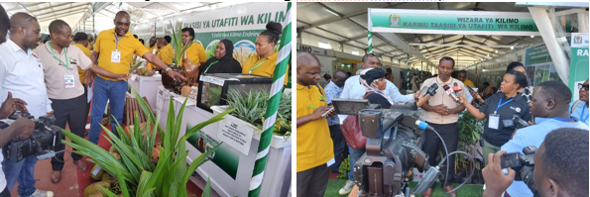

***Photo 1:(Left)TARI Mikocheni Center Manager, Dr. Fred Tairo (First right) explaining on technologies developed by the center to TARI Director General, Dr. Thomas Bwana(second right); Photo 2: (Right) TARI Director General, Dr.Thomas Bwana speaking to journalists during the 48th DITF.***

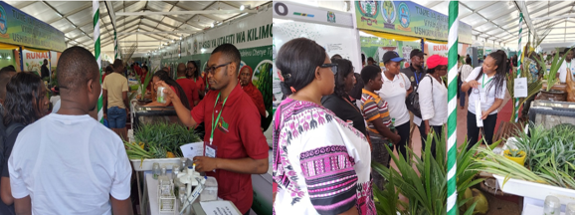

***Photo 3: (Left) TARI Mikocheni Researcher, Mr.Jackson Rashid (right) explaining to farmers on how to produce pineapple seedlings using Tissue Culture Technology; Photo 4: (Right) Researcher from TARI Mikocheni, Ms. Elisiana Kweka elaborating to farmers on how to use hook to control Rhinoceros beetles in coconut during the 48th DITF.***

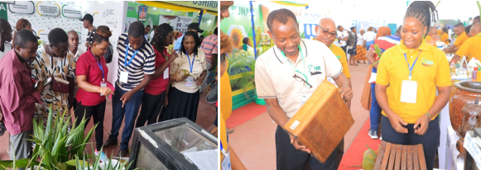

***Photo 5: (Left) Researcher from TARI Mikocheni, Ms. Zainab Mziray (Fourth right) elaborating to farmers on the use of good quality coconut seeds; Photo6: (Right) Researcher from TARI Mikocheni, Ms. Suzana Theonest (right) showing coconut wood made briefcase to TARI Director General, Dr.Thomas Bwana during the 48th DITF..***

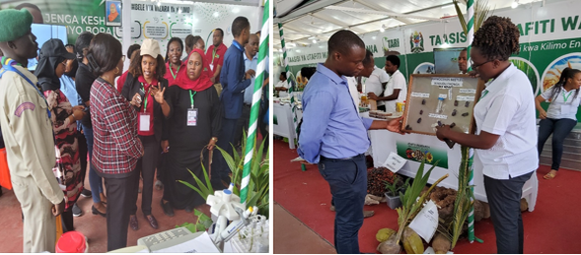

***Photo 7: (Left) Deputy Secretary Ministry of Lands, Housings and Human Settlements, Hon Lucy Kabyemera (with draft coat) listening explanations from Director of Technology Transfer and Partnership, Dr. Geradina Mzena(with Cap) on different Agricultural Technologies developed by TARI; Photo8: (Right) Researcher from TARI Mikocheni, Ms.Nduminaike Kimaro(with white Tshirt) explaining to farmer on the effect of Rhinoceros beetle in coconut during the 48th DITF.***

**Below are some of the pictures taken during Nane Nane exhibition at Nzuguni grounds in Dodoma.**

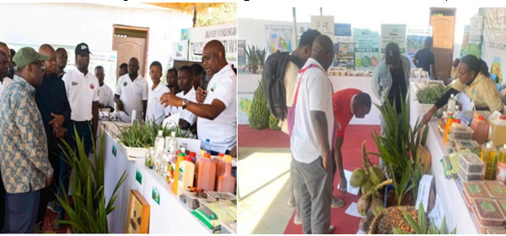

***Photo 9:(Left)TARI Mikocheni Center Manager, Dr. Fred Tairo (first right) explaining on technologies developed by the center to Chief Secretary, Dr.Mosses Kusiluka(first left);Photo 10: (Right) Researcher from TARI Mikocheni, Ms.Violeth Mwaijande(right) explaining to farmers on how mites affect coconuts during Nane Nane Exhibition.***

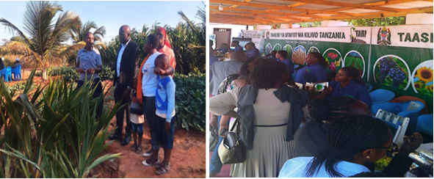

***Photo 11: (Left) Agricultural Officer from TARI Mikocheni, Ms. Dorah Mugomba (first left) explaining to farmers on the benefits of intercropping coconuts with other crops; Photo 12: (Right) Different stakeholders visited TARI Pavilion during Nane Nane exhibition.***

**Below are some of the pictures taken during Nane Nane exhibition at Mwl. J.K. Nyerere grounds in Morogoro;**

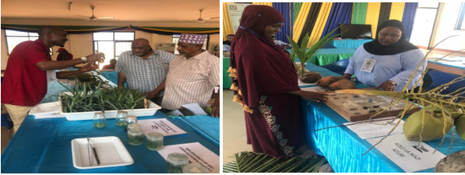

***Photo 13:(Left) Researcher from TARI Mikocheni, Mr.Emmanuel Haule(left) explaining on the media used to produce pinneaple in Tissue culture laboratory ;Photo 14: (Right) Centre Coordinator of Technology Transfer and Partnership from TARI Mikocheni, Ms.Vidah Mahava(right) explaining to farmer on how rhinoceros beetles affecting coconuts production during Nane Nane exhibition.***

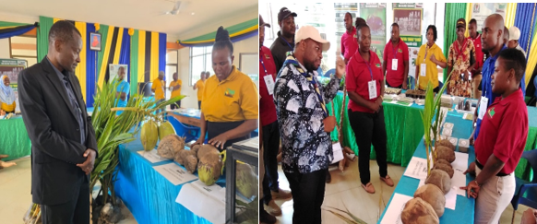

***Photo 15:(Left)Researcher from TARI Mikocheni, Ms.Evarista Shao(right)explaining to TARI General Director,Dr.Thomas Bwana(left) on the selection of good quality coconut seed Photo 16: (Right) Regional Commissioner of Dar es Salaam, Hon.Albert Chalamila (left), asking different questions related to coconut production when visited TARI Pavilion during Nane Nane exhibition.***

**2.2.4. Number of stakeholders reached with technologies at TARI Mikocheni Centre**

In July to September 2024, total numbers of **75 (43 Males and 32 Females)** students from five training Institutes visited TARI Mikocheni Centre. The aim of the visit to get awareness on Tissue culture technology, DNA extraction and PCR techniques in Molecular Biology laboratory and controlling pests in coconuts.

**Table 3: Number of attained students with TARI Mikocheni technologies**

|  |  |  |  |
| --- | --- | --- | --- |
| **University/Institute/College** | **Attained students** | | **Total** |
| **Males** | **Females** |
| University of Dar es Salaam (UDSM) | 7 | 3 | 10 |
| University of Dodoma (UDOM) | 1 | 4 | 5 |
| Mbeya University of Science and Technology(MUST) | 0 | 1 | 1 |
| Dar es Salaam Institute of Technology (DIT) | 4 | 0 | 4 |
| Borigaram Agricultural Technical College, | 31 | 24 | 55 |
| **TOTAL** | **43** | **32** | **75** |

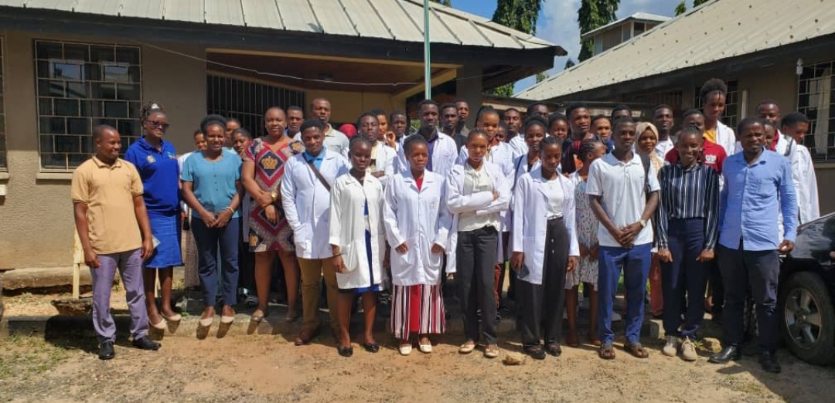

***Photo 17: Researchers from TARI Mikocheni, Ms.Nduminaike Kimaro (second left), Ms. Christina Nyika (third left), Ms. Christina Kidulile (fourth left) and students from Borigaram Agricultural Technical College group photo at TARI Mikocheni Centre.***

**2.2.4 Stakeholders reached with improved technologies at Mikocheni Sub-stations.**

In this reporting time total number of **208 Farmers (133 Males and 75 Females**) were reached at Mikocheni sub-stations, in which **133 (81 Males and 52 Females)** visited and contacted via phone Chambezi sub-station and **75 Farmers (54 Males and 21 Females)** visited and contacted via phone Mkuranga Sub-station requested on buying coconut seedlings, asking different questions concerning management and pest control in coconuts, mangoes and oranges.

**Table 4:** **Number of stakeholders reached with technologies at Chambezi and Mkuranga Sub-stations.**

|  |  |  |
| --- | --- | --- |
| **Place** | **Stakeholders** | **Technologies disseminated** |
| Chambezi | 133 Farmers (81 Males and 52 Females) | 1. Coconuts intercropped with mangoes and orange to control pests through weaver ants which feed on Coreid bugs.  2. Mechanical remover of beetles using hook.  3. Cultural control by cleaning field removing dead logs which are breeding site for Rhinoceros beetles.  4. Using of Traps (Pheromones, PVC Pipe and Tin) to trap beetles. |
| Mkuranga | 75 Farmers (54 Males and 21 Females) | 1. Coconuts intercropped with mangoes and orange to control pests through weaver ants which feed on Coreid bugs.  2. Mechanical remover of beetles using hook.  3. Cultural control by cleaning field removing dead logs which are breeding site for Rhinoceros beetles.  4. Using of Traps (Pheromones, PVC Pipe and Tin) to trap beetles. |
| **Total number of technologies disseminated** | | **4** |

**3. Knowledge Management and Communication**

**3.1 TARI Website Content management**

Different information uploaded to TARI website as shown by the table 5 below:

**Table 5:** Type and numbers of information uploaded to TARI website

|  |  |  |  |  |
| --- | --- | --- | --- | --- |
| **Centre** | **Type of information uploaded** | **Number/frequency** | **Remarks/any feedback** | **Challenges** |
| TARI – Mikocheni | News | 3 | - | Lack of facilities including Internet, Camera for taking photos and documentaries, and Mobile phone for easy sharing of information especially in social media |
| Publications | 4 |
| Images/photos | 36 |
| Videos | 4 |
|  |  |

**3.2 Information Education and Communication materials**

Planned number of materials for dissemination in this reporting time were 1,350 leaflets and 4 rollup banners on Good Agronomic Practices for coconut farming, Coconut pests, their effects and control measures, About TARI Mikocheni centre and Benefits of Virgin Coconut Oil (VCO) where 1,120 leaflets and 4 rollup banners managed to be disseminated.

**Table 6: Information materials produced and distributed**

|  |  |  |  |  |  |  |  |
| --- | --- | --- | --- | --- | --- | --- | --- |
| Number of print communication materials | | | | | | | |
| Posters | Signboards | Fliers | Brochures | Banners | Wheel covers | Leaflets | Others specify |
| - | - | - | - | 4 | - | 1,120 | - |
|  |  |  |  |  |  |  |  |

1. **TARI Visibility**

**4.1 Signboards: -NIL-**

Preparation of signboards: No any area fixed with uniform format and designed signboard.

**4.2 Mass media prepared by TARI Mikocheni.**

In this reporting period, Mass Media planned to air 8 TV while aired 5 TV. Also planned Radio were 8 while aired 1 radio, 8 newspapers actual released were 3 and 150 social media while aired 51 as shown on the table below:

**Table 7: Number of TVs, radio, newspapers, and social media produced and disseminated.**

|  |  |  |  |  |  |  |
| --- | --- | --- | --- | --- | --- | --- |
| **Numbers prepared/hired/made/received** | | | | | | |
| **TV** | **Radio** | **Newspapers** | **Social media** | **Short Messages** | **Phone calls** | **Others specify** |
| 5 | 1 | 3 | 51 | 61 | 57 | - |

**5.0 Strengthening Partnerships and Collaboration**

**5.1. Visitations**

Total number of **16 visitors (11 Males and 5 Females)** stakeholders visited the Centre for different purposes from July to September 2024 as shown on Table 8 below.

**Table 8: Visitors visited the Centre.**

|  |  |  |  |  |
| --- | --- | --- | --- | --- |
| **S/No** | **Date of the visit** | **Type of visitors** | **Total number** | **Aim of the visit** |
|  | 4th July 2024 | A farmer from Kitunda –DSM | 1 Female | She wanted to buy coconut seedlings |
|  | 8th July 2024 | A farmer from Mbezi –DSM | 1 Female | She wanted to get information on coconut farming as well as buying coconut seedlings |
|  | 24thJuly 2024 | An Individual farmer from-DSM | 1Male | He wanted watermelon seeds for production and he was directed to Tengeru |
|  | 25thJuly 2024 | A farmer from Kimara –DSM | 1Male | He wanted to buy coconut seedlings |
|  | 26thJuly 2024 | An individual farmer from Kinondoni-DSM | 1 Female | She wanted to buy coconut seedlings |
|  | 22nd August 2024 | A worker from Jubilee Life Insurance-DSM | 1Male | He wanted watermelon seeds for production and he was directed to Tengeru |
|  | 27th August 2024 | Agricultural experts from Agro Globe Limited from Egypt | 2 Males | They wanted to work with TARI to disseminate their technologies to Tanzania farmers interested to the following crops grapes directed to Makutopora, wheat directed to Uyole, Onion directed to Tengeru and Rice directed to Dakawa. |
|  | 28thAugust 2024 | An individual farmer from Mabwepande-DSM | 1Female | She wanted to buy sesame seeds and she was directed to TARI Naliendelee |
|  | 6th September 2024 | A farmer from DSM | 1 Male | He wanted to buy coconut and oil palm seedlings (directed to TARI Kihinga) |
|  | 17th September 2024 | A farmer from Kinondoni -DSM | 1 Male | He wanted to buy watermelon seeds(directed to TARI Tengeru) |
|  | 18th September 2024 | An individual farmer from Mabwepande-DSM | 1Male | He wanted to buy coconut seedlings |
|  | 20th September 2024 | A worker from TAFOSDE COMPANY | 1 Male | He wanted to make an appointment for campaign on youth relations |
|  | 25th September 2024 | Workers from LAND MATRIX LIMITED | 1 Male and 1 Female | Follow up on letter for presentation to TARI Mikocheni |
|  | 27th September 2024 | A farmer from Dodoma | 1 Male | He wanted to buy coconut seedlings |

**5.3 Challenges**

* In adequate coconuts seedlings for disseminating to coconut farmers.
* Stakeholders requested on Tissue culture seedlings for planting in farms such as banana, pineapple, sweet potatoes, etc.
* Lack of coconut by products to sell to stakeholders such as such as furniture made from coconut wood, coconuts crisps, coco peat, coconut porridge etc.
* Lack of business cards for further communication to distribute to the stakeholders.
* There is no updated telephone number on website for the customers/stakeholders to get in touch with the Centre easily and on time.
* Lack of funds to implement annually planned activities.

**5.4 Conclusion and Recommendations**

* Funds should be provided to support nursery practices in order to increase coconut seedlings and production of Tissue culture seedlings to satisfy the needs of farmers.
* The Centre should make coconuts by products to satisfy the need of the stakeholders e.g. making the use of old coconut trees to produce coconut wood furniture’s.
* The Institute should have business card for various stakeholders which request for them.
* There should be updated telephone numbers on website so that customers/stakeholders can get in touch with the center easily and on time.
* Timely allocation of funds to accomplish planned activities