TANZANIA AGRICULTURAL RESEARCH INSTITUTE

2nd Quarter Progress Report from 1stOCTOBER to 31stDECEMBER 2022

Technology Transfer and Partnership-TARI Mikocheni

Prepared by:

Vidah Y. Mahava

Coordinator for Technology Transfer and Partnership TARI Mikocheni

DECEMBER 31st 2022

1.0 Introduction
Tanzania Agricultural Research Institute-(TARI-Mikocheni) is one of the 17 research centres under TARI.TARI-Mikocheni mandate is in two-folds, namely conduct and promote research for the development of the coconut sub-sector and promote research and utilization of agricultural biotechnology for socio-economic development in the country.
The centre’s head office is in Dar es Salaam at Mikocheni B, Plot 22 along the Coca Cola Road. It has two sub-stations, namely Chambezi and Mkuranga, where most of the research activities are conducted. The former is located about 55 KM North of Dar es Salaam near Bagamoyo town at latitude S6.52⁰ and longitude E 38.91⁰, while Mkuranga sub-station is located at S 7.12⁰ and Longitude E 39.20⁰, about 50 KM South of Dar es Salaam.
There are two departments: 1) Research and Innovation and 2) Technology Transfer and Partnership. Under these departments there are six subprograms: Crop Research, Natural Resources, Post-harvest Management, Socio-economics and Marketing; Technology Dissemination, Commercialization and Partnership; and Knowledge Management and Communication Programs.
The Mikocheni centre basically has two research programs, which its mandates are: Coconut and Biotechnology. The coconut program is the main with four (4) research units which include: Agronomy, Disease & Pest Control, Socio-economics, Post-harvest and Technology Transfer; the Biotechnology Program accommodate three (3) units Tissue Culture, Molecular Diagnostics and Genetic Engineering Laboratories. All the research activities in each unit in the coconut program are designed to address all agricultural challenges facing the coconut agro-ecological systems which include poor coconut husbandry practices, effect of drought stress, poor soil fertility, incidence and severity of noxious pests, high incidence and damage by the coconut Lethal Disease and planting of low yielding varieties. Other challenges are low expansion, low level of rehabilitation of the area under coconuts, limited value addition/processing and poor marketing. Biotechnology in the centre acts as a tool cut across all crops and supports other research mandate.
- Technology Dissemination pathways used by TARI
Various pathways were used for dissemination of agricultural technologies from research to different stakeholders which includes demonstration plots and the use of hubs (AgriTeCH).
2.1: Farmers visited Agricultural Technology Transfer Hubs (AgriTecH)
Table 1: Farmers who visited TARI AgriTecH hubs
AgriTecH Hub | Farmers |  | Total
 | Male | Female
Nzuguni, Dodoma | 39 | 14 | 53
FatmaMwasa, Tabora | 39 | 31 | 70
Mwl. Julius Nyerere, Morogoro | 28 | 8 | 36
Nyakabindi, Shinyanga | 76 | 44 | 120
TOTAL | 182 | 97 | 279

2.2: Demo plots planned, established and technologies disseminated through AgriTecH
20 demo plots planned to be established from October to December 2022 but only nine (9), demo plots managed to be established in which eight(8) demo plots were established at FatmaMwasa-Tabora with Coconuts intercropped with improved sweet potatoes varieties(X-LUAMBANO and NASPOT-13) for Slips/cuttings multiplication for the aim of distributing them to groups and individual farmer. One (1) demo plot at Nyakabindi-Shinyanga hub with coconuts intercropped with maize crop. Other hubs were still maintaining their established demo plots. Which was one (1) demo plot at Nzuguni-Dodoma with Coconuts only in absence of intercropped crop due to absence of rainfall, two (2) demo plots at Mwalimu Julius Nyerere-Morogoro one (1) demo plot on Banana tissue culture and one (1) Coconuts intercropped with mangoes and oranges.

Table 2: Technologies disseminated by TARI through AgriTecH(s)
AgriTecH | Crop | Variety/technology disseminated
FatmaMwasa, Tabora | 1. Coconuts, sweet potatoes | Coconuts intercropping improved sweet potatoes(X-LUAMBANO and NASPOTI-13)
 |  | Ridge formation to create good drainage and root expanding areas for smooth sweet potatoes growth
 | Total No. technologies disseminated | 3
Nzuguni,Dodoma | 1.Coconuts | Coconuts improved varieties(East African Tall)
 | Total No. technologies disseminated | 1
Mwl. Julius Nyerere, Morogoro | 1.Banana tissue culture | Clean banana tissue culture plants
 | 2. Coconuts, Mangoes, oranges | Intercropping with leguminous crops
 | Total No. technologies disseminated | 2
Nyakabindi,Shin yanga | 1.Coconuts,Maize | Coconut intercropping with maize crops
 |  | Pest control using cultural method through cleaning the fields to remove breeding sites
 | Total No. technologies disseminated | 2
TOTAL | Total No. technologies disseminated | 8
2.3 Demonstration plots established by TARI Centre
In this reporting time the total number of 31 demonstration plots were established, which are 29 demo plots under FRESH-WP2 Project and 2 demo plots under Pineapple MD2 Project.

2.3.1 Demonstration plots established under FRESH-WP2 Project
Agronomy department were the main participants in this project in collaboration with other departments at TARI Centre. One(1) demo plot at TARI Mikocheni substation (Mkuranga) where Coconuts are intercropped with improved vegetables varieties and 28 established demo plots for improved vegetables are found at two regions Dar es salaam (GezaUlole Village Kigamboni District and Pugu Kinyamwezi Farmers Training Centre at Ilala District and Pwan (Kiromo Village at Bagamoyo District and Mwalusembe Village at Mkuranga District).The aim of these demo plots were to showcase technologies to farmers on improved vegetable varieties, proper nursery establishment and Good Agronomic practices (GPAs).

Demo plots established on improved vegetable varieties in different districts are shown on pictures below:
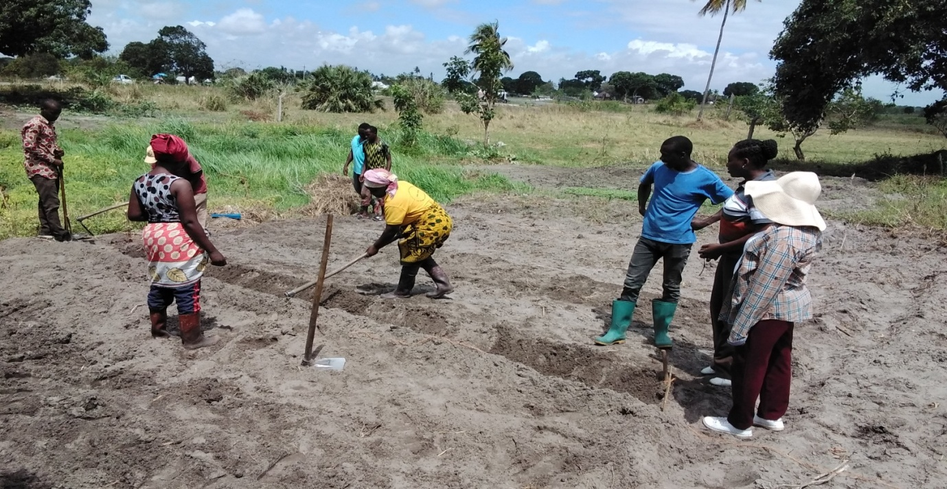
Picture1: Agronomists from TARI Mikocheni preparing demo plots with farmers and Extension Officer at Kilomo Village in Bagamoyo District
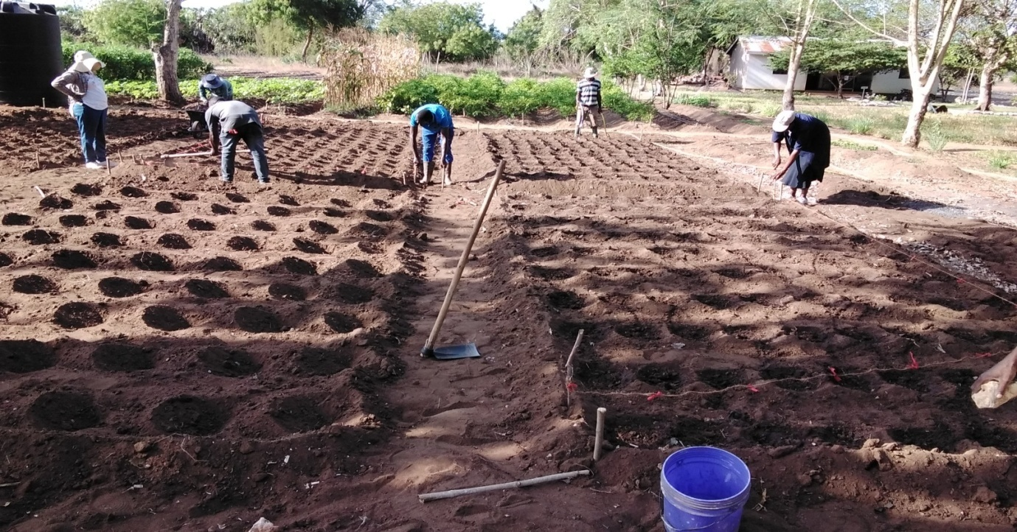
Picture 2: Agronomists from TARI Mikocheni making holes on measured demo plots for planting improved vegetable varieties with farmers and Extension Officer at GezaUlole Village in Kigamboni District
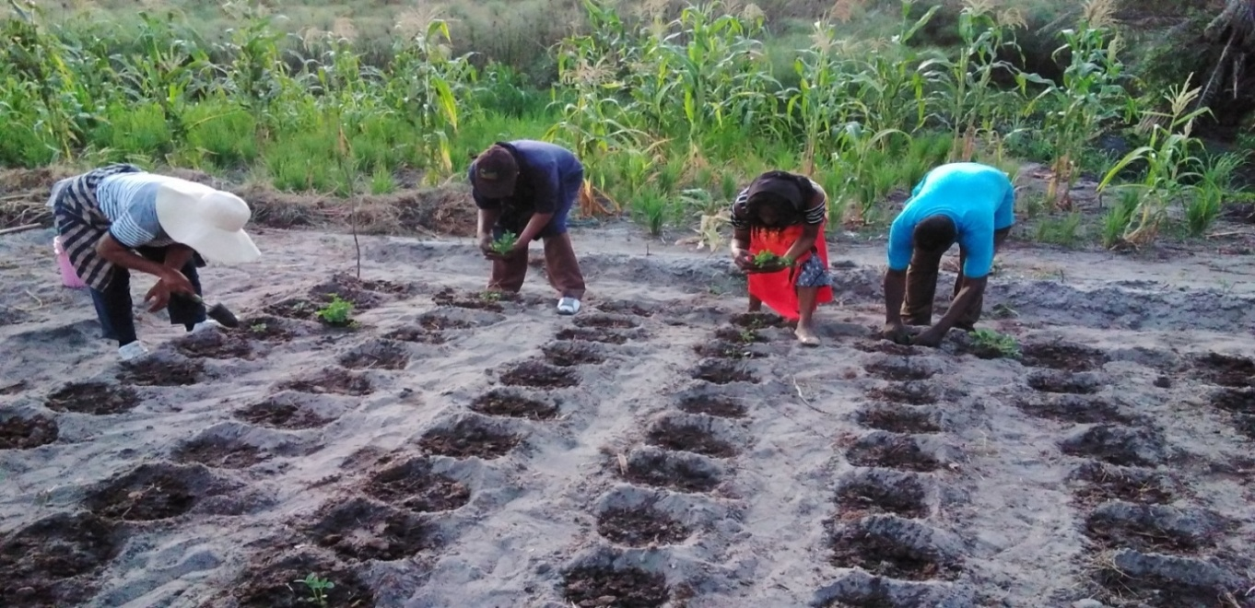
Picture 3: Agronomists from TARI Mikocheni sowing transplanted African nightshade on the demo plots with farmers and Extension Officer at Mwalusembe Village in Mkuranga District
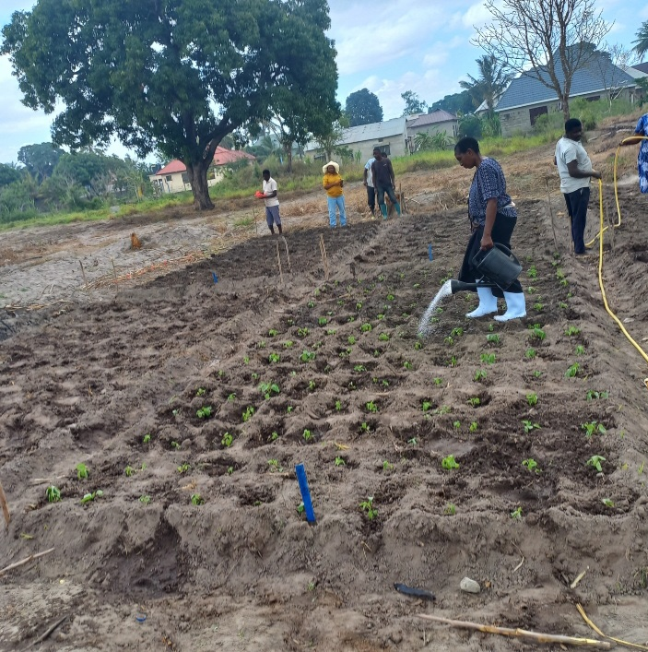
Picture 4: Agronomists from TARI Mikocheni watering the transplanted Amaranth on demo plots with farmers and Extension Officer at Pugu Kinywamwezi Farmers Training Centre Village in Ilala District

2.3.2 Demonstration plots established under: Tissue culture-based massive production and unrestricted access to high quality pineapple planting materials project
Biotechnology department were the main participants in this project in collaboration with other departments at TARI Mikocheni Centre. One (1) demo plot in Kisambwa Tandai Village at Kinole Ward in Morogoro Municipal and one (1) demo plot in Madeke Village at Mfriga Ward in Njombe District. The aim of these demo plots were to showcase technologies to farmers on improved pineapple variety of MD2 produced by the Centre through tissue culture and Good Agronomic Practices (GPAs) which are proper nursery establishment, spacing and proper management practices.

Demo plots established on improved Pineapple MD2 variety in different districts are shown on pictures below:
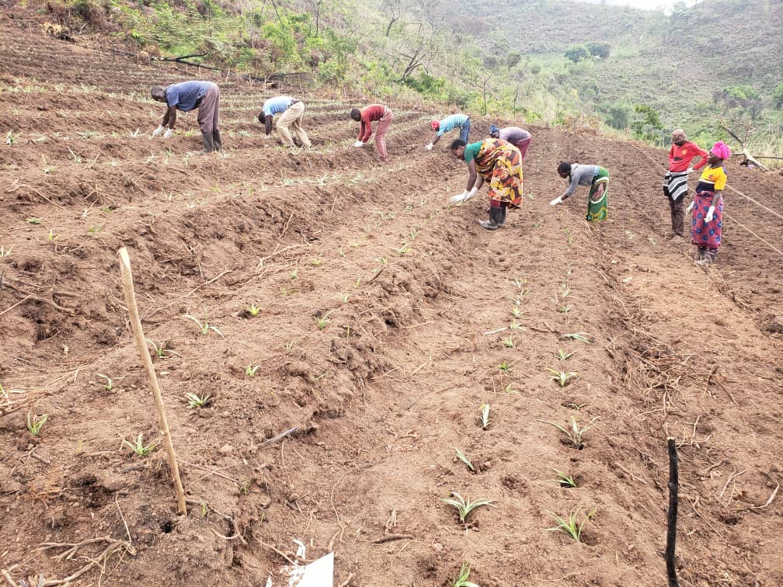
Picture 5:Farmers transplating MD2 pineapple variety in the field in Madeke Village at Mfriga Ward in Njombe District

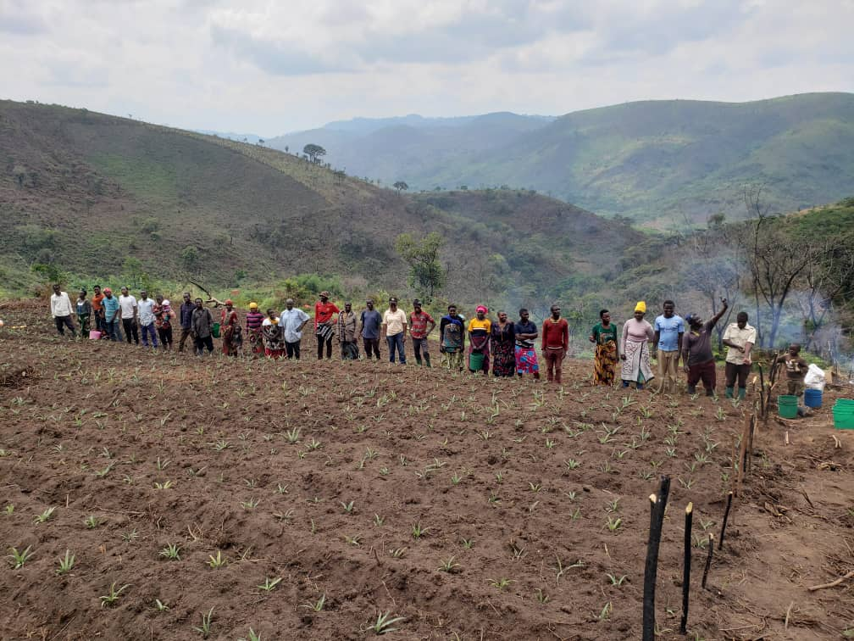
Picture 6: Scientist from TARI Mikocheni, Agricultural Field Officers and farmers on transplanted Pineapple MD2 Demo plot in Madeke village at Mfriga Ward in Njombe District

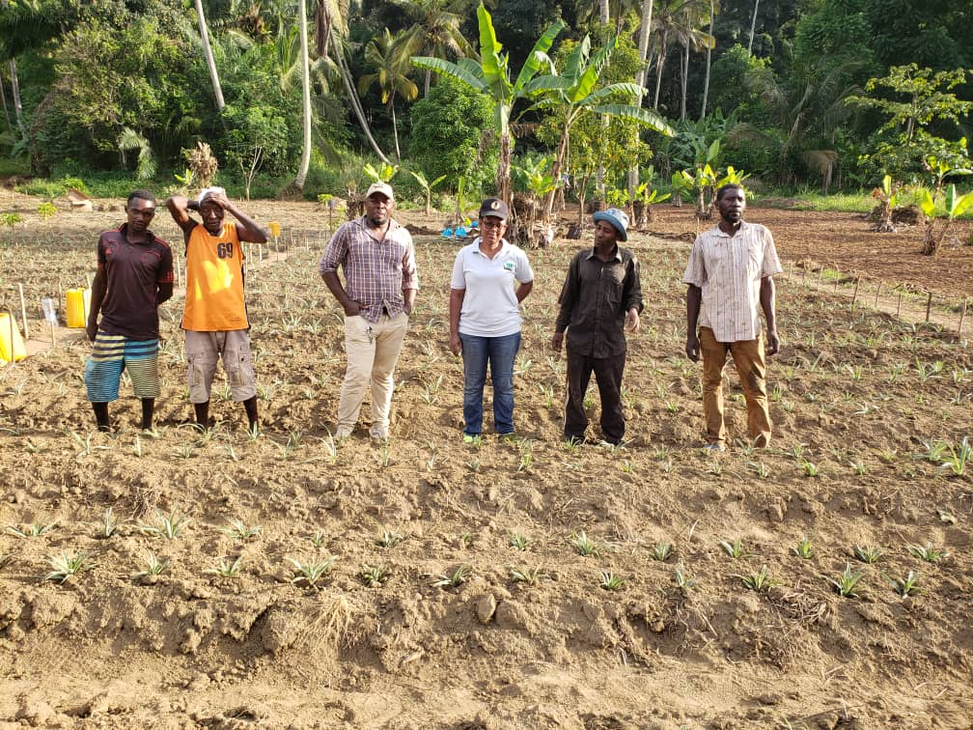
Picture 7: Project Manager third from right, Dr. Happiness Mollel, Agricultural Officer fourth from right to together with farmers on the transplanted Pineapple MD2 variety demo plot in Kisambwa Tandai village at Kinole Ward in Morogoro Municipal.

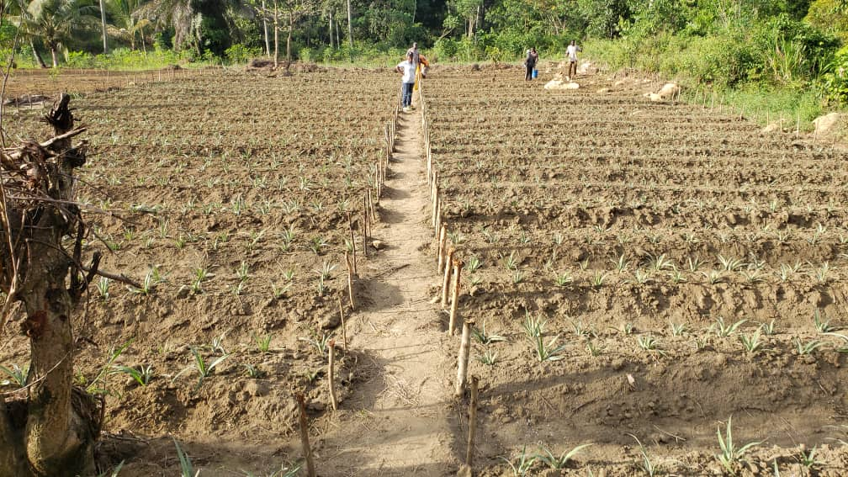
Picture 8: Pineapple MD2 variety demo plot in Kisambwa Tandai Village at Kinole Ward in Morogoro Municipal.

2.4 Farmers’ Field day executed by TARI Centre
During the reporting time the centre planned to conduct four Farmer Field Days (FFDs) but only three (FFDs) were done in two regions Dar es Salaam (GezaUlole Village Kigamboni District and Pugu Kinyamwezi Farmers Training Centre at Ilala District and Pwani (Kiromo Village at Bagamoyo District. The aim of these FFDs were to showcase technologies to farmers on intercropping coconuts with Improved Vegetable Varieties: There are three improved varieties of Amaranthus (Poli, Nguruma and Akeri), One variety of African nightshade (Ambureni) and two varieties of African Eggplant (Tengeru white and DB3). Other technologies demonstrated are: Good Agronomic Practices (GPAs) which are establishment and management of nurseries, spacing, harvesting, post-harvest methods and proper management practices.

Farmers Field Days to showcase the farmers on improved vegetable varieties in different districts are shown on pictures below:
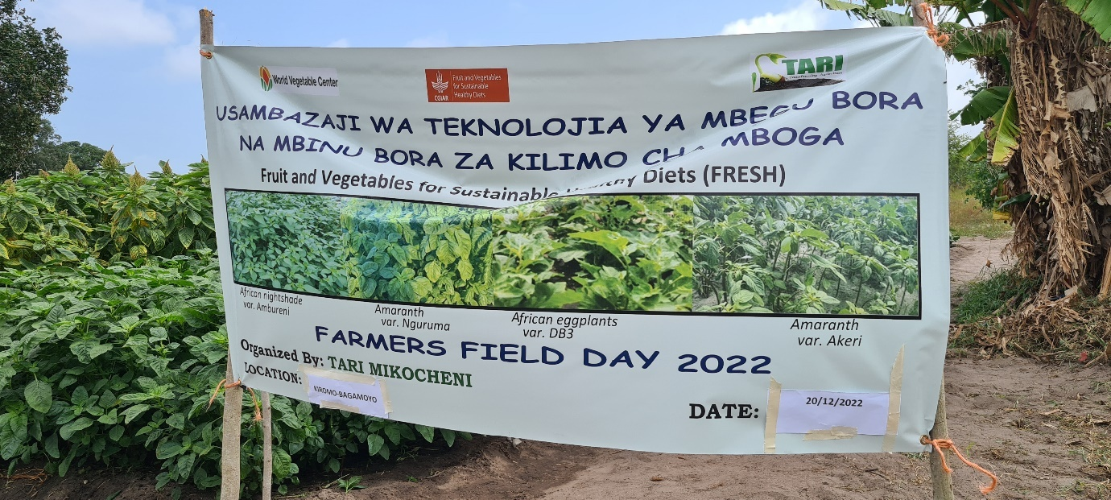 Picture 9: Farmer Field Day Kiromo Village at Bagamoyo District on 20th December 2022
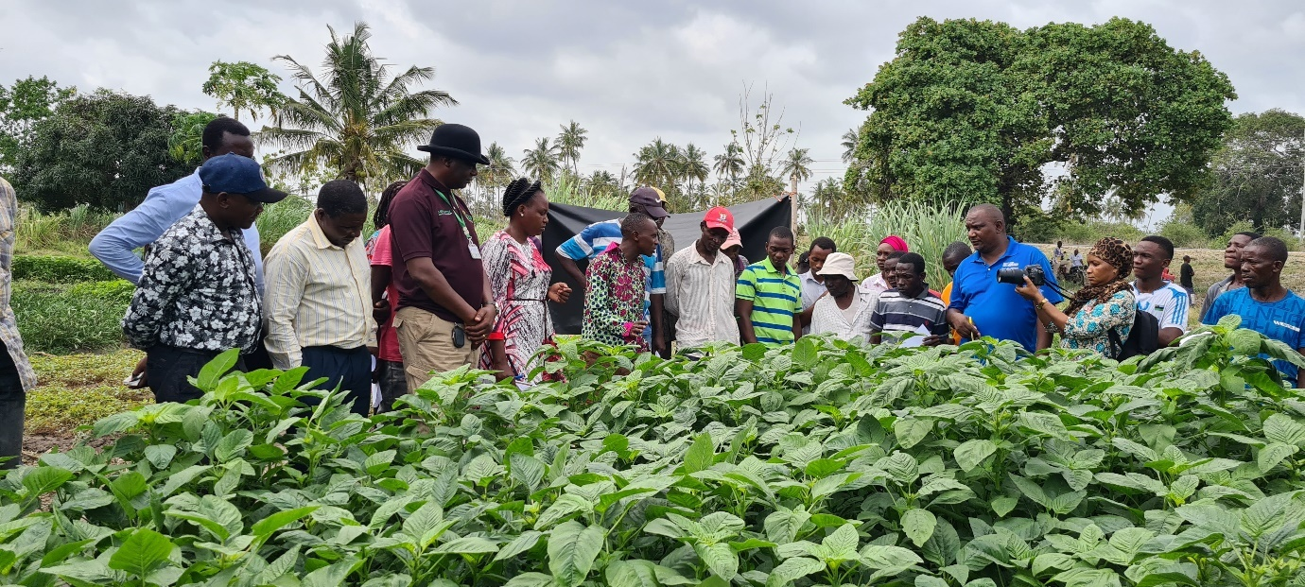
Picture 10: Scientists from TARI Mikocheni, Councilor, Agricultural Field Officers, farmers, Ward Executives, processors, journalists and other stakeholders participating in FFD at Kiromo Village- Bagamoyo District
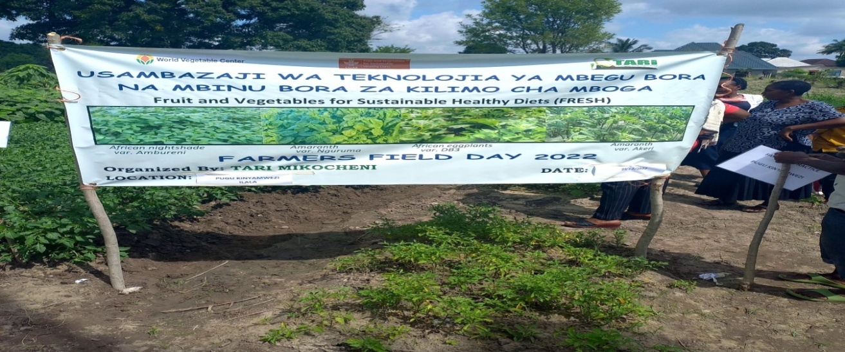
Picture 11: FFD at Pugu Kinyamwezi Farmers Training Centre in Ilala District on 29th December 2022

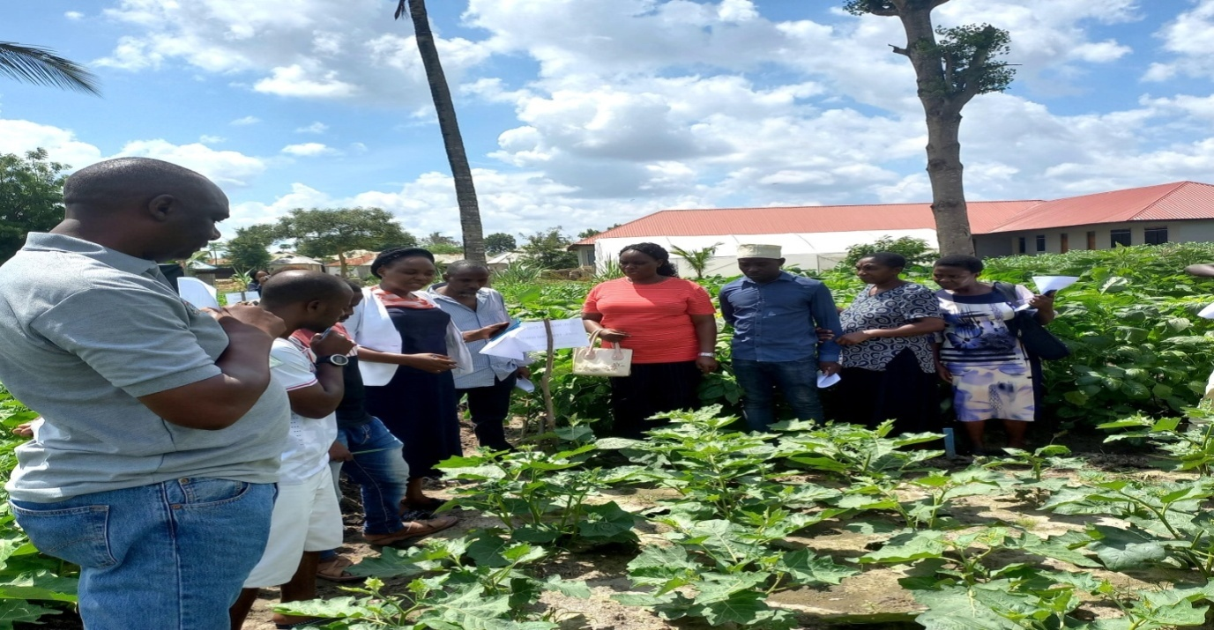
Picture 12: Dr. Fred Tairo (Centre Manager- TARI Mikocheni at the left, Ms. Violet Mwaijande fourth from left explaining on different technologies demonstrated during the FFD at Pugu Kinyamwezi Farmers Training Centre in Ilala District
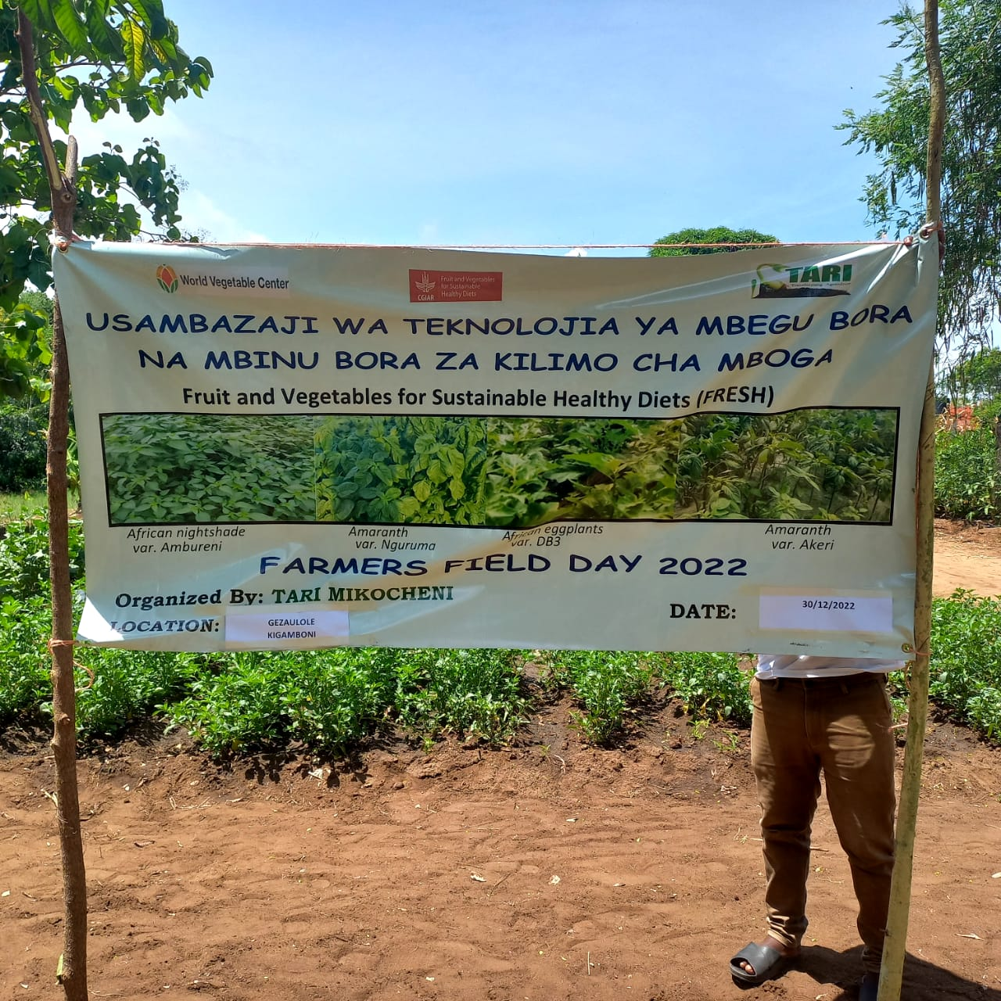 Picture 13: FFD at GezaUlole Farmers Training Centre in Kigamboni District on 30th December 2022
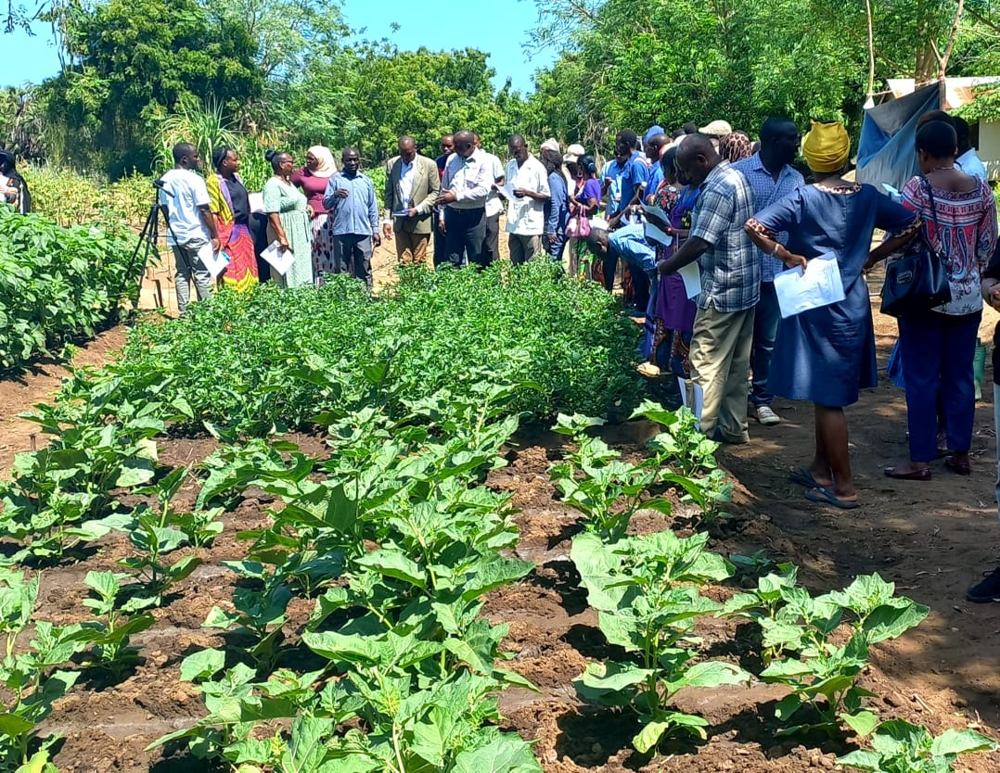
Picture 14: Dr. Fred Tairo (Centre Manager- TARI Mikocheni at the centre explaining different technologies to farmers,Depurty Mayor of Kigamboni Dr.Stephano Warioba sixth from left, DAICO from Kigamboni Municipal Ms. Priscilla Mhina third from left and Project Coordinator second from left Ms.Violet Mwaijande during the FFD at GezaUlole Farmers Training Centre in Kigamboni District

2.5 Stakeholders reached with improved technologies disseminated by TARI Mikocheni
In this reporting time total number of 421 stakeholders (233 Males and 188 Females) were reached on different technologies from TARI Mikocheni Centre and out of these, 85 farmers (45 Males and 40 Females) visited Chambezi and 44 farmers (36 Males and 8 Females) visited Mkuranga. Farmers were interested on asking different questions concerning management of coconuts and pest control in coconut farming.

Total number of 134 farmers (61 Males and 73 Females) from Bagamoyo, 72 (31 Males and 41 Females) from Kigamboni, 52 (39 Males and 13 Females) Ilala Districts were reached on improved vegetable varieties and postharvest handling and processing of vegetables.

Total number 29 farmers (15 Males and 13 Females) from Madeke Village at Mfriga Ward in Njombe District and 5 Males farmers from Kisambwa Tandai Village at Kinole Ward in Morogoro Municipal were reaches on improved pineapple variety of MD2 produced by the Centre through tissue culture and Good Agronomic Practices (GPAs) which are proper demo plot establishment, spacing and proper management practices.

Table 3: Stakeholders reached with Improved Technologies Disseminated from TARI Mikocheni Centre to various places
Place |  | Stakeholders | Technologies disseminated
Bagamoyo (Kilomo) |  | 134 (61 Males and 73 Females) | 1. Improved vegetable varieties i.e. Amaranth (Nguruma, Poli and Akeri), African nightshade (Ambureni) and African eggplant (DB3 and Tengeru).  2. Proper Transplanting (plants to be embedded with soil for faster root establishment).  3.Demoplot preparation(Well measured demo plots with proper edges)  4. Proper Spacing for (Amaranth 40cmx30cm, African night shade60 cmx30 cm and African eggplant 60cmx50cm).  5. Proper management practices like irrigation, weeding and fertilizer application.  6.Proper harvesting methods of vegetable in the field to encourage vegetative growth  7.Postharverst processing of harvested Amaranth seeds for various uses
Kigamboni (GezaUlole) |  | 72 (31 Males and 41 Females)
Ilala (PuguKinyamwezi Farmers Centre) |  | 52 (39 Males and 13 Females)
Chambezi | 85 farmers (45 Males and 40 Females) |  |  | 1. Coconuts intercropped with mangoes and orange to control pests through weaver ants which feed on coreid bugs.  2. Mechanical remover of beetles using hook.  3. Cultural control by cleaning field removing dead logs which are breeding site for beetles.  4. Using of Traps (Pheromones, PVC Pipe and Tin) to trap beetles.
Mkuranga | 44 farmers (36 Males and 8 Females) |  |  | 1. Coconuts intercropped with mangoes and orange to control pests through weaver ants which feed on coreid bugs.  2. Mechanical remover of beetles using hook.  3. Cultural control by cleaning field removing dead logs which are breeding site for beetles.  4.Using of Traps(Pheromones, PVC Pipe and Tin) to trap beetles  5. Coconuts intercropped with Improved vegetables varieties Amaranth (Nguruma, Poli and Akeri), African nightshade (Ambureni) and African eggplant (DB3 and Tengeru).
Kisambwa Tandai | 5 Males |  |  | 1.Improved pineapple variety (MD2)  2.Proper spacing recommendations 25cmx25cmx60cm  3.Proper demo plot establishment  4.Good Agronomic Practices
Madeke | 29 (16 Males and 13 Females) |  |  | 1.Improved pineapple variety (MD2)  2.Proper spacing recommendations 25cmx25cmx60cm  3.Proper demo plot establishment  4.Good Agronomic Practices
Total number of technologies disseminated |  |  |  | 16

3. Knowledge Management and Communication
3.1TARI Website Content Management
Different information was uploaded to TARI website as shown by the table below:
Table 4: Type and numbers of information uploaded to TARI website from October to December are shown on Table below:
Centre | Type of information uploaded | Number/frequency | Remarks/any feedback | Challenges
TARI - Mikocheni | News | 5 | Different activities | Lack of facilities including Internet, Computer, Scanner, Photocopy machine and Mobile phone
 | Publications | 1
 | Images/photos | 17
 | Videos | 0

3.2. Information Education and Communication Materials
Planned number of materials to be disseminated from October to December 2022 were 500 (300 leaflets, 10 Posters, 15 banners, 20 fliers, 100 brochures, 53 signboards and 12 wheel covers on coconut, tissue culture and vegetables (Amaranth, African nightshade and African Eggplant) but only 200 leaflets were managed to be disseminated other publications failed to be published due to lack of funds for printing.

Table 5: Information Materials Produced and Distributed
Centre | Number of print communication materials
 | Posters | Signboards | Fliers | Brochures | Banners | Wheel covers | Leaflets | Others specify
TARI - Mikocheni | - | 24 | - | - | 4 | - | 200 | -

4 TARI Visibility
4.1 Signboards Nil
Preparation of signboards: areas fixed with signboards with uniform format and design across TARI Centres

4.2 Mass media prepared by TARI Mikocheni
In this reporting period Mass Media TARI-Mikocheni planned to air 12 TV but only aired 3 TV. Also planned Radio were 12 while aired 3 radio, also Planned 12 newspapers actual released were 3 also Planned Social Media were 80 while aired Social Media were 42 as shown on the table below:

Table 6: Number of TVs, radio, newspapers and social media produced and disseminated

Centre | Numbers prepared/hired/made/received
TARI - Mikocheni | TV | Radio | Newspapers | Social media | Short Messages | Phone calls | Others specify
 | 3 | 3 | 3 | 42 | 64 | 63 | -
5.0 Strengthening Partnerships and Collaboration
The Partnership and collaboration in this reported time was from different stakeholders which are: Upholding Agriculture Practices (FUAP), visited the Centre to persuade on the way they will collaborate by acquiring experts from different departments and work as team so as to benefits the small farmers on Agricultural activities. Also a Danish Manufacturer (Ampliqon) visit the Centre to discuss on how to collaborate in different Agricultural activities taking place at the Centre, mainly dealing with distribution of laboratory enzymes and reagents. Furthermore Ambassadors from SANLAM Life Insurance visit the centre to establish the relationship with staffs regarding personal loans from Akiba Commercial Bank (ACB).

5.1 Meetings/ conferences/ symposia/ workshops
Seven researchers (4 females and 3 males) attended meeting at Tanga (VETA Conference Hall) from 3rd to 4th October 2022 which the main objective was to review scientific researchers’ works. Three (2 Female and 1Male) researchers attended the meeting on 25th October 2022 in which the aim was to launch Biotechnology Science in Tanzania (BST) at COSTECH Quarters.One researcher (Female) from Technology Transfer and Partnership (TTP) attended stakeholder workshop on the evaluation of the AWARD Strategy 2017-2022 held in Nairobi (Kenya) from 14th to 18th November 2022and One researcher( Female) from Technology Transfer and Partnership (TTP),attended meeting held at Zanzibar Investment Promotion Authority (ZIPA) in Zanzibar from 13th to 16thDecember 2022which its main objective was to discuss on investment and partnering of coconut production investors and others.
Table 7: Meetings/conferences/symposia/workshops conducted/attended by TARI staffs
No | Tittle/themes | Dates | Venue | Partners | Type of event(workshop/Meeting
- 1 | Internal Program Review(IPR) | 3rd -4th October 2022 | VETA Conference hall -Tanga | Researchers from TARI Mikocheni, TARI HQ,TARI Kibaha, TARI Mlingano, OCD, SISAL BOARD,REDESO AND OXFARM | It was a meeting on reviewing scientific researcher papers, proposals and discussing scientific information taking place throughout the year
- 2 | Tanzania Commission for science and Technology(COSTECH) | 25th October 2022 | COSTECH | Researchers from Agriculture, Livestock ,Environment and Health sectors, Social media | Meeting on launching Biotechnology Science in Tanzania(BST),also presenting on different biotechnologies development from various sectors in Tanzania
 | Partnership and Collaboration | 14th -18th 2022 | World Agroforestry campus (CIFOR-ICRAF), Gigiri (next to the UN complex) | AWARD participating countries from Zambia, Ghana, Nigeria, Senegal, Ethiopia, Uganda, South Africa, Malawi, Kenya and Burkina Faso | Stakeholder workshop on the evaluation of the AWARD Strategy 2017-2022
 | Partnership and Collaboration | 24th November 2022 | Peacock Hotel | TARI, Tumaini Youth Empowerment in Agriculture and Extension Services | Key stakeholders Initial strategic planning meeting on soliciting funds from Prime Minister’s office there after working together
 | Partnership, Collaboration and Project Implementation | 28th November 2022 | The Embassy of Norway | Norwegian Institute of Bio economy Research (NIBIO) | Donors, Project Implementers and Partners meeting on Institutional capacity building on climate-smart and resource efficient rice production (with focus on System of Rice Intensification) in Tanzania
 | Partnership and Collaboration | 13th -16th 2022 | Zanzibar Investment Promotion Authority Meeting room | TRA, ZIPA, Ministry of Finance, Ministry of Investment and  Bureau Veritas | Meeting

5.2. Visitations
Total number of 37 (29 Males and 8 Females) stakeholders visited the centre for different purposes this in this reporting time as shown in Table 8 below.
Table 8: Visitors visited the centre
S/No | Date of the visit | Type of visitors | Total number | Aim of the Visit
 | 12th October 2022 | Upholding Agriculture Practices (FUAP)& Netherlands senior experts(PUM) | 4 (Males and 1 Female) | To persuade the centre on partnership with FUAD by acquiring experts from different departments and work as team so as to benefits the small farmers on Agricultural activities
 | 20st October 2022 | Soil scientists | 2 (Males) | To discuss on how, when and where to take soil sampling in determining the soil constituents suitable for coconut productions
 | 21th October 2022 | Individual Farmer from Mkuranga | 1 (Male) | To ask on improved pineapple varieties and banana from tissue culture farming, when, where to get the best pineapple varieties.  He also wanted to buy pineapples and banana improved varieties to plant on his farm
 | 25th October 2022 | Individual farmer | 1 (Female) | She wanted to buy Virgin Coconut oil to use it for different purposes
 | 28th October 2022 | Ampliqon | 4 (Males) | To discuss on how to collaborate in different Agricultural activities taking place at the Centre, mainly dealing with distribution of laboratory enzymes reagents
6. | 1st November 2022 | Accountant | 1 (Male) | Payment follow up for Uhuru publication Magazine
7. | 4th November 2022 | Individual farmer from Dodoma | 1 (Male) | He wanted to be educated on coconut farming and buying seedlings for establishment of coconut farm
8. | 17th November 2022 | Ambassadors from SANLAM life Insurance | 2 (1 Male and 1 Female) | To establish the relationship with staffs regarding personal loans from Akiba Commercial Bank(ACB)
9. | 22th November 2022 | Individual farmers | 2 (1 Male and 1 Female) | Wanted to know on coconut farming education provided by the Centre
10. | 25th November 2022 | Private Company | 1 (Male) | He wanted to buy 6000 coconut seedlings for plantation
11. | 27th November 2022 | Individual farmer | 1 (Male) | He wanted to buy coconut seedlings for farm establishment
12. | 28th November 2022 | Individual farmer | 1 (Male) | He wanted to get education on cultivating different crops such Coconuts, maize, cassava and beans
13. | 30th November 2022 | Individual farmer | 1 (Male) | He wanted to get coconut farming education
14. | 8th December 2022 | District Commissioner from Mbeya | 1 (Male) | He wanted to be educated on coconut farming and buying seedlings for establishment of coconut farm
 |  | Individual farmer | 1 (Male) | Wanted to know on mites pesticides
15. | 12th December 2022 | Individuals farmers from Dar es Salam | 2 (1 Male and 1 Female) | They wanted to be educated on coconut farming and buying seedlings for establishment of coconut farm
16. | 16th December2022 | Head of Agricultural Section | 1(Female) | She wanted to buy coconut seedlings and to be educated on coconut farming
17. | 19th December 2022 | Individual farmers | 1 (Male) | Wanted to know on coconut farming education provided by the Centre and fertilizer application for Avocados
18. | 21th December 2022 | Individual farmer from Ubungo | 1 (Female) | She wanted to buy coconut seedlings for plantation
19. | 28th December 2022 | Individual farmers from Morogoro | 2(1 Male and 1 Female) | They wanted to get leaflets for Coconut farming
20. | 30th December 2022 | Retired staffs who want to engage themselves in agriculture | 3 (Males) | They wanted to get information on growing different crops: coconut, avocados and macadamia. Also they wanted to how they can start agricultural project. Also they wanted to know about biotechnology and especially on the seeds that are developed by tissue culture

5.3. Challenges
- Absence of water to irrigate due to rain absence which hinder demo plots establishment and other crops to be planted in coconut plantations.
- Lack of additional coconuts seedlings for planting in AgriTech Hubs.
- Shortage of adequate supply of coconut seedlings in case buyer demand is higher more than 5000 seedlings at once.
- Time consuming and tiresome work in extracting virgin coconut oil due to old manual pressing machine and local coconut graters.
- Lack of farming equipment’s i.e. tractors for clearing and tillage in coconuts plantations.
- Coconuts thieves due to surrounded bushes and shortage of farm guards in Chambezi and Mkuranga substations.
- Limited funds for Technology Transfer and Partnership activities at the Centre.

5.4. Conclusion and Recommendations
- Alternative source of water supply in substations and AgriTech hubs should be established so as to solve the water shortage problem in absence of rainfall which delay planting also drip irrigation should be emphasized to reduce water loss in fields.
- Good management practices in coconuts should be the priority so as more coconuts will be harvested which will increase number of coconut seedlings incase demand is higher.
- Funds are needed in order to manage different activities in the centre and sub stations. Being the coconut production centre in the country and the production of coconut is along the value chain, buying of modern electric extracting machine and graters for fast extraction process which will save time and reduce labourers cost which is crucial.
- Modern tractors should be provided for land clearing in order to reduce bushes which reduce productivity, hibernate thieves and wild animals.
- Adequate farm guards should be hired to ensure maximum security, especially in substations of Chambezi and Mkuranga were coconut production is higher.

