TANZANIA AGRICULTURAL RESEARCH INSTITUTE

Quarterly Report from 1stJANUARY–31stMARCH 2023

Technology Transfer and Partnership-TARI Mikocheni

Prepared by:

Vidah Y. Mahava

Coordinator for Technology Transfer and Partnership TARI Mikocheni

MARCH 31st2023

1.0 Introduction
Tanzania Agricultural Research Institute-(TARI-Mikocheni) is one of the 17 research centres under TARI.TARI-Mikocheni mandate is in two-folds, namely conduct and promote research for the development of the coconut sub-sector and promote research and utilization of agricultural biotechnology for socio-economic development in the country.
The centre’s head office is in Dar es Salaam at Mikocheni B, Plot 22 along the Coca Cola Road. It has two sub-stations, namely Chambezi and Mkuranga where most of the research activities are conducted. The former is located about 55 KM North of Dar es Salaam near Bagamoyo town at latitude S6.52⁰ and longitude E 38.91⁰, while Mkuranga sub-station is located at S 7.12⁰ and Longitude E 39.20⁰, about 50 KM South of Dar es Salaam.
There are two departments: 1) Research and Innovation and 2) Technology Transfer and Partnership. Under these departments there are six subprograms: Crop Research, Natural Resources, Post-harvest Management, Socio-economics and Marketing;Technology Dissemination, Commercialization and Partnership; and Knowledge Management and Communication Programs.
The Mikocheni centre basically has two research programs, which its mandates are: Coconut and Biotechnology. The coconut program is the main with four (4) research units which include: Agronomy, Disease & Pest Control, Socio-economics, Post-harvest and Technology Transfer; the Biotechnology Program accommodate three (3) units Tissue Culture, Molecular Diagnostics and Genetic Engineering Laboratories. All the research activities in each unit in the coconut program are designed to address all agricultural challenges facing the coconut agro-ecological systems which include poor coconut husbandry practices, effect of drought stress, poor soil fertility, incidence and severity of noxious pests, high incidence and damage by the coconut Lethal Disease and planting of low yielding varieties. Other challenges are low expansion, low level of rehabilitation of the area under coconuts, limited value addition/processing and poor marketing. Biotechnology in the centre acts as a tool cut across all crops and supports other research mandate.
- Technology Dissemination pathways used by TARI
Various pathways were used for dissemination of agricultural technologies from research to different stakeholders. These pathways were demonstration plots, the use of hubs (AgriTeCH) and Farmers Field Days (FFDs).
2.1: Farmers visited Agricultural Technology Transfer Hubs (AgriTecH)
Table 1: Farmers who visited TARI AgriTecH hubs for the third quarter
AgriTecH Hub | Farmers |  | Total
 | Male | Female
Nzuguni, Dodoma | 21 | 9 | 30
FatmaMwasa, Tabora | 68 | 53 | 121
Mwl. Julius Nyerere, Morogoro | 44 | 9 | 53
Nyakabindi, Shinyanga | 364 | 192 | 556
TOTAL | 497 | 263 | 760
2.1 Demonstration plots planned and established by AgriTechs hubs
At Nzuguni- Dodoma demonstration plot was planned and established with intercropped coconuts with cowpea. At Mwalimu Julius Nyerere-Morogoro demonstration plot planned will include the following crops Coconut, Oranges, Mangoes and Cowpea as cover crop while at Nyakabindi hub planned to establish demo plot with coconuts intercropped with beans after previously harvesting intercropped maize crop while at FatmaMwasa-Tabora the established demo plots were replanted again with sweet potatoes.
2.2 Technologies disseminated through AgriTecHs
(1)One demo plot at Nyakabindi-Shinyanga hub with coconuts only as for maize crops were harvested in early March, one (1) demo plot at Nzuguni-Dodoma coconuts are intercropped with cowpea,(1)one demo plot at Fatma Mwasa-Tabora coconuts are intercropped with improved sweet potatoes varieties(X-LUAMBANO and NASPOT-13) for Slips/cuttings multiplication for the aim of distributing them to groups and individual farmers (2) demo plots at Mwalimu Julius Nyerere-Morogoro one (1) demo plot on Banana tissue culture and one (1) Coconuts intercropped with mangoes and oranges.
Table 2: Technologies disseminated by TARI through AgriTecH(s)
AgriTecH | Crop | Variety/technology disseminated
FatmaMwasa, Tabora | 1. Coconuts and sweet potatoes | Coconuts intercropping improved sweet potatoes(X-LUAMBANO and NASPOTI-13)
 |  | Ridge formation to create good drainage and root expanding areas for smooth sweet potatoes growth
 | Total No. technologies disseminated | 2
Nzuguni, Dodoma | 1.Coconuts,cowpea | Coconuts intercropped with cowpea
 | Total No. technologies disseminated | 1
Mwl. Julius Nyerere, Morogoro | 1.Banana tissue culture | Clean banana tissue culture plants
 | 2.Coconuts, Mangoes, Oranges | Intercropping with fruit tree crops
 | Total No. technologies disseminate | 2
Nyakabindi, Shinyanga | 1.Coconuts | Coconut (East African Tall)
 |  | Pest control using cultural method through cleaning the fields to remove breeding sites
 | Total No. technologies disseminated | 2
TOTAL | Total No. technologies disseminated | 7
2.3 Farmers’ Field Day executed by TARI
In this reporting period the centre conducted one Farmer Field Day (FFD) on 2nd January 2023at Mwalusembe Village in Mkuranga District. The aim of this FFD was to showcase technologies to farmers on intercropping coconuts with Improved Vegetable Varieties:There are three improved varieties of Amaranthus (Poli, Nguruma and Akeri), One variety of African nightshade (Ambureni) and two varieties of African Eggplant (Tengeru white and DB3).Other technologies demonstrated were: Good Agronomic Practices (GPAs) which are establishment and management of nurseries, spacing, harvesting, post-harvest methods and proper management practices.

Farmers Field Days to showcase the farmers on improved vegetable varieties in Mkuranga District are shown on pictures below:

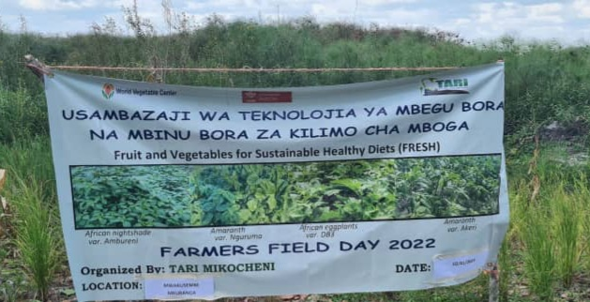
Picture 1: Farmer Field Day at Mwalusembe Village in Mkuranga District

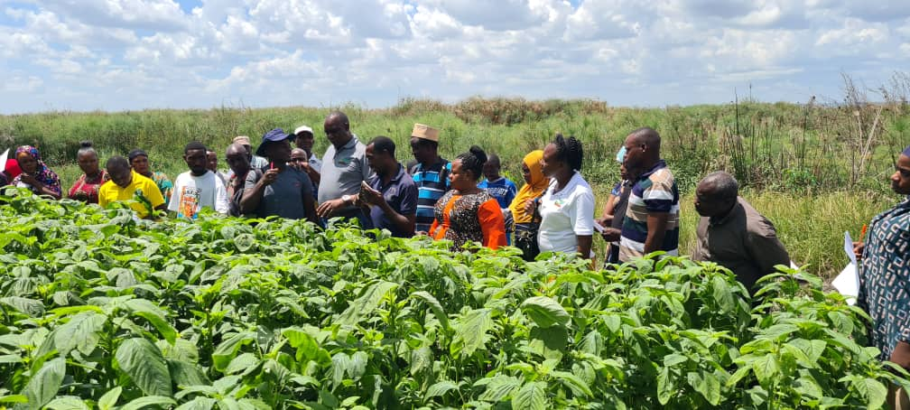
Picture 2:Dr. Fred Tairo Centre Manager from TARI Mikocheni (at the centre) elaborating on the intercropped improved vegetable varieties with coconuts during FFD at Mwalusembe village in Mkuranga District

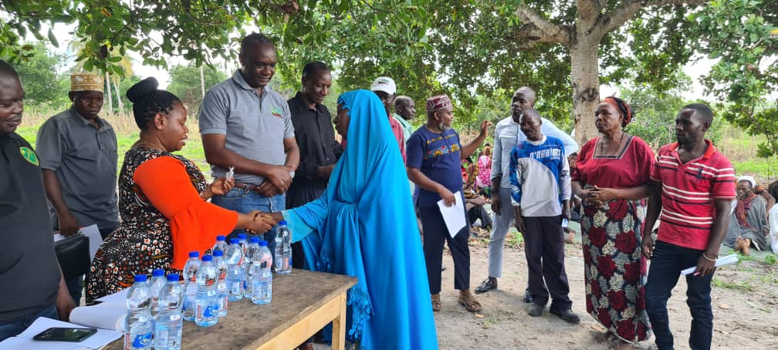
Picture 3:Ms.Anna Kiria, Ward Officer at Mkuranga distributing the seeds to farmers, right next to her is Dr. Fred Tairo (Centre Manager- TARI Mikocheni) during FFD at Mwalusembe Village in Mkuranga District

2.4. Stakeholders reached with improved technologies disseminated by TARI Mikocheni
Total number of 956 stakeholders were reached on various technologies disseminated by TARI Mikocheni from January to March 2023 in which 114 farmers (Males 62 and 52 Females) were reached during Farmers Field Day at Mkuranga on improved vegetable varieties and postharvest handling and processing of vegetables. In substations 252 farmers (79+Males and 39+ Females) in which 157(78 Males and 79 Females) visited Chambezi sub-station and 95(75 Males and 20 Females)visited Mkuranga sub-station in this reporting time request on buying coconut seedlings, asking different questions concerning management of coconuts, intercropping and pest control in coconut farming. These stakeholders had many questions also about other crops.

Total number of 590 stakeholders (279 Males and 311 Females) from University of Dar es Salaam were reached on two mandate function of TARI Mikocheni Centre.

Table 3: Stakeholders reached with Technologies Disseminated from TARI Mikocheni Centre to various places
Place | Stakeholders | Technologies disseminated
Mwalusembe | 114(62 Males and 52Females) | 1. Improved vegetable varieties i.e. Amaranth (Nguruma, Poli and Akeri), African nightshade (Ambureni) and African eggplant (DB3 and Tengeru white).  2.Proper harvesting methods of vegetable in the field to encourage vegetative growth  3.Postharverst processing of harvested Amaranth seeds for various uses
Chambezi | 157 (78 Males and 79 Females) |  | 1. Coconuts intercropped with mangoes and orange to control pests through weaver ants which feed on coreid bugs.  2. Mechanical remover of beetles using hook.  3. Cultural control by cleaning field removing dead logs which are breeding site for beetles.  4. Using of Traps (Pheromones, PVC Pipe and Tin) to trap beetles.
Mkuranga | 95(75 Males and 20 Females |  | 1. Coconuts intercropped with mangoes and orange to control pests through weaver ants which feed on coreid bugs.  2. Mechanical remover of beetles using hook.  3. Cultural control by cleaning field removing dead logs which are breeding site for beetles.  4.Using of Traps(Pheromones, PVC Pipe and Tin) to trap beetles  5. Coconuts intercropped with Improved vegetables varieties Amaranth (Nguruma,Poli and Akeri), African nightshade (Ambureni) and African eggplant (DB3 and Tengeru white).
University of Dares salaam(UDSM) | 590 (Males 279 and Females 311) |  | 1. Intercropping coconuts with various crops, i.e. Mangoes, Banana, vegetables, etc.  2.Biotechnology Program which accommodate three (3) units Tissue Culture, Molecular Diagnostics and Genetic Engineering Laboratories
Total number of technologies disseminated |  |  | 10

3. Knowledge Management and communication
3.1TARI Website Content management
Different information was uploaded to TARI website as shown by the table below:
Table 4: Type and numbers of information uploaded to TARI website for the third quarter.
Centre | Type of information uploaded | Number/frequency | Remarks/any feedback | Challenges
TARI - Mikocheni | News | 6 |  | Lack of facilities including Internet, Computer, Scanner, Photocopy machine and Mobile phone
 | Publications | 4
 | Images/photos | 6
 | Videos | 0

3.2 Information education and Communication Materials
Planned number of materials to be disseminated were 300 leaflets on coconut, tissue culture and vegetables (Amaranth, African nightshade and African Eggplant) where 100leaflets were managed to be disseminated.

Table 5: Information materials produced and distributed

Centre | Number of print communication materials
 | Posters | Signboards | Fliers | brochures | Banners | Wheel covers | Leaflets | Others specify
TARI - Mikocheni | - | - | - | - | - | - | 100 | -

4 TARI Visibility
4.1 Signboards NIL
Preparation of signboards: areas fixed with signboards with uniform format and design across TARI Centres NIL

4.2 Mass media prepared by TARI Mikocheni in Quarter three
In this reporting period Mass Media planned to air 5 TV while aired 1 TV. Also planned Radio were 6 while aired 1 radio, also Planned 6newspapers actual released were 4 also Planned Social Media were 65 while aired Social Media were 30 as shown on the table

Table 6: Number of TVs, radio, newspapers and social media produced and disseminated

Centre | Numbers prepared/hired/made/received
TARI - Mikocheni | TV | Radio | Newspapers | Social media | Short Messages | Phone calls | Others specify
 | 1 | 1 | 4 | 30 | 75 | 42 | -
5.0 Strengthening Partnerships and Collaboration
The collaboration made in this reporting time was between TARI Mikocheni and two TARI’S centers which are TARI Kihinga and TARI Mlingano. The collaboration between TARI Mikocheni aimed at producing sisal seedlings through tissue culture Technology. Sisal mother stocks were received from TARI Mlingano aim to be multiplied so as to reach total of 500,000 sisal seedlings by July 2023.Another collaboration was between TARI Mikocheni and TARI Kihinga which is in the initial stage, total number of 7671 oil palm hybrids of high quality named TENERA resulted from crossing of DURA and PISIFERA varieties were received so as to be tested in Biotechnology unit for confirming hybrid performance. In working together Sisal and Oil palm will be produced more as they are among cash crops which the government emphasize to revive so as to increase their production in the country.
The partnership involved was between TARI Mikocheni and International Institute of Tropical Agriculture(IITA) where scientists from Germany visiting the center and use Tissue Culture Laboratory as a venue to build capacity to Mikocheni researchers on how to eliminate virus in cassava this is the one of productive relationship between TARI and IITA.
The following are the pictures taken during those collaborating activities in Biotechnology Laboratory at Mikocheni Centre

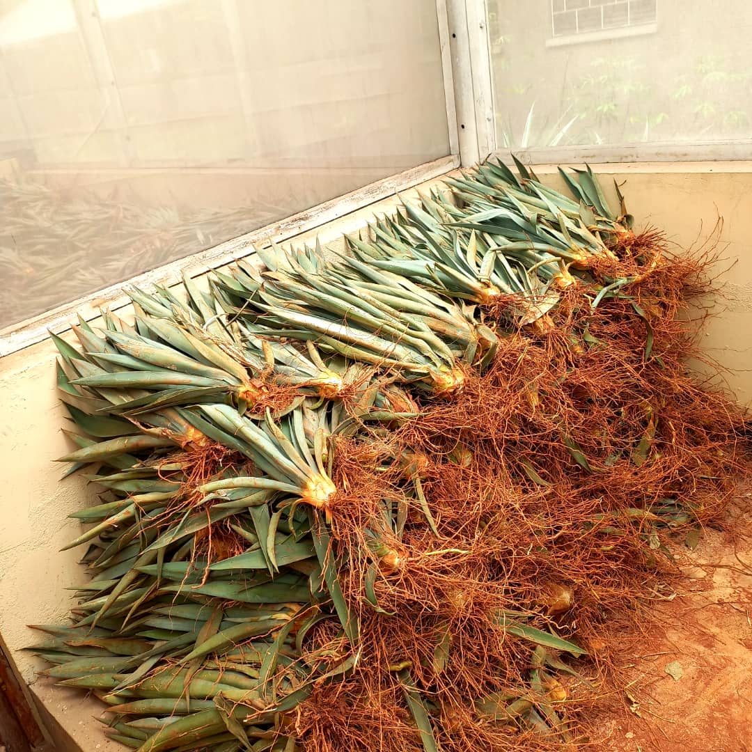
Picture 1: Some of the sisal mother stocks received from TARI Mlingano
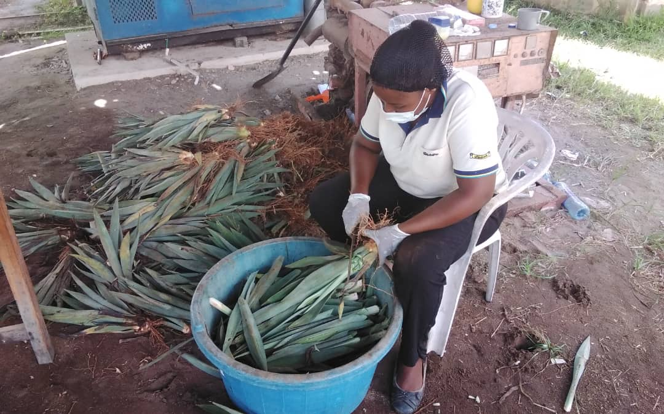
Picture 2:Ms.Mwajabu Kassim, Temporary labourer at TARI Mikocheni removing some leaves in sisal mother stocks before transferring them to laboratory

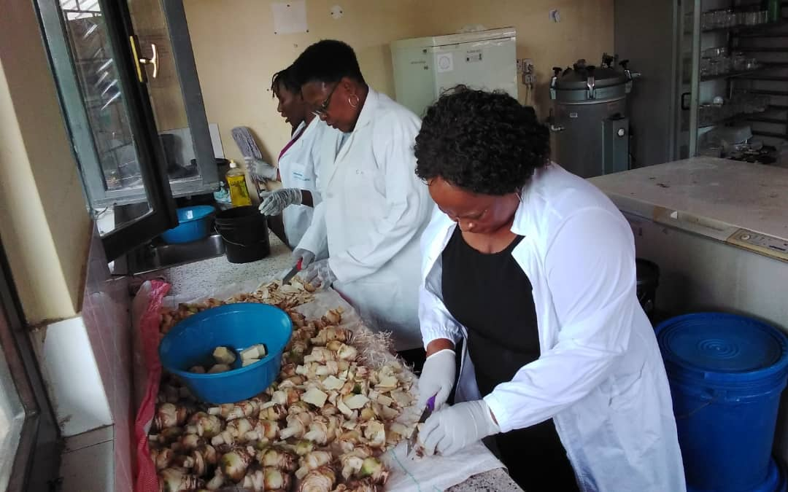
Picture 3: Ms. Rose Kaguo(right) and Ms. Fracia Swai(between) scientists from TARI Mikocheni reducing the size of trimmed sisal mother stocks in initial stage of producing sisal seedlings
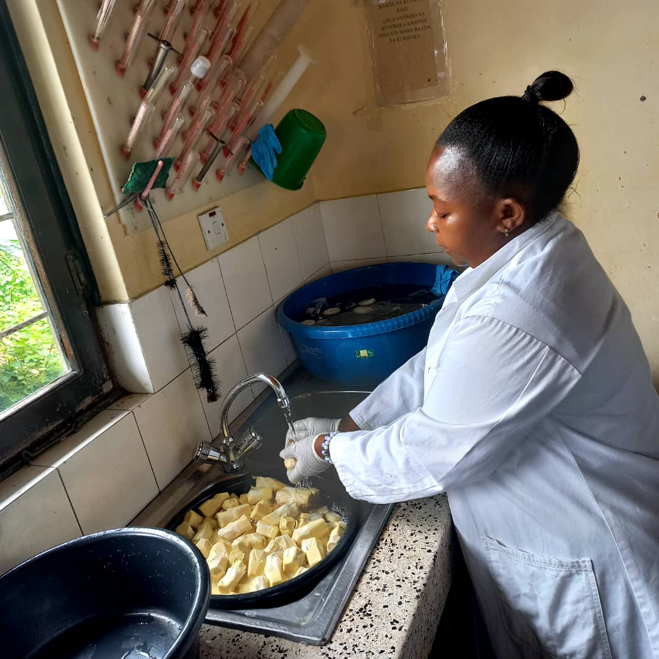
Picture 4:Ms. Margareth Lupembe a researcher from TARI Mikocheni cleaning the sisal mother stocks to remove impurities.
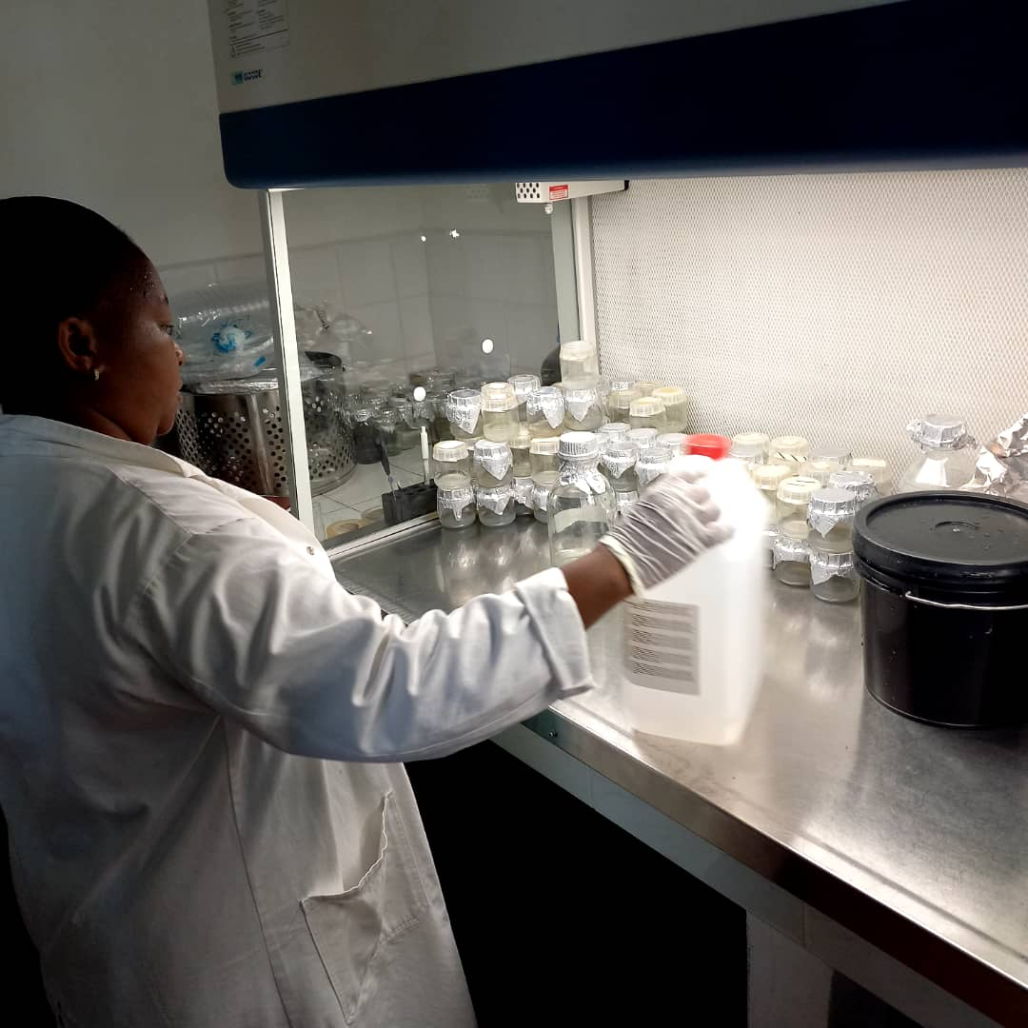
Picture 5: Ms Margareth Lupembe a researcher from TARI Mikocheni in Transfer room preparing ethanol and water solution for dinsfecting the trimmed sisal mother stocks

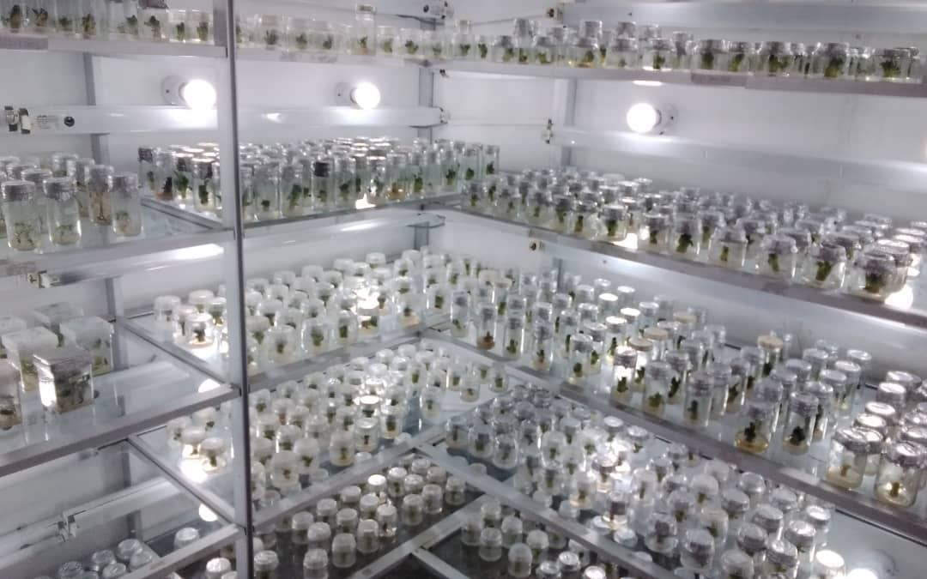
Picture 6: The front view of some sisal seedlings Tissue culture bottles in grass shelves within the Growth chamber in Tissue Culture Laboratory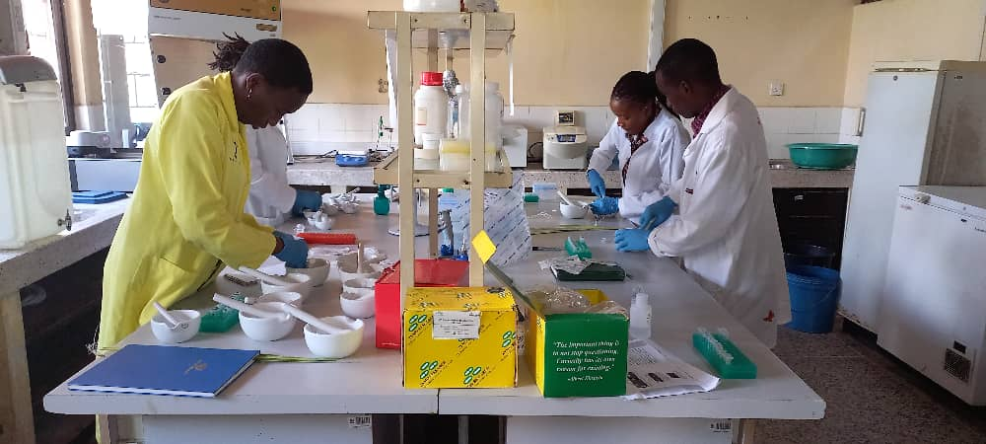
Picture 7:Ms.Hilda Bachwenkizi (in yellow coat) a researcher working with intern students from University of Dar es Salaam in extracting DNA content from TENERA species to test for high quality hybrid variety
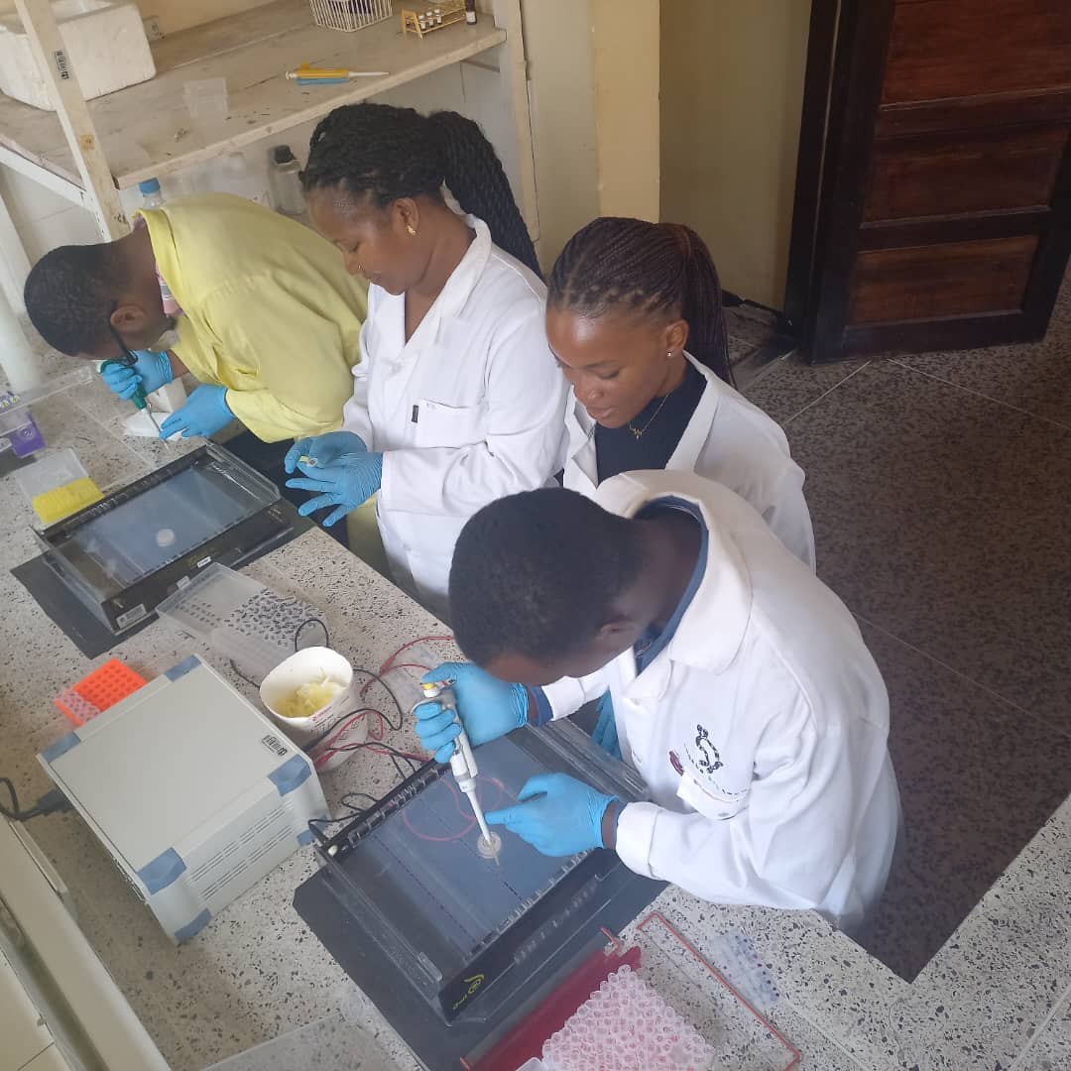
Picture 8:Mr.Jackson Rashid(with yellow coat) followed by Ms Happiness Samuel both researchers at TARI Mikocheni demonstrating to intern students from University of Dar es salaam on how to load DNA samples in gel wells for electrophoresis process to check the quality of DNA in oil palm(TENERA) variety

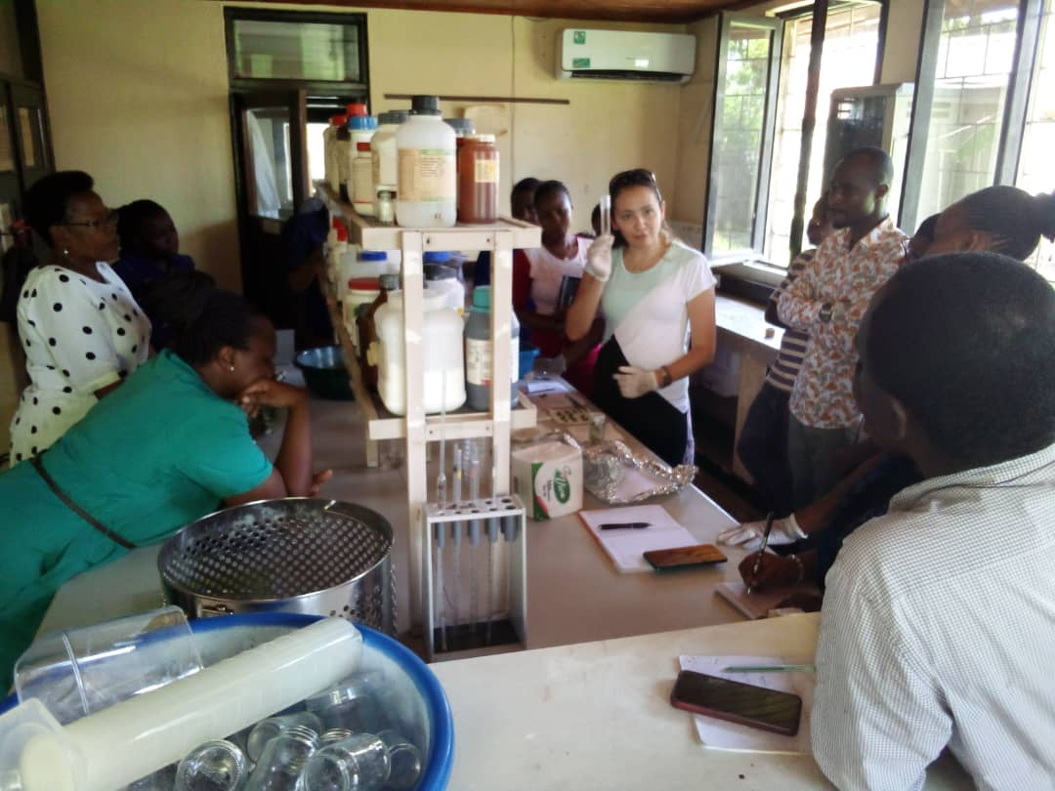
Picture 9:Dkt.Samar Sheat (at the centre) from International Institute of Tropical Agriculture (IITA) elaborating on how to eliminate virus in cassava plant to TARI Mikocheni researchers

5.1 Meetings/ conferences/ symposia/ workshops
In this reporting time, One researcher(Male) from Pest Control Unit attended the meeting held at ARNATOUGLO Hall on 7th January 2023 where the main objective was to make arbitration of land disputes in between regions and two Researchers(Females) from Technology Transfer and Partnership (TTP),attended meeting held at University of Dar es Salaam at New Library Hall on 10th January 2023 where the main objective was to officially launch of the Dar es Salaam University Agribusiness and Natural Resources Economics Associations(DUANEA) in promoting youth inclusion in Agriculture development. Two researchers(1 Male and 1 Female) from Biotechnology and Technology Transfer Units attended the meeting held COSTECH headquarter on 7th and 8th March 2023 where the main objective was to build capacity to journalists on how to prepare reports related to science, technology and innovation. One researcher (Male) from Biotechnology unit attended meeting held at Speke Munyoyo in Uganda (Kampala) on 6th to 13th March 2023 where the main objective was to discuss on development of African Cassava Whitefly Project (ACWP).One researcher (Female) from Biotechnology attended one day workshop on 07 March, 2023in which the aim was to discuss on plant variety protection at Sheraton Hotel in Arusha. One researcher (Female) attended a workshop on 12th March 2023 in which the aim was Investment seminar and the official opening of the window to receive applications for participation in the iMBEJU program of the CRDB bank at Mwalimu J.K.Nyerere International Conference Centre.

Table 7: Meetings/conferences/symposia/workshops conducted/attended by TARI staffs
No | Tittle/themes | Dates | Venue | Partners | Type of event workshop/  Meeting
 | Preparation of new fertilizer analysis before it is imported in the country for the use | 16th February 2023 and 7th March 2023 | Tanzania Fertilizer Authority Office in Dar es Salaam | Tanzania Agricultural Research Institute (TARI) Tanzania Fertilizer Authority (TFA), Tanzania Fertilizer Regulatory Authority (TFRA), Tanzania Plant Health and Pesticides (TPHPA) | Meeting
 | Visiting committee of Ministries in Regions in Arbitration of land disputes | 7th January 2023 | ARNATOUGLO Hall | Ministry of Lands, Housing and Human Settlements Development, TARI, TAMISEMI, Ministry of Agriculture, Ministry of Livestock and Fisheries | Meeting
 | Officially launch of the Dar es Salaam University Agribusiness and Natural Resources Economics Associations(DUANEA) | 10th January 2023 | New Library Hall (UDSM) | Government Ministries and Authorities, International Institutions, Non governments Organizations, Financial Institutions, DUANEA Members and UDSM Staffs | Meeting
 | Capacity building to journalists on how to prepare reports related to Science (Research), Technology and Innovation | 7th-8th March 2023 | Tanzania Commission for Science and Technology (COSTECH) HQs | Media houses available in Dar es Salaam, | Meeting
 | African Cassava Whitefly Project (ACWP) | 6th -13th March 2023 | Speke Munyonyo Hotel | National Resources Institute-University of Greenwich, NaCRRI-NARO National Crop Resources Research Institute- Uganda, Department of Agriculture and Research Services (DARS)-Malawi | Meeting
 | Plant Variety Protection | 7th March | The Four Point by Sheraton Hotel- Arusha | National Resources Institute-University of Greenwich, NaCRRI-NARO National Crop Resources Research Institute- Uganda, Department of Agriculture and Research Services (DARS)-Malawi | Workshop
 | Investment seminar and the official opening of the window to receive applications for participation in the iMBEJU program of the CRDB bank | 12 March, 2023 | Mwalimu Nyerere International Conference Centre | CRDB Bank, Tanzania Commission for Science and Technology (COSTECH), Private Sectors, Tanzania Agricultural Research Institute (TARI | Workshop
5.2 Internship Programmes
In this reporting time TARI Mikocheni received 3 intern students (1) Male from Sokoine University of Agriculture and 2(1 Male and 1 Female) from University of Dar es Salaam.
Table 9: Number Intern students attached to the Centre
Centre | Type | From | Number
Mikocheni working in Biotechnology Unit (Tissue Culture Laboratory) | Intern Student | Sokoine University of Agriculture | 1 Male
Mikocheni working in Biotechnology Unit (Molecular Biology Laboratory) | Intern Student | University of Dar es salaam | 2(1 Male and 1 Female)

5.3. Visitations
Total number of 171 (121 Males and 50 Females) stakeholders visited the centre for different purposes from January to March 2023 as shown in table 8 below.
Table 8: Visitors visited Mikocheni centre
S/No | Date of the visit | Type of visitors | Total number | Aim of the visit
 | 2nd January 2023 | Individual farmer from Dares salaam | 1 Male | He wanted to be educated on vegetable seeds for garden establishment
 | 9thJanuary 2023 | Workers from JUMACO | 3(1 Male and 2 Female) | They wanted to request meeting with workers and establishing Poster for plots advertisements
 | 11th January 2023 | Individual farmer from Sumbawanga | 1 Male | He wanted to buy Banana and lemon seedlings
 | 16th January 2023 | Individual farmers from Dar es salaam | 1 Female | Wanted to know on coconut farming education/knowledge provided by the Centre and she was satisfied by the information provided
 |  |  | 1Male | He wanted to buy sweet pepper seeds where she was directed and connected to TARI Tengeru
 | 17thJanuary 2023 | Individual farmers from Dar es salaam | 1 Male | He wanted to buy coconut seedlings for plantation
 |  |  | 1 Male | He wanted to know on watermelon production, he was also directed and connected to TARI Tengeru
 | 18th January 2023 | Individual farmers | 1 Male | He wanted to buy palm seedlings
 |  |  | 1 Male | He wanted to be educated on Coconut farming
 |  |  | 1 Female | Mwananchi Communication Company personnel who wanted to work on us on publishing different articles about Mikocheni Centre, coconut production and biotechnology
 | 19th January 2023 | Individuals famers from Dar es Salaam | 2 Males | They wanted to learn on coconut and vegetable production.
 |  |  | 1 Female | She wanted to get information on Coconut production and Biotechnology
 | 20th January 2023 | Individual farmer from Dar es Salaam | 1 Female | She wanted to get information on vegetable production
 |  |  | 1 Male | He wanted to get advice on coconut farming
 | 23th January 2023 | Tutors and Students from BORIGARAM College-Kigamboni | 31(19Males and 12 Females) | They came to get practical training on how to produce different crop seedlings ,i.e. Cassava, pineapple, banana and Sweet potatoes using Tissue Culture Technology
 | 24th January 2023 | Extension Officer from Ilala District | 1 Female | She wanted to buy sweet potatoes slips
 | 25th January 2023 | Individual farmers from Kigamboni | 2(1 Male and 1 Female) | Information and advice on coconut farming
 |  |  | 3(2 Females and 1Male) | They wanted to get education/knowledge on how to control pests on Coconut farming
 | 26th January 2023 | Individual farmers from Dar es Salaam | 1 Female | She wanted to buy coconut seedlings for plantation
 |  |  | 1 Male | He wanted to get information on Banana diseases(directed to Ma was directed to Hombolo
 | 27th January 2023 | Individual farmers from Dar es Salaam | 2 Males | They wanted to buy coconut seeds, coconut farming knowledge and onion production information
 | 03th February 2023 | Individual farmer from Dar es Salaam | 1 Male | He wanted to be educated on coconut and mango farming and requested on soil sample analysis
 | 06th February 2023 | Individual farmers from Dar es Salaam | 1 Female | Wanted to know on coconut farming education/knowledge provided by the Centre and she was satisfied by the information provided
 |  |  | 1Male | He wanted to buy coconut seedlings
 | 08th February 2023 | Individual farmers from Dar es Salaam | 1 Male | He wanted to be educated on coconut farming, he was also interested on buying cassava, tomatoes, maize, carrots and sunflower and he was directed to Ilonga and Tengeru Research Institutes
 |  |  | 1 Female | She wanted to know where to get sweet potatoes slips, she was directed and connected to FatmaMwasa Hub manager-Tabora
 | 09th February 2023 | Individual farmer | 1 Male | He wanted to get information on Amaranths seeds and he was connected to Agronomy department
 | 10th February 2023 | Individual farmers from Dar es Salaam | 1Male | He wanted to get information on cassava production
 |  |  | 2(1 Male and 1 Female) | They wanted to get education on coconut farming
 | 13th February 2023 | Individual farmer from Dares salaam | 1 Male | He wanted to get information on coconut production
 | 15th February 2023 | Individual farmers from Dar es Salaam | 2 Females | They came to get information on coconut farming and buying coconut seedlings
 |  | Self-employer | 1 Female | She wanted to get and buy virgin coconut oil
 | 16th February 2023 | Individual farmer from Dar es Salaam | 1 Male | He wanted to get coconut farming leaflets and brochures
 | 18th February 2023 | Nanyumbu District Commissioner from Mtwara Region | 1 Female | She asked on coconut seedlings and farming
 | 19th February 2023 | Commissioner General of the Drug Control and Enforcement Authority | 1 Male | He wanted to get coconut information and coconut seedlings for establishment of farming
 | 21th February 2023 | Individual farmer from Dar es Salaam | 1 Male | He wanted to get information on coconut farming
 | 22th February 2023 | Reporter from Mwananchi Communication Limited | 1 Female | She requested on documentary information for publishing article concerning technologies provided by the centre on Mwananchi newspaper
 | 27th February 2023 | Director General of TAKUKURU Tanzania | 1 Male | He wanted coconut seedlings for coconut farming
 |  |  | 1 Female | She wanted to get information on coconut farming
 | 28th February 2023 | Individuals farmers from Dar es Salaam | 1 Male | He wanted to get information on cassava production
 |  |  | 1 Male | He wanted to get information on coconut production
 |  |  | 1 Male | He wanted to get information on how to make decomposed manure on coconut husks
 |  |  | 1 Female | She wanted to get information on banana production and get banana seedlings for plantation
 | 1st March 2023 | Peasant from Bagamoyo | 1 Male | He wanted to get information on coconut production
 |  | Farmer from Dar es Salaam | 1 Male | He wanted to get information on beans production and he was directed to Uyole
 | 2nd March 2023 | Reporter from Voice of America(VoA) | 1 Male | He wanted information on different activities done and services provided by the centre so as to disseminate them to various agricultural stakeholders through via mass media
 |  | A farmer from Chanika | 1 Male | He wanted to buy coconut seedlings
 | 6th March 2023 | Worker from Inqaba Biotech Tanzania | 1 Male | Distributing Laboratory equipment’s and reagents for genetic testing of various species in Biotechnology laboratory
 | 7th March 2023 | News reporter from different media and entrepreneurs | 20(Males and 7 Females) | They wanted to get information and oversee on different activities done by the centre and using that content to prepare news for their respective mass media
 | 8th March 2023 | Students from Lund University in Sweden | 5 Females | They were investigating on their carried samples on different crops
 | 9th March 2023 | A farmer from Bunju | 1 Female | She wanted information on Mangoes production
 |  | A farmer from Lindi | 1 Male | He wanted coconut seedlings
 | 13th March 2023 | A farmer from Dar es Salaam | 1 Male | To get information on coconut farming
 | 15th March 2023 | Reporters from Channel 10 | 3 Males | To get information on coconut farming for the documentaries
 | 20th March 2023 | Individual farmers from Dar es Salaam | 5(4 Males and 1 Female) | They asked questions concerning coconut production and requesting coconut seeds
 | 22th March 2023 | Farmers from Dar es Salaam | 2(1 Male and 1 Female) | They wanted to get information on coconut seedlings
 | 23th March 2023 | Farmers from Dares salaam | 2(1 Male and 1 Female) | They wanted to get information on coconut farming and request on coconut seedlings
 | 24th March 2023 | A farmer from Dar es Salaam | 1 Male | He wanted to get information on mangoes and maize production
 |  | A blogger from Michuzi Blog | 1 Female | She wanted to get information on Tissue culture Laboratory for the blog
 | 27th March 2023 | Farmers from different places | 4(3 Males and 1 Female) | They wanted information on coconut farming and seedlings, palm and sesame production
 | 28th March 2023 | Farmers from DSM and researcher from Mkuranga | 5 Males | They wanted information on coconut farming and seedlings
 | 30th March | Farmers from DSM and Mtwara | 3(2 Males and 1 Female) | They wanted to buy coconut seedlings and get information on coconut and cassava production

5.4 Challenges
- Delay in salary payments to farm workers/ guards
- Lack of working equipment to farm guards at TARI Mikocheni Sub-Stations (Chambezi and Mkuranga) i.e. Raincoats, gumboots and defensive weapon against invaders.
- Lack of farming equipment i.e. tractors for clearing and tillage in coconuts plantations and Agritech hubs.
- Coconuts thieves due to surrounded bushes and shortage of farm guards at Chambezi and Mkuranga sub-stations
- Water cut off which hinder coconut seedlings nursery development and other demonstration plots establishments.
- Limited funds for TTP activities at the Centre which hinder publications of updated news and scientific findings and development of dissemination materials like brochures, leaflets, banners, posters, calendars etc.

5.5. Conclusion and Recommendations
- Salary should be paid on time to meet the demands of the labourers needs.
- Working equipment to farm guards should be provided to increase their efficiency.
- Modern tractors should be provided for land clearing in order to reduce bushes which reduce productivity, hibernate thieves and wild animals.
- Adequate farm guards should be hired to ensure maximum security, especially at Chambezi and Mkuranga Sub-stations where coconut production is higher.
- Bill payment on time to avoid water cut off at TARI Mikocheni sub-stations.
- Funds should be provided for TTP activities at the centre.

