**TANZANIA AGRICULTURAL RESEARCH INSTITUTE**

‘

**3rd Quarter Progress Report 1st January to 31st March 2025**

**Technology Transfer and Partnership-TARI Mikocheni**

**Prepared by:**

**Vidah Y. Mahava**

**Coordinator for Technology Transfer and Partnership TARI Mikocheni**

**March 31st 2025**

**1.0 Introduction**

Tanzania Agricultural Research Institute-(TARI-Mikocheni) is one of the 17 research centres under TARI.TARI-Mikocheni mandate is in two-folds, namely conduct and promote research for the development of the coconut sub-sector and promote research and utilization of agricultural biotechnology for socio-economic development in the country.

The centre’s head office is in Dar es Salaam at Mikocheni B, Plot 22 along the Coca Cola Road. It has two sub-stations, namely Chambezi and Mkuranga, where most of the research activities are conducted. The former is located about 55 KM North of Dar es Salaam near Bagamoyo town at latitude S6.520 and longitude E 38.910, while Mkuranga sub-station is located at S 7.120 and Longitude E 39.200, about 50 KM South of Dar es Salaam.

There are two departments: 1) Research and Innovation and 2) Technology Transfer and Partnership. Under these departments there are six subprograms: Crop Research, Natural Resources, Post-harvest Management, Socioeconomics and Marketing; Technology Dissemination, Commercialization and Partnership; and Knowledge Management and Communication Programs.

The Mikocheni centre basically has two research programs, which its mandates are: Coconut and Biotechnology. The coconut program is the main with four (4) research units which include: Agronomy, Disease & Pest Control, Socioeconomics, Post-harvest, and Technology Transfer; the Biotechnology Program accommodate three (3) units Tissue Culture, Molecular Diagnostics and Genetic Engineering Laboratories. All the research activities in each unit in the coconut program are designed to address all agricultural challenges facing the coconut agro-ecological systems which include poor coconut husbandry practices, effect of drought stress, poor soil fertility, incidence and severity of noxious pests, high incidence and damage by the coconut Lethal Disease and planting of low yielding varieties. Other challenges are low expansion, low level of rehabilitation of the area under coconuts, limited value addition/processing and poor marketing. Biotechnology in the centre acts as a tool cut across all crops and supports other research mandate.

1. **Technology Dissemination pathways used by TARI.**

Various pathways were used for dissemination of agricultural technologies from research to different stakeholders which includes the use of hubs (AgriTecHs), demonstration plots and agricultural exhibitions.

**2.1: Technologies disseminated through AgriTecH(s)**

In this reporting time Agricultural Technology Hubs (AgriTechs) continued to disseminate agricultural technologies as follow: At Mwl Julius Nyerere Hub in Morogoro with two (2) demo plots in which one demo plot has Banana tissue culture with varieties of Mzuzu, Kimalindi, Bukoba and Fia 23 and the second demo plot has coconuts intercropped with Mangoes and Oranges. At Nzuguni Hub in Dodoma the demo plot has coconuts only. At Fatma Mwasa Hub in Tabora the demo plot has coconuts intercropped one variety of Sweet potato (KABODE) and at Nyakabindi- Shinyanga Hub the demo plot has coconuts only.

**Table 1: Technologies disseminated by TARI through AgriTecH(s)**

|  |  |  |
| --- | --- | --- |
| **AgriTecH** | **Crop** | **Variety/technology disseminated** |
| Fatma-Mwasa, Tabora | 1. Coconuts and Sweet potatoes | Intercropping Coconuts (East African Tall) with Sweet potato (KABODE) |
| **Total No. technologies disseminated** | **1** |
| Nzuguni, Dodoma | 1.Coconuts | Coconuts (East African Tall) |
| **Total No. technologies disseminated** | **1** |
| Mwl. Julius Nyerere, Morogoro | 1.Banana Tissue culture | Banana (Mzuzu, Kimalindi, Bukoba and Fia 23) |
| 2.Coconuts, Mangoes and Oranges | Intercropping Coconuts (East African Tall) with fruit tree crops |
| **Total No. technologies disseminate** | **2** |
| Nyakabindi, Shinyanga | 1.Coconuts and Maize | Coconuts (East African Tall) |
| **Total No. technologies disseminated** | **1** |
| **TOTAL** | **Total No. technologies disseminated** | **5** |

**2.2. Stakeholders reached with improved technologies disseminated by TARI Mikocheni**

**2.2.1. Number of stakeholders reached with technologies at TARI Mikocheni Centre**

In this reporting time, total numbers of **14 (9 Males and 5 Females)** students from Sokoine University of Agriculture(SUA) and Borigaram Agricultural Technical College(BATC) visited TARI Mikocheni Centre purposely for field training. During the training students acquired skills on various technologies disseminated by the Centre such as Tissue culture technology, DNA extraction, PCR techniques in Molecular Biology laboratory, controlling coconut pests, agronomic practices in coconuts and extension services to coconut farmers.

**Table 2: Number of attained students with TARI Mikocheni technologies**

|  |  |  |  |
| --- | --- | --- | --- |
| **University/Institute/College** | **Attained students** | | **Total** |
| **Males** | **Females** |
| Sokoine University of Agriculture(SUA) | 8 | 4 | 12 |
| Borigaram Agricultural Technical College(BATC) | 1 | 1 | 2 |
| **TOTAL** | **9** | **5** | **14** |

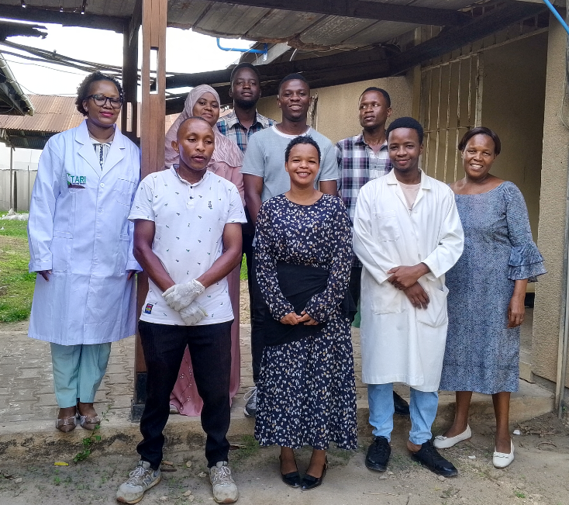

***Photo 1: Researchers from TARI Mikocheni, Ms.Happiness Samuel (first left), Ms. Evarista Shao (first right) and some of the students from Sokoine University of Agriculture group photo at TARI Mikocheni Centre.***

**2.2.2 Stakeholders reached with improved technologies at Mikocheni Sub-stations.**

In this reporting time total number of **173 Farmers (118 Males and 55 Females**) were reached at Mikocheni sub-stations, in which **135 (83 Males and 52 Females)** visited and contacted via phone Chambezi sub-station and **38 Farmers (35 Males and 3 Females)** visited and contacted via phone Mkuranga Sub-station requested on buying coconut seedlings, asking different questions concerning management and pest control in coconuts, mangoes and oranges.

**Table 3:** **Number of stakeholders reached with technologies at Chambezi and Mkuranga Sub-stations.**

|  |  |  |
| --- | --- | --- |
| **Place** | **Stakeholders** | **Technologies disseminated** |
| Chambezi | 135 Farmers (83 Males and 52 Females) | 1. Coconuts intercropped with mangoes and orange to control pests through weaver ants which feed on Coreid bugs  2. Mechanical remover of beetles using hook  3. Cultural control by cleaning field removing dead logs which are breeding site for Rhinoceros beetles  4. Using of Traps (Pheromones, PVC Pipe and Tin) to trap beetles |
| Mkuranga | 35 Farmers (35 Males and 3 Females) | 1. Coconuts intercropped with mangoes and orange to control pests through weaver ants which feed on Coreid bugs  2. Mechanical remover of beetles using hook  3. Cultural control by cleaning field removing dead logs which are breeding site for Rhinoceros beetles  4. Using of Traps (Pheromones, PVC Pipe and Tin) to trap beetles |
| **Total number of technologies disseminated** | | **4** |

**3. Knowledge Management and Communication**

**3.1 TARI Website Content management**

Different information was uploaded to TARI website as shown by the table 4 below:

**Table 4:** Type and numbers of information uploaded to TARI website

|  |  |  |  |  |
| --- | --- | --- | --- | --- |
| **Centre** | **Type of information uploaded** | **Number/frequency** | **Remarks/any feedback** | **Challenges** |
| TARI- Mikocheni | News | 0 | - | Lack of facilities including Internet, Camera for taking photos and documentaries, and Mobile phone for easy sharing of information especially in social media |
| Publications | 1 |
| Images/photos | 5 |
| Videos | 2 |
|  |  |

**3.2 Information Education and Communication materials**

Planned number of materials for dissemination in this reporting time were 300 leaflets on Good Agronomic Practices for coconut farming, Coconut pests, their effects and control measures, About TARI Mikocheni centre and Benefits of Virgin Coconut Oil (VCO) where only 156 leaflets managed to be disseminated.

**Table 5: Information materials produced and distributed**

|  |  |  |  |  |  |  |  |
| --- | --- | --- | --- | --- | --- | --- | --- |
| Number of print communication materials | | | | | | | |
| Posters | Signboards | Fliers | Brochures | Banners | Wheel covers | Leaflets | Others specify |
| - | - | - | - | - | - | 156 | - |
|  |  |  |  |  |  |  |  |

1. **TARI Visibility**

**4.1 Signboards: -NIL-**

Preparation of signboards: No any area fixed with uniform format and designed signboard.

**4.2 Mass media prepared by TARI Mikocheni**

In this reporting period, Mass Media planned to air 1 TV while aired 0 TV. Also planned Radio were 1 while aired 0 radio, also Planned 1 newspapers actual released were 0 also planned social media were 9 while aired social media were 1 as shown on the table 6 below:

**Table 6: Number of TVs, radio, newspapers, and social media produced and disseminated.**

|  |  |  |  |  |  |  |
| --- | --- | --- | --- | --- | --- | --- |
| **Numbers prepared/hired/made/received** | | | | | | |
| **TV** | **Radio** | **Newspapers** | **Social media** | **Short Messages** | **Phone calls** | **Others specify** |
| 0 | 0 | 0 | 1 | 75 | 80 | - |

**5.0 Strengthening Partnerships and Collaboration**

**5.1. Visitations**

In this reporting time **t**otal number of **36 visitors (30 Males and 6 Females)** stakeholders visited the Centre for different purposes from January to March 2025 as shown on Table 7 below.

**Table 7: Visitors visited the Centre.**

|  |  |  |  |  |
| --- | --- | --- | --- | --- |
| **S/No** | **Date of the visit** | **Type of visitors** | **Total number** | **Aim of the Visit** |
|  | 3rd January 2025 | A farmer from Kigamboni-DSM | 1 Male | He wanted coconut seedlings |
| A farmer from DSM | 1 Male | He wanted banana seedlings, directed to TARI Maruku |
|  | 6th January 2025 | A farmer from DSM | 1 Male | He wanted coconut seedlings |
|  | 17th January 2025 | A farmer from Upanga-DSM | 1 Male | He wanted coconuts seedlings |
| A farmer from Kisarawe -DSM | 1 Male | He wanted coconut seedlings |
|  | 20th January 2025 | A farmer from Kisarawe-DSM | 1Male | He wanted cassava seedlings and fertilizer, directed to TARI Kibaha |
|  | 21th January 2025 | A farmer from DSM | 1 Male | He wanted education on coconut farming |
|  | 30th January 2025 | An individual farmer | 1 Male | He wanted sesame seeds, directed to TARI Naliendele |
| 7. | 3rd February 2025 | Farmers from Kinondoni-DSM | 2 Males and 1 Female | They wanted education on irrigation farming, greenhouse agriculture and elaboration concerning oil crops |
| 8. | 11th February 2025 | Farmers from DSM | 2 Males | They wanted education on coconut farming |
| 9. | 12th February 2025 | A farmer from Coast | 1 Male | He wanted and received mango seedlings |
| 10. | 17th February 2025 | Farmers from DSM | 2 Males | They wanted to be educated on how to cultivate coconut and to get coconut seedlings |
| 11. | 19th February 2025 | A farmer from Ubungo-DSM | 1 Female | She wanted coconut seedlings |
| 3 Males | They wanted education on sisal production |
| 12. | 20th February 2025 | A visitor | 1 Female | Official visit |
| 13. | 24th February 2025 | A visitor | 1 Male | Official visit |
| 14. | 4th March 2025 | Workers from ABSA and DTB Bank | 1 Male and 1 Female | Official visit to make follow up on request letter |
| 15. | 5th March 2025 | Individual farmer from Mikocheni-DSM | 1 Male | He wanted education on coconut farming |
| 16. | 6th March 2025 | Farmers from DSM | 2 Males | They wanted education on coconut and cashew nut farming |
| 17. | 7th March 2025 | Farmer from Kimara-DSM | 1 Male | He wanted education on oil palm production and oil palm seedlings |
| 18. | 10th March 2025 | Farmer from UDSM | 1 Female | She wanted virgin coconut oil and maize seeds, directed to ASA and TARI Ilonga |
| 19. | 12th March 2025 | Agricultural equipment sellers from AFRICANLION | 2 Males | They wanted to sell Agricultural equipment’s to Mikocheni staffs |
| 20. | 17th March 2025 | Individual farmer from DSM | 1 Male | Information on exportation of Agricultural products |
| 21. | 20th March 2025 | Individual farmer from Mikocheni-DSM | 1 Male | He wanted education on coconut farming |
| 22. | 22nd March 2025 | Agricultural Officer from Mkinga -Tanga | 1 Male | He wanted to get information on the procedures for establishment of coconut nurseries and distribution of coconut seedlings to farmers |
| Regional Commissioner from Tanga | 1Female | She wanted to buy coconut seedlings |
| 23. | 26th March 2025 | Farmer from Mikumi-Morogoro | 1 Male | He wanted to buy coconut seedlings |

**6. Challenges**

* Limited number of facilities and equipment to accomplish planned tasks performed at the Centre.
* Limited funds which result to the shortage of dissemination materials like brochures and leaflets to farmers visiting Chambezi and Mkuranga substations.
* Lack of working equipment to farm guards at TARI Mikocheni sub-stations (Chambezi and Mkuranga), i.e., Rain coats, gumboots and defensive weapon against invaders
* Lack of farming equipment and transport vehicles i.e. tractors for clearing and tillage in coconuts plantations and vehicles for patrol around the farms.
* Incidence of coconuts thieves due to surrounded bushes and shortage of farm guards at Chambezi and Mkuranga sub-stations

**7. Recommendations**

* Adequate number of facilities and Equipment to accomplish planned tasks performed at the Centre.
* Adequate Funds should be provided for TTP activities at the centre.
* Working equipment to farm guards should be provided to increase their efficiency.
* Modern tractors should be provided for land clearing in order to reduce bushes which reduce productivity, hibernate thieves and wild animals.
* Adequate farm guards should be hired to ensure maximum security, especially at Chambezi and Mkuranga sub-stations where coconut production is higher.
* Gap filling is required to on coconuts so as to increase coconut production at Chambezi and Mkuranga substations.