**TANZANIA AGRICULTURAL RESEARCH INSTITUTE**

‘

**PROGRESS REPORT FOR THE FOURTH QUARTER FINANCIAL YEAR 2023/2024**

**TECHNOLOGY TRANSFER AND PARTNERSHIP DEPARTMENT**

**TARI MIKOCHENI**

**PREPARED BY:**

**VIDAH Y. MAHAVA**

**1ST APRIL-30TH JUNE, 2024**

**TECHNOLOGY TRANSFER AND PARTNERSHIP DEPARTMENT**

**SUMMARY OF PROGRESS REPORT OF IMPLEMENTED ACTIVITIES IN THE FOURTH QUARTER OF THE FINANCIAL YEAR 2023/2024 STARTING 1ST APRIL-30TH JUNE, 2024**

**Date:**

**Ajenda Number:** 4

**Objective: Presentation of the progress report on implementation of Technology Transfer and Partnership Department for the 4TH quarter of financial year 2023/2024**

1. **Introduction**

Technology Transfer and Partnership (TTP) is one of the two department at TARI-Mikocheni centre, deals with promotion and dissemination of generated technologies in collaboration with the department of research and innovations. It is also responsible for forging partnership with partners in conducting joint research and dissemination of agricultural based technologies.

The department works with different stakeholders including smallholder farmers, processors, universities and media houses in packaging, promoting and disseminating technologies to end users. It uses different pathways in transferring technologies including demonstration plots and the use of hubs (AgriTecH)

The department is composed of two sections: Communication Knowledge Management and Technology Transfer and Partnerships

1. **Planed activities for 4th quarter as per approved work plan 2023/2024**

During this quarter, the department planned to conduct a number of activities as summarized hereunder: -

1. Visiting and preparation of AgriTecH hubs (Morogoro and Dodoma)
2. Participation in Agricultural exhibitions (MAKISATU, World Food Day and other Agricultural Technology Transfer Exhibition)
3. Preparation of one (1) farmer’s field day
4. Establishment of 7 demonstration plots
5. Establishment of one (1) Centre display Unit
6. **Implementation and Achievements**

**3.1** **Visiting and preparation of demonstration plots in AgriTecH hubs** (J. K. Nyerere-Morogoro and Nzuguni-Dodoma). In this quarter, a total of five technologies were disseminated to farmers through our 4 Agritech hubs (table 1).

**Table 1: Technologies disseminated by TARI through Agri.-TecH(s)**

|  |  |  |
| --- | --- | --- |
| **AgriTecH-Hub** | **Crop** | **Variety/technology disseminated** |
| Fatma Mwasa, Tabora | Coconuts and Sweet potatoes | Coconuts (East African Tall) intercropped with sweet potatoes varieties of X-LUAMBANO and KABODE |
| Nzuguni, Dodoma | Coconuts, Maize and Beans | Coconuts (East African Tall) intercropped with local varieties of maize and improved varieties of cowpeas |
| Mwl. Julius Nyerere, Morogoro | Banana tissue culture | Banana (Mzuzu, Kimalindi, Bukoba and FHia 23) |
| Coconuts, Mangoes and Oranges | Intercropping with fruit tree crops |
| Nyakabindi, Shinyanga | 1.Coconuts | Coconuts (East African Tall) |
| **TOTAL** | **Total No. technologies disseminated** | **5** |

**3.2 Participation in Agricultural exhibitions (MAKISATU, World Food Day and other Agricultural Technology Transfer Exhibition)**

The department managed to participate Agriculture Exhibitions week prepared by the Ministry of Agriculture at Parliament grounds in Dodoma with the aim of creating awareness to the member of parliament on Different Agricultural Technologies developed by researchers. **Total number of 355 Member of parliament/visitors (255 Males and 100 Females)** were reached with TARI Agricultural Technologies displayed during the Ministry of Agriculture Exhibition week at Parliament grounds in Dodoma City. A total of 13 Centres participated and show cased 79 technologies most of these were improved seeds and others were technologies on soils, pest control and mechanization. Technologies displayed by TARI Mikocheni were East Africa Tall coconut (EAT) seeds and seedlings, Integrated Pest Management (IPM) in controlling Rhinoceros beetles, coconut bugs and mites in coconuts and improved pineapple variety of MD2 resulted from Tissue Culture Technology**.** The Exhibitions started from 28th April 2024 and ended on 3rd May 2024.

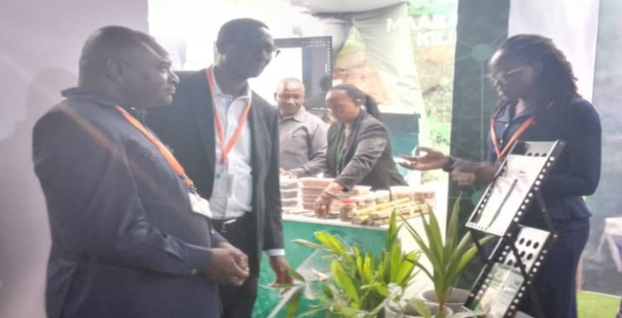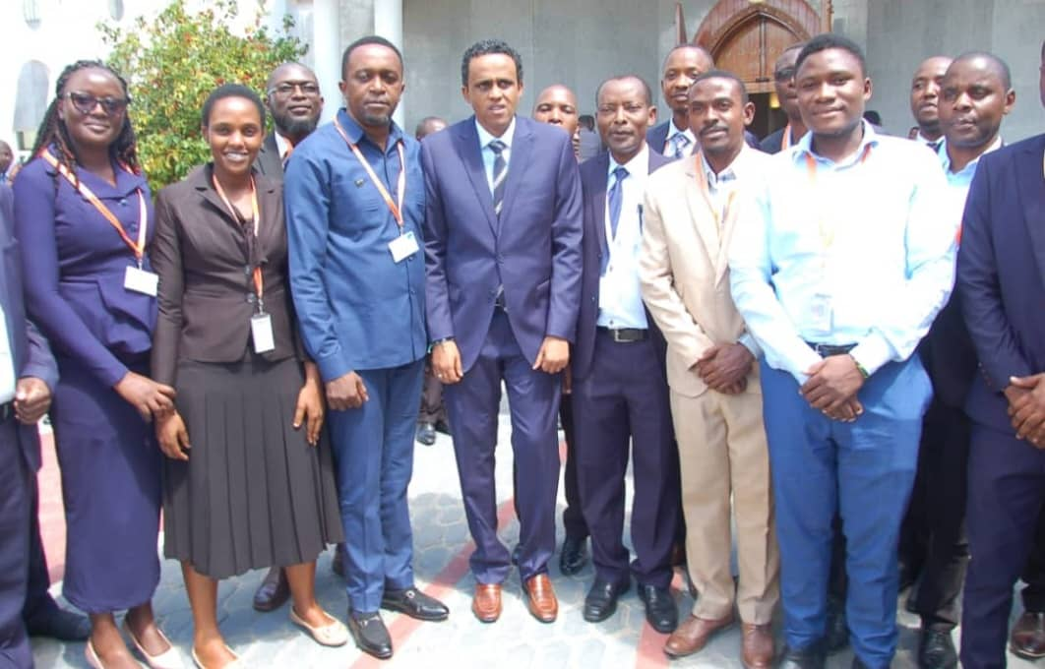

*(Left) Some member of parliament during Ministry of Agriculture Exhibition week and (Right) Some member of parliament including Hon. Hussein Bashe (Fourth from left), Minister of Agriculture, Dr. Thomas Bwana (Fifth from left)-TARI Director General and researchers group photo during Ministry of Agriculture Exhibition week at parliament grounds*

**3.3 Preparation of one (1) farmer’s field day**

TARI Mikocheni through Technology Transfer and Partnership Department(TTP) managed to organized and host one Farmer Field Day (FFD) on 11th June 2024 at Mkuranga sub-station in Pwani region. Different agricultural technologies were displayed and disseminated to farmers and other stakeholders including the use of improved variety example East African Tall (EAT) coconut variety, Good Agronomic Practices (GAPs), Integrated Pest Management (IPM), MD2 Pineapple variety resulted from Tissue Culture Technology, DNA fingerprinting using Polymerase Chain Reaction (PCR) Machine, Processing of Virgin Coconut Oil (VCO) and other coconut products and Intercropping system. **Total number of 322 (208 Males and 114 Females) farmers and other stakeholders** managed to participate well on such Farmer Field Day (FFD). Other important stakeholders managed to participate Farmer Field Day (FFD) were Mkuranga District Council, Mkuranga Coco Peat Company, International Institute of Tropical Agriculture (IITA), FARMBASE Limited, Tanzania Fertilizer Regulatory Authority (TFRA) and CRDB Bank.

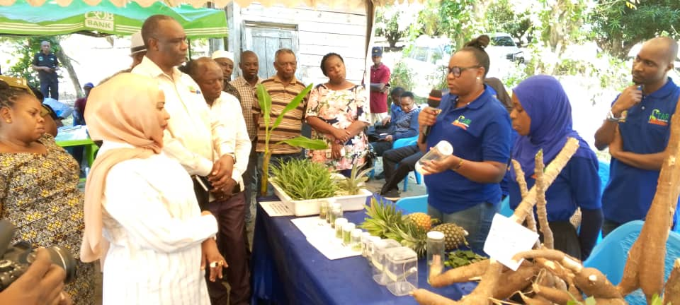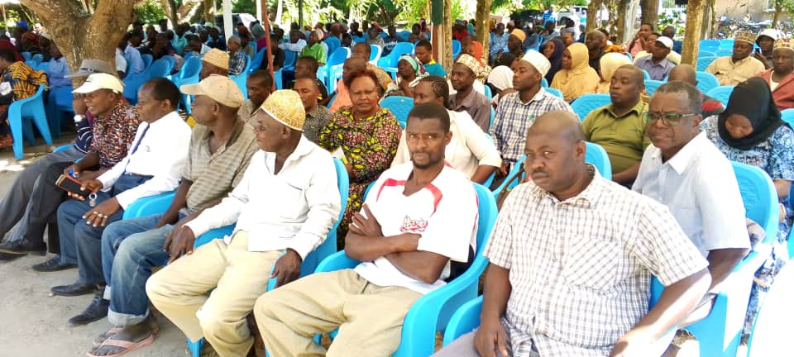

### *Guest of honour, Hon. Khadija Nassir (Left), Mkuranga District Commissioner and Farmers (Right) during Farmer Field Day (FFD) held on 11 June, 2024 at Mkuranga Sub-station in Mkuranga District*

**3.4 Establishment of demonstration plots**

Technology Transfer and Partnership department in collaboration with Agronomy Unit visited Muheza District from 26th to 29th May 2024.The purpose of the visit was to establish coconut nursery demonstration plot at Songa Batini village, Muheza District in Tanga Region. The team managed to establish one coconut nursery demonstration plot. During establishment of coconut nursery demonstration plot, researchers managed to create awareness where farmers trained on coconut seed selection, planting techniques and management of coconut seedlings in nursery. **Total number of** **31 (21 Males and 10 Females) farmers and 5 extension officers were trained.** TARI Mikocheni is also expecting to establish two more coconut nursery demonstration plots in Lindi and Mtwara region.

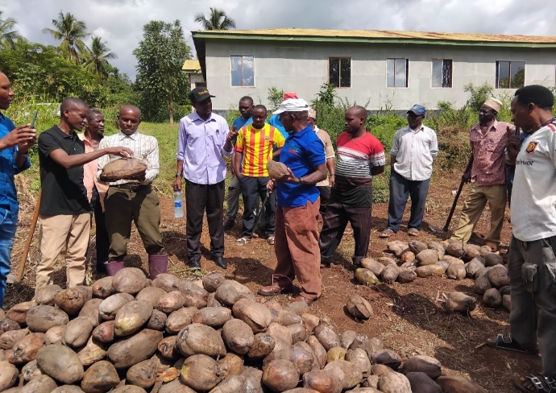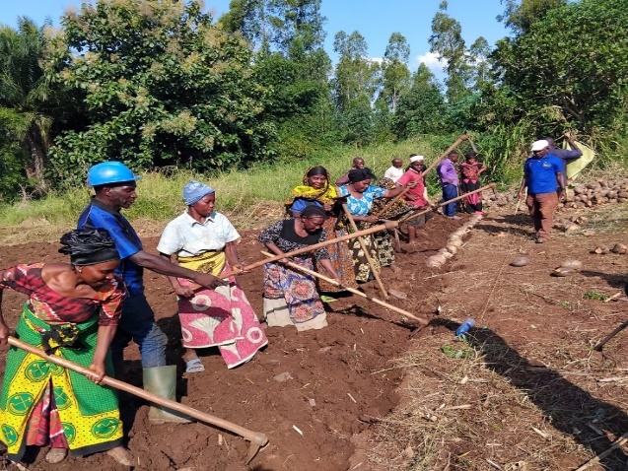

*Farmers participating during establishment of coconut nursery demo plot*

**3.5 Establishment of Center Display Unit**

Technology Transfer and Partnership Department managed to establish one Center Display Unit where different Agricultural Technologies Dissemination materials included Roll up banners, Leaflets, Brochures and screen for displaying different activities and agricultural technologies developed by the center.

1. **Knowledge Management and Communication**

**4.1 TARI Website Content management**

Different information uploaded to TARI website as shown by the table 2 below:

**Table 2:** Type and numbers of information uploaded to TARI website for quarter four

|  |  |  |  |  |
| --- | --- | --- | --- | --- |
| **Centre** | **Type of information uploaded** | **Number/frequency** | **Remarks/any feedback** | **Challenges** |
| TARI – Mikocheni | News | 3 | - | Lack of facilities including Internet, Camera for taking photos and documentaries, and Mobile phone for easy sharing of information especially in social media |
| Publications | 4 |
| Images/photos | 24 |
| Videos | 2 |
|  |  |

**4.2 Information Education and Communication materials**

Planned number of materials for dissemination in this reporting time were 450 leaflets on coconut, tissue culture and improved vegetables where only 237 leaflets were managed to be disseminated.

**Table 3: Information materials produced and distributed**

|  |  |  |  |  |  |  |  |
| --- | --- | --- | --- | --- | --- | --- | --- |
| Number of print communication materials | | | | | | | |
| Posters | Signboards | Fliers | Brochures | Banners | Wheel covers | Leaflets | Others specify |
| - | 1 | - | - | - | - | 237 | - |
|  |  |  |  |  |  |  |  |

1. **TARI Visibility**

**5.1 Signboards: One (1)**

Preparation of signboards: One (1) areas (TARI Mikocheni main office) fixed with one signboard with uniform format and design.

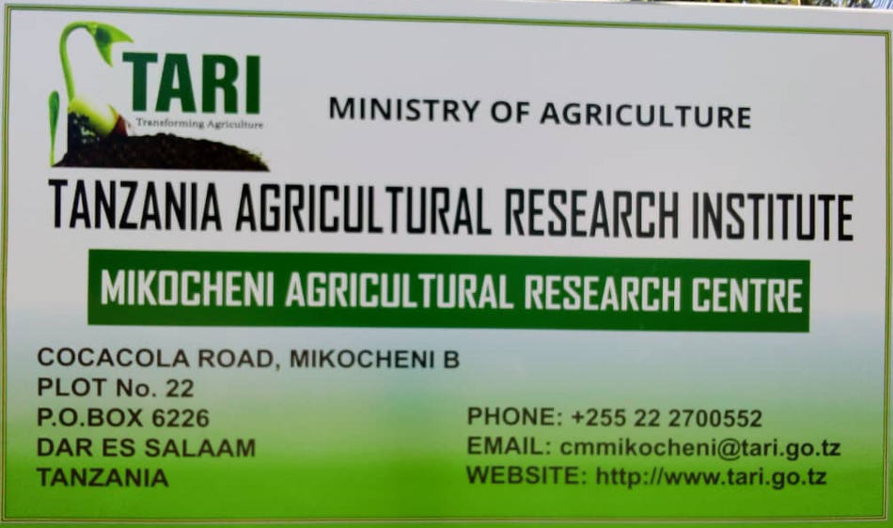

**5.2 Mass media prepared by TARI Mikocheni in 4th Quarter**

In this reporting period, Mass Media planned to air 3 TV while aired 4 TV. Also planned Radio were 3 while aired 0 radio, also Planned 3 newspapers actual released were 4 also planned social media were 200 while aired social media were 113 as shown on the table 4 below.

**Table 4: Number of TVs, radio, newspapers, and social media produced and disseminated.**

|  |  |  |  |  |  |  |
| --- | --- | --- | --- | --- | --- | --- |
| **Numbers prepared/hired/made/received** | | | | | | |
| **TV** | **Radio** | **Newspapers** | **Social media** | **Short Messages** | **Phone calls** | **Others specify** |
| 4 | 0 | 4 | 113 | 46 | 82 | - |

1. **Strengthening Partnerships and Collaboration**

**6.1 Meetings/ conferences/ symposia/ workshops**

Ms. Vidah Mahava**,** Centre Coordinator of Technology Transfer and Partnership (CCTTP) attended one day, meeting on 10th May 2024 at Sea Shell Hotel in Dar es Salaam. The aim of the meeting was to discuss on how to access acquisition of Green Climate Funds in Tanzania. Ms. Vidah Mahava also attended a meeting from 20th to24th May 2024 at Johannesburg in South Africa. The aim of the meeting was to discuss on the innovative technological ideas in improving agricultural practices among members of Southern African Development Community (SADC). Three Secretaries (Females) from Administration Unit attended five days on the 11th Annual professional Meeting of the Tanzania Association of Secretaries and Administrative Professionals (TAPSEA) Meeting from 20th to 24th May 2024 at CCM Kirumba Stadium in Mwanza Region with the aim of reminding them on the ethics of their duties and allow them to share work experiences among themselves from various working places as summarized in the table below;

**Table 5: Meetings/ conferences/ symposia/ workshops attended by TARI Staffs**

|  |  |  |  |  |  |
| --- | --- | --- | --- | --- | --- |
| **No** | **Tittle/themes** | **Dates** | **Venue** | **Partners** | **Type of event(workshop/Meeting** |
| 1. | Access to Acquisition of Green Climate Funds in Tanzania | 10th May 2024 | Seashell Hotel in Dar es Salaam | Tanzania Civil Society Forum on Climate Change (FORUMCC), CRDB BANK, Ministry of Agriculture (MoA) and Mwananchi Official | Meeting |
| 2. | Innovative technological ideas in improving agricultural practices among members of Southern African Development Community (SADC). | 20th to 24th May 2024 | Johannesburg in South Africa. | Lesotho, Mauritius, Angola, Zambia, Malawi, Mozambique, South Africa, Seychelles and Zimbabwe | Meeting |
| 3. | 11th Tanzania Annual Secretaries Association Meeting | 20th to 24th May 2024 | CCM Kirumba Stadium in Mwanza | All Secretaries from Tanzania and Zanzibar Government and Non-Government Institutions | Meeting |

**6.2 Visitations**

Total number of **28 visitors (19 Males and 9 Females)** stakeholders visited the Centre for different purposes from April to June as shown in Table 6 below.

**Table 6: Visitors visited the centre**

|  |  |  |  |  |
| --- | --- | --- | --- | --- |
| **S/No** | **Date of the visit** | **Type of visitors** | **Total number** | **Aim of the visit** |
|  | 2th April2024 | A farmer from Kinondoni-Dsm | 1 Male | He wanted to buy coconut seedlings |
|  | 5thApril 2024 | A Representative from Eastern Africa Grain Council (EAGC) | 1 Female | She wanted to get information for Non GMO Certification |
|  | 12thApril 2024 | Representatives fromOccupational Safety and Health Authority(OSHA) | 1 Female&1Male | They wanted to meet Mikocheni workers in order to give them information on safety at work |
|  | 15thApril 2024 | A farmer from Mbezi-Dsm | 1Male | He wanted to buy coconut seedlings |
| Students from Gerezani Secondary School | 1 Male &2 Females | They wanted to get information on Agricultural Research |
|  | 17thApril 2024 | Farmers from Bagamoyo-Pwani | 3 Males | They wanted to buy coconut seedlings |
|  | 19thApril 2024 | A faermer from Kinondoni - Dsm | 1 Male | He wanted to buy coconut seedlings |
|  | 10th May 2024 | Farmer s from Kinondoni-DSM | 1 Male & 1Female | They wanted to buy coconut seedlings |
|  | 14th May 2024 | A Representative from ABSA Bank | 1 Female | She wanted to get inform workers on available loans |
|  | 15th  May 2024 | Farmers from Dar es Salaam | 1Male | He wanted to get information concerning research on sweet potatoes |
| 1 Male | He wanted to buy coconut seedlings |
|  | 16th May 2024 | A farmer from Dar es salaam | 1Female | She wanted to buy pineapple seedlings |
|  | 20th May 2024 | A Representative from Energy Company | 1 Male | He wanted to do presentation to the workers at the centre on products that use electricity |
| A farmer from DSM | 1 Male | He wanted to get information on coconut farming |
|  | 21st May 2024 | A farmer from Kinondoni - DSM | 1 Female | She wanted to coconut, banana, mango seedlings and vegetables |
|  | 22nd May 2024 | A farmer from Segerea -DSM | 1 Male | He wanted to get information on coconut farming |
|  | 13th June 2024 | Farmer from Pwani | 1 Male | He wanted to buy pineapple seedlings where he was directed to Dr. Happyness Mollel |
| Farmer from DSM | 1 Male | Official visit where he also asked on coconut farming knowledge |
|  | 18th June 2024 | Farmer from Sudan Country | 1 Male | He asked on coconut farming knowledge and border quarantine certification procedures |
| Farmer from Goba-DSM | 1 Male | He wanted to get information on coconut farming |
|  | 21st June 2024 | Farmer from Upanga-DSM | 1 Female | She wanted to get information on coconut farming |
|  | 26th June 2024 | Farmer from Dodoma | 1 Male | He wanted to get information on coconut farming |

**7. Stakeholders reached with improved technologies at Mikocheni Sub-stations**

**A total of 185 Farmers (126 Males and 59 Females) were reached at Mikocheni sub-stations,** where 141 Farmers (92 Males and 49 Females) visited Chambezi sub-station and 44 Farmers (34 Males and 10 Females**)** visited Mkuranga sub-station. Farmers visited for the purpose of buying coconut, mangoes and oranges seedlings, asking different questions concerning coconuts, mangoes and oranges farming practices.

**Table 7: Number of stakeholders reached with different Agricultural Technologies at Chambezi and Mkuranga sub-stations.**

|  |  |  |
| --- | --- | --- |
| **Place** | **Stakeholders** | **Technologies disseminated** |
| Chambezi | 141 Farmers (92 Males and 49 Females) | 1. Coconuts intercropped with mangoes and orange to control pests through weaver ants which feed on coreid bugs.  2. Mechanical remover of beetles using hook.  3. Cultural control by cleaning field removing dead logs which are breeding site for beetles.  4. Using of Traps (Pheromones, PVC Pipe and Tin) to trap beetles. |
| Mkuranga | 44 Farmers (34 Males and 10 Females) | 1. Coconuts intercropped with mangoes and orange to control pests through weaver ants which feed on coreid bugs.  2. Mechanical remover of beetles using hook.  3. Cultural control by cleaning field removing dead logs which are breeding site for beetles.  4. Using of Traps (Pheromones, PVC Pipe and Tin) to trap beetles. |
| **Total number of technologies disseminated** | | **4** |

1. **Challenges**
2. Absence of water to irrigate due to rain absence which hinder coconut productivity and other crops to be intercropped with coconuts.
3. Lack of coconuts seedlings for disseminating to coconut farmers/stakeholders.
4. Lack of funds for supporting processing of other various coconut products. i.e., Coconut oil, milk, powder, soap etc. Insufficient/Lack of funds has also caused failure of researchers from TARI Mikocheni in participating **MAKISATU** and **World Food Day**
5. **Conclusion and Recommendations**
6. Alternative on water supply in substations should be established to solve the water shortage problem in absence of rainfall which reduce coconut productivity.
7. Sufficient budget is required for fully implementation of all planned activities example participation of researchers during MAKISATU and World Food Day, coconut seedlings production to satisfy the demands of coconut growers
8. Due to the need of other coconut products, funds should be provided for expanding and rehabilitation of the extracting machines and processing premises.
9. **Request to the management**

The department is kindly asking the management to accept the quarter report presented here

Vidah Mahava

**Head Technology Transfer and Partnership Department–TARI-Mikocheni**